1. During a routine inspection, a technician discovered that software that was installed on a computer was secretly collecting data about websites that were visited by users of the computer. Which type of threat is affecting this computer?

DoS attack​  
identity theft  
**spyware**  
zero-day attack

2. Which term refers to a network that provides secure access to the corporate offices by suppliers, customers and collaborators?

Internet  
intranet  
**extranet**  
extendednet

3. A large corporation has modified its network to allow users to access network resources from their personal laptops and smart phones. Which networking trend does this describe?

cloud computing  
online collaboration  
**bring your own device**  
video conferencing

4. What is an ISP?

It is a standards body that develops cabling and wiring standards for networking.  
It is a protocol that establishes how computers within a local network communicate.  
**It is an organization that enables individuals and businesses to connect to the Internet.**  
It is a networking device that combines the functionality of several different networking devices in one.

5. Match the requirements of a reliable network with the supporting network architecture. (Not all options are used.)

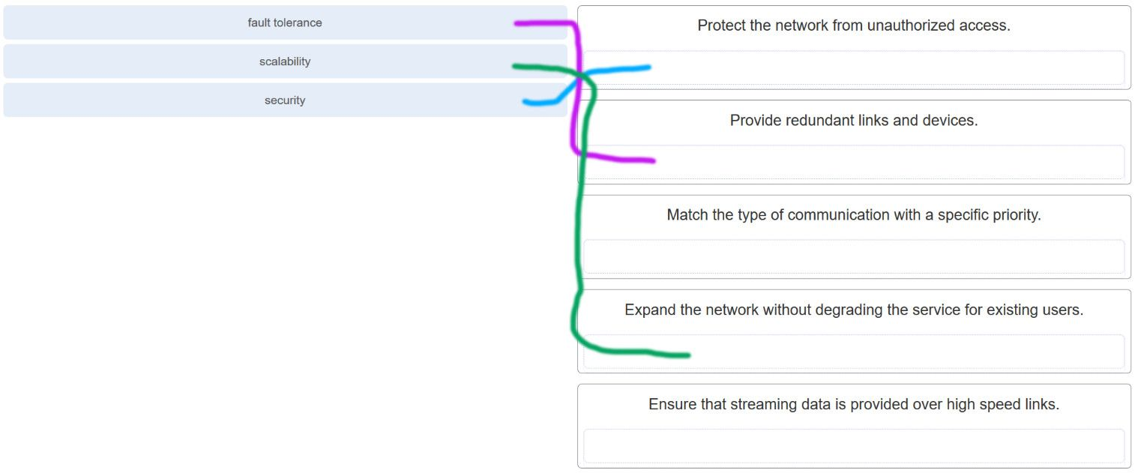

CCNA 1 v7.0 Modules 1 – 3 Exam Answers p5

6. An employee at a branch office is creating a quote for a customer. In order to do this, the employee needs to access confidential pricing information from internal servers at the Head Office. What type of network would the employee access?

**an intranet**  
the Internet  
an extranet  
a local area network

7. Which statement describes the use of powerline networking technology?

New “smart” electrical cabling is used to extend an existing home LAN.  
A home LAN is installed without the use of physical cabling.  
**A device connects to an existing home LAN using an adapter and an existing electrical outlet.**  
Wireless access points use powerline adapters to distribute data through the home LAN.

8. A networking technician is working on the wireless network at a medical clinic. The technician accidentally sets up the wireless network so that patients can see the medical records data of other patients. Which of the four network characteristics has been violated in this situation?

fault tolerance  
scalability  
**security**  
Quality of Service (QoS)  
reliability

Explanation: Network security includes protecting the confidentiality of data that is on the network. In this case, because confidential data has been made available to unauthorized users, the security characteristic of the network has failed.

9. Match each characteristic to its corresponding Internet connectivity type. (Not all options are used.)

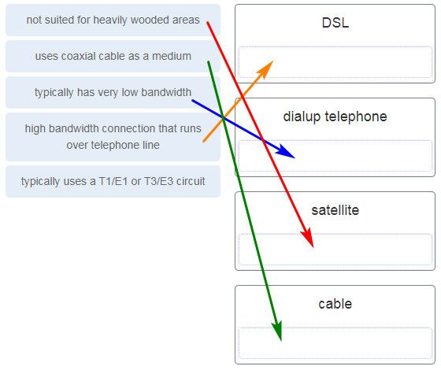

CCNA 1 v7.0 Modules 1 – 3 Exam Answers p9

Explanation: DSL is an always-on, high bandwidth connection that runs over telephone lines. Cable uses the same coaxial cable that carries television signals into the home to provide Internet access. Dialup telephone is much slower than either DSL or cable, but is the least expensive option for home users because it can use any telephone line and a simple modem. Satellite requires a clear line of sight and is affected by trees and other obstructions. None of these typical home options use dedicated leased lines such as T1/E1 and T3/E3.

10. What two criteria are used to help select a network medium from various network media? (Choose two.)

the types of data that need to be prioritized  
the cost of the end devices utilized in the network  
**the distance the selected medium can successfully carry a signal**  
the number of intermediate devices installed in the network  
**the environment where the selected medium is to be installed**

11. What type of network traffic requires QoS?

email  
on-line purchasing  
**video conferencing**  
wiki

12. A user is implementing security on a small office network. Which two actions would provide the minimum security requirements for this network? (Choose two.)

**implementing a firewall**  
installing a wireless network  
**installing antivirus software**  
implementing an intrusion detection system  
adding a dedicated intrusion prevention device

Explanation: Technically complex security measures such as intrusion prevention and intrusion prevention systems are usually associated with business networks rather than home networks. Installing antivirus software, antimalware software, and implementing a firewall will usually be the minimum requirements for home networks. Installing a home wireless network will not improve network security, and will require further security actions to be taken.

13. Passwords can be used to restrict access to all or parts of the Cisco IOS. Select the modes and interfaces that can be protected with passwords. (Choose three.)

**VTY interface**  
**console interface**  
Ethernet interface  
boot IOS mode  
**privileged EXEC mode**  
router configuration mode

14. Which interface allows remote management of a Layer 2 switch?

the AUX interface  
the console port interface  
**the switch virtual interface**  
the first Ethernet port interface

Explanation: In a Layer 2 switch, there is a switch virtual interface (SVI) that provides a means for remotely managing the device.

15. What function does pressing the Tab key have when entering a command in IOS?

It aborts the current command and returns to configuration mode.  
It exits configuration mode and returns to user EXEC mode.  
It moves the cursor to the beginning of the next line.  
**It completes the remainder of a partially typed word in a command.**

Explanation: Pressing the Tab key after a command has been partially typed will cause the IOS to complete the rest of the command.

16. While trying to solve a network issue, a technician made multiple changes to the current router configuration file. The changes did not solve the problem and were not saved. What action can the technician take to discard the changes and work with the file in NVRAM?

**Issue the reload command without saving the running configuration.**  
Delete the vlan.dat file and reboot the device.  
Close and reopen the terminal emulation software.  
Issue the copy startup-config running-config command.

Explanation: The technician does not want to make any mistakes trying to remove all the changes that were done to the running configuration file. The solution is to reboot the router without saving the running configuration. The copy startup-config running-config command does not overwrite the running configuration file with the configuration file stored in NVRAM, but rather it just has an additive effect.

17. An administrator uses the Ctrl-Shift-6 key combination on a switch after issuing the ping command. What is the purpose of using these keystrokes?

to restart the ping process  
**to interrupt the ping process**  
to exit to a different configuration mode  
to allow the user to complete the command

18. Refer to the exhibit.

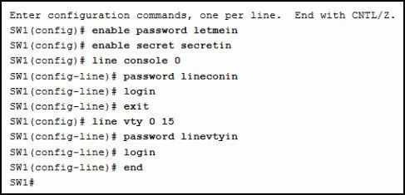

CCNA 1 v7.0 Modules 1 – 3 Exam Answers p18

A network administrator is configuring access control to switch SW1. If the administrator uses a console connection to connect to the switch, which password is needed to access user EXEC mode?

letmein  
secretin  
**lineconin**  
linevtyin

Explanation: Telnet accesses a network device through the virtual interface configured with the line VTY command. The password configured under this is required to access the user EXEC mode. The password configured under the line console 0 command is required to gain entry through the console port, and the enable and enable secret passwords are used to allow entry into the privileged EXEC mode.

19. A technician configures a switch with these commands:

SwitchA(config)# interface vlan 1

SwitchA(config-if)# ip address 192.168.1.1 255.255.255.0

SwitchA(config-if)# no shutdown

What is the technician configuring?

Telnet access  
**SVI**  
password encryption  
physical switchport access

Explanation: For a switch to have an IP address, a switch virtual interface must be configured. This allows the switch to be managed remotely over the network.

20. Which command or key combination allows a user to return to the previous level in the command hierarchy?

end  
**exit**  
Ctrl-Z  
Ctrl-C

Explanation: End and CTRL-Z return the user to the privileged EXEC mode. Ctrl-C ends a command in process. The exit command returns the user to the previous level.

21. What are two characteristics of RAM on a Cisco device? (Choose two.)

RAM provides nonvolatile storage.  
**The configuration that is actively running on the device is stored in RAM.  
The contents of RAM are lost during a power cycle.**  
RAM is a component in Cisco switches but not in Cisco routers.  
RAM is able to store multiple versions of IOS and configuration files.

22. Which two host names follow the guidelines for naming conventions on Cisco IOS devices? (Choose two.)

Branch2!  
**RM-3-Switch-2A4**  
Floor(15)  
HO Floor 17  
**SwBranch799**

Explanation: Some guidelines for naming conventions are that names should:  
Start with a letter  
Contain no spaces  
End with a letter or digit  
Use only letters, digits, and dashes  
Be less than 64 characters in length

23. How is SSH different from Telnet?

SSH makes connections over the network, whereas Telnet is for out-of-band access.  
**SSH provides security to remote sessions by encrypting messages and using user authentication. Telnet is considered insecure and sends messages in plaintext.**  
SSH requires the use of the PuTTY terminal emulation program. Tera Term must be used to connect to devices through the use of Telnet.  
SSH must be configured over an active network connection, whereas Telnet is used to connect to a device from a console connection.

Explanation: SSH is the preferred protocol for connecting to a device operating system over the network because it is much more secure than Telnet. Both SSH and Telnet are used to connect to devices over the network, and so are both used in-band. PuTTY and Terra Term can be used to make both SSH and Telnet connections.

24. An administrator is configuring a switch console port with a password. In what order will the administrator travel through the IOS modes of operation in order to reach the mode in which the configuration commands will be entered? (Not all options are used.)

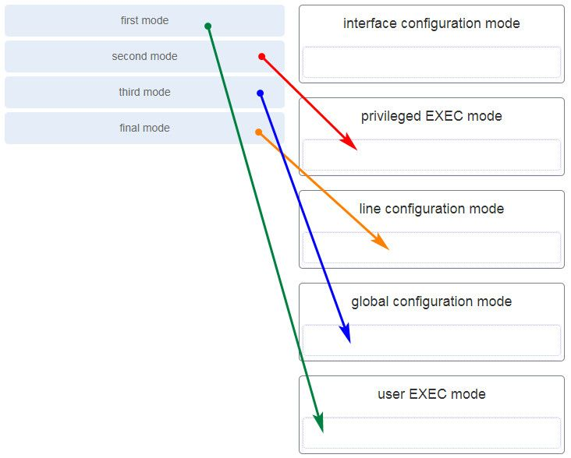

CCNA 1 v7.0 Modules 1 – 3 Exam Answers p24

Explanation: The configuration mode that the administrator first encounters is user EXEC mode. After the enable command is entered, the next mode is privileged EXEC mode. From there, the configure terminal command is entered to move to global configuration mode. Finally, the administrator enters the line console 0 command to enter the mode in which the configuration will be entered.

25. What are three characteristics of an SVI? (Choose three.)

It is designed as a security protocol to protect switch ports.  
**It is not associated with any physical interface on a switch.**  
**It is a special interface that allows connectivity by different types of media**.  
It is required to allow connectivity by any device at any location.  
It provides a means to remotely manage a switch.  
**It is associated with VLAN1 by default.**

Explanation: Switches have one or more switch virtual interfaces (SVIs). SVIs are created in software since there is no physical hardware associated with them. Virtual interfaces provide a means to remotely manage a switch over a network that is using IP. Each switch comes with one SVI appearing in the default configuration “out-of-the-box.” The default SVI interface is VLAN1.

26. What command is used to verify the condition of the switch interfaces, including the status of the interfaces and a configured IP address?

ipconfig  
ping  
traceroute  
**show ip interface brief**

Explanation: The show ip interface brief command is used to display a brief synopsis of the condition of the device interfaces. The ipconfig command is used to verify TCP/IP properties on a host. The ping command is used to verify Layer 3 connectivity. The traceroute command is used to trace the network path from source to destination.

27. Match the description with the associated IOS mode. (Not all options are used.)

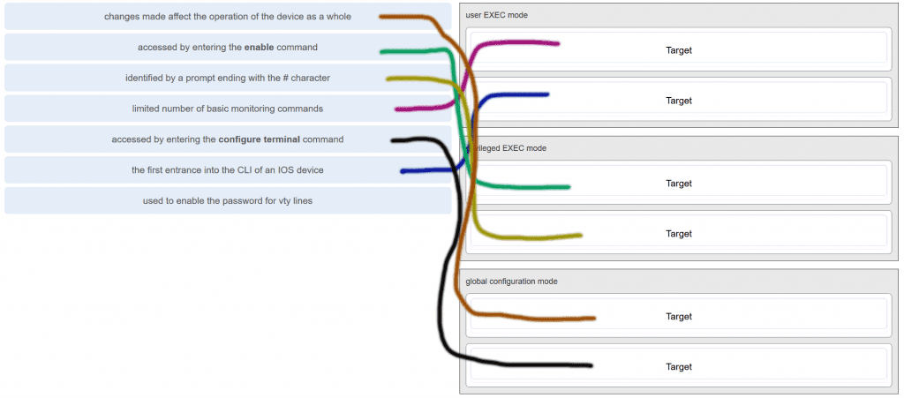

CCNA 1 v7.0 Modules 1 – 3 Exam Answers p27

28. Match the definitions to their respective CLI hot keys and shortcuts. (Not all options are used.)

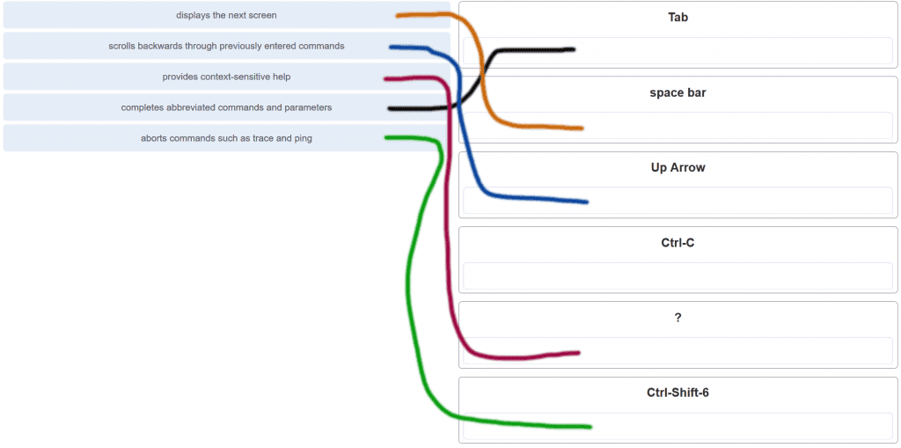

CCNA 1 v7.0 Modules 1 – 3 Exam Answers p28

29. In the show running-config command, which part of the syntax is represented by running-config?

the command  
**a keyword**  
a variable  
a prompt

Explanation: The first part of the syntax, show, is the command, and the second part of the syntax, running-config, is the keyword. The keyword specifies what should be displayed as the output of the show command.

30. After making configuration changes on a Cisco switch, a network administrator issues a copy running-config startup-config command. What is the result of issuing this command?

The new configuration will be stored in flash memory.  
**The new configuration will be loaded if the switch is restarted.**The current IOS file will be replaced with the newly configured file.  
The configuration changes will be removed and the original configuration will be restored.

31. What command will prevent all unencrypted passwords from displaying in plain text in a configuration file?

(config)# enable password secret  
(config)# enable secret Secret_Password  
(config-line)# password secret  
**(config)# service password-encryption**  
(config)# enable secret Encrypted_Password

32. A network administrator enters the service password-encryption command into the configuration mode of a router. What does this command accomplish?

This command encrypts passwords as they are transmitted across serial WAN links.  
**This command prevents someone from viewing the running configuration passwords.**  
This command enables a strong encryption algorithm for the enable secret password command.  
This command automatically encrypts passwords in configuration files that are currently stored in NVRAM.  
This command provides an exclusive encrypted password for external service personnel who are required to do router maintenance.

Explanation: The startup-config and running-config files display most passwords in plaintext. Use the service password-encryption global config command to encrypt all plaintext passwords in these files.

33. What method can be used by two computers to ensure that packets are not dropped because too much data is being sent too quickly?

encapsulation  
**flow control**  
access method  
response timeout

Explanation: In order for two computers to be able to communicate effectively, there must be a mechanism that allows both the source and destination to set the timing of the transmission and receipt of data. Flow control allows for this by ensuring that data is not sent too fast for it to be received properly.

34. Which statement accurately describes a TCP/IP encapsulation process when a PC is sending data to the network?

Data is sent from the internet layer to the network access layer.  
Packets are sent from the network access layer to the transport layer.  
**Segments are sent from the transport layer to the internet layer.**Frames are sent from the network access layer to the internet layer.

Explanation: When the data is traveling from the PC to the network, the transport layer sends segments to the internet layer. The internet layer sends packets to the network access layer, which creates frames and then converts the frames to bits. The bits are released to the network media.

35. What three application layer protocols are part of the TCP/IP protocol suite? (Choose three.)

ARP  
**DHCP**  
**DNS**  
**FTP**  
NAT  
PPP

Explanation: DNS, DHCP, and FTP are all application layer protocols in the TCP/IP protocol suite. ARP and PPP are network access layer protocols, and NAT is an internet layer protocol in the TCP/IP protocol suite.

36. Match the description to the organization. (Not all options are used.)

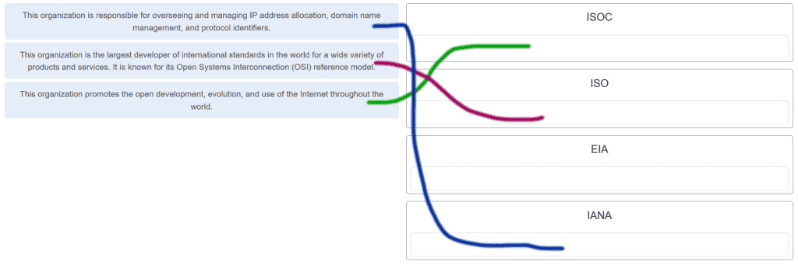

CCNA 1 v7.0 Modules 1 – 3 Exam Answers p36

37. Which name is assigned to the transport layer PDU?

bits  
data  
frame  
packet  
**segment**

Explanation: Application data is passed down the protocol stack on its way to be transmitted across the network media. During the process, various protocols add information to it at each level. At each stage of the process, a PDU (protocol data unit) has a different name to reflect its new functions. The PDUs are named according to the protocols of the TCP/IP suite:  
Data – The general term for the PDU used at the application layer.  
Segment – transport layer PDU  
Packet – network layer PDU  
Frame – data link layer PDU  
Bits – A physical layer PDU used when physically transmitting data over the medium

38. When IPv4 addressing is manually configured on a web server, which property of the IPv4 configuration identifies the network and host portion for an IPv4 address?

DNS server address  
**subnet mask**  
default gateway  
DHCP server address

Explanation: There are several components that need to be entered when configuring IPv4 for an end device:  
IPv4 address – uniquely identifies an end device on the network  
Subnet mask – determines the network address portion and host portion for an IPv4 address  
Default gateway – the IP address of the router interface used for communicating with hosts in another network  
DNS server address – the IP address of the Domain Name System (DNS) server  
DHCP server address (if DHCP is used) is not configured manually on end devices. It will be provided by a DHCP server when an end device requests an IP address.

39. What process involves placing one PDU inside of another PDU?

**Encapsulation**  
encoding  
segmentation  
flow control

Explanation: When a message is placed inside of another message, this is known as encapsulation. On networks, encapsulation takes place when one protocol data unit is carried inside of the data field of the next lower protocol data unit.

40. What layer is responsible for routing messages through an internetwork in the TCP/IP model?

**Internet**  
transport  
network access  
session

Explanation: The TCP/IP model consists of four layers: application, transport, internet, and network access. Of these four layers, it is the internet layer that is responsible for routing messages. The session layer is not part of the TCP/IP model but is rather part of the OSI model.

41. For the TCP/IP protocol suite, what is the correct order of events when a Telnet message is being prepared to be sent over the network?

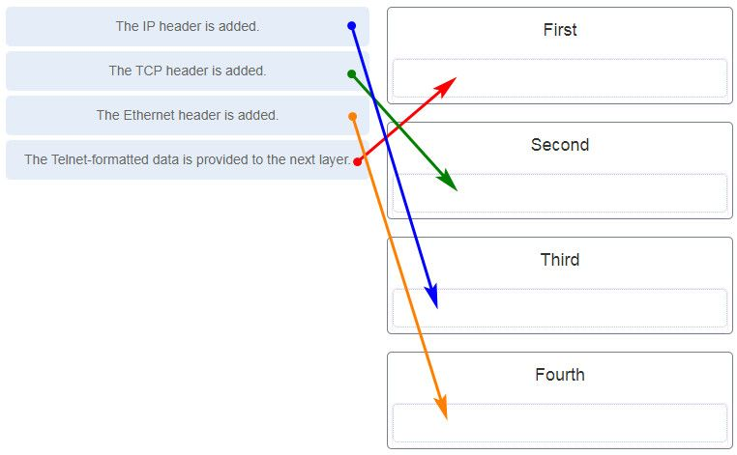

CCNA 1 v7.0 Modules 1 – 3 Exam Answers p41

42. Which PDU format is used when bits are received from the network medium by the NIC of a host?

file  
**frame**  
packet  
segment

Explanation: When received at the physical layer of a host, the bits are formatted into a frame at the data link layer. A packet is the PDU at the network layer. A segment is the PDU at the transport layer. A file is a data structure that may be used at the application layer.

43. Refer to the exhibit.

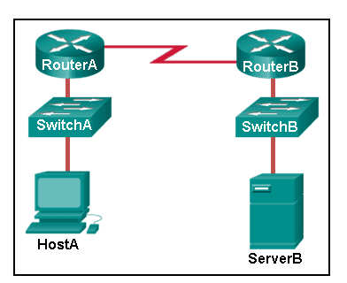

CCNA 1 v7.0 Modules 1 – 3 Exam Answers p43

ServerB is attempting to contact HostA. Which two statements correctly identify the addressing that ServerB will generate in the process? (Choose two.)

ServerB will generate a packet with the destination IP address of RouterB.  
ServerB will generate a frame with the destination MAC address of SwitchB.  
**ServerB will generate a packet with the destination IP address of RouterA.**  
**ServerB will generate a frame with the destination MAC address of RouterB**.  
ServerB will generate a packet with the destination IP address of HostA.  
ServerB will generate a frame with the destination MAC address of RouterA.

44. Which method allows a computer to react accordingly when it requests data from a server and the server takes too long to respond?

encapsulation  
flow control  
access method  
**response timeout**

45. A web client is receiving a response for a web page from a web server. From the perspective of the client, what is the correct order of the protocol stack that is used to decode the received transmission?

**Ethernet, IP, TCP, HTTP**  
HTTP, TCP, IP, Ethernet  
Ethernet, TCP, IP, HTTP  
HTTP, Ethernet, IP, TCP

Explanation:  
1. HTTP governs the way that a web server and client interact.  
2. TCP manages individual conversations between web servers and clients.  
3. IP is responsible for delivery across the best path to the destination.  
4. Ethernet takes the packet from IP and formats it for transmission.

46. Which two OSI model layers have the same functionality as a single layer of the TCP/IP model? (Choose two.)

**data link**  
network  
**physical**  
session  
transport

47. At which layer of the OSI model would a logical address be added during encapsulation?

physical layer  
data link layer  
**network layer**  
transport layer

48. What is a characteristic of multicast messages?

**They are sent to a select group of hosts.**  
They are sent to all hosts on a network.  
They must be acknowledged.  
They are sent to a single destination.

Explanation: Multicast is a one-to-many type of communication. Multicast messages are addressed to a specific multicast group.

49. Which statement is correct about network protocols?

Network protocols define the type of hardware that is used and how it is mounted in racks.  
**They define how messages are exchanged between the source and the destination.**They all function in the network access layer of TCP/IP.  
They are only required for exchange of messages between devices on remote networks.

50. What is an advantage of network devices using open standard protocols?

Network communications is confined to data transfers between devices from the same vendor.  
**A client host and a server running different operating systems can successfully exchange data.**  
Internet access can be controlled by a single ISP in each market.  
Competition and innovation are limited to specific types of products.

51. Which device performs the function of determining the path that messages should take through internetworks?

**a router**  
a firewall  
a web server  
a DSL modem

Explanation: A router is used to determine the path that the messages should take through the network. A firewall is used to filter incoming and outgoing traffic. A DSL modem is used to provide Internet connection for a home or an organization.

52. Open the PT Activity.

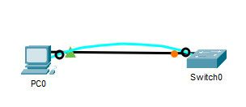

CCNA 1 v7.0 Modules 1 – 3 Exam Answers p52

Perform the tasks in the activity instructions and then answer the question.  
What is the IP address of the switch virtual interface (SVI) on Switch0?

192.168.5.10  
192.168.10.5  
192.168.10.1  
192.168.5.0

Explanation: After the enable command is issued, the show running-configuration command or the show ip interfaces brief command will display the IP address of the switch virtual interface (SVI).

53. Why would a Layer 2 switch need an IP address?

to enable the switch to send broadcast frames to attached PCs  
to enable the switch to function as a default gateway  
**to enable the switch to be managed remotely**  
to enable the switch to receive frames from attached PCs

Explanation: A switch, as a Layer 2 device, does not need an IP address to transmit frames to attached devices. However, when a switch is accessed remotely through the network, it must have a Layer 3 address. The IP address must be applied to a virtual interface rather than to a physical interface. Routers, not switches, function as default gateways.

54. Refer to the exhibit.

CCNA 1 v7.0 Modules 1 – 3 Exam Answers p54

CCNA 1 v7.0 Modules 1 – 3 Exam Answers p54

An administrator is trying to configure the switch but receives the error message that is displayed in the exhibit. What is the problem?

The entire command, configure terminal, must be used.  
The administrator is already in global configuration mode.  
**The administrator must first enter privileged EXEC mode before issuing the command.**The administrator must connect via the console port to access global configuration mode.

Explanation: In order to enter global configuration mode, the command configure terminal, or a shortened version such as config t, must be entered from privileged EXEC mode. In this scenario the administrator is in user EXEC mode, as indicated by the > symbol after the hostname. The administrator would need to use the enable command to move into privileged EXEC mode before entering the configure terminal command.

55. What term describes a network owned by one organization that provides safe and secure access to individuals who work for a different organization?

**Extranet**  
cloud  
BYOD  
quality of service

56. What term describes storing personal files on servers over the internet to provide access anywhere, anytime, and on any device?

**Cloud**  
BYOD  
quality of service  
converged network

57. What term describes a network where one computer can be both client and server?

**peer-to-peer**  
cloud  
BYOD  
quality of service

58. What term describes a type of network used by people who work from home or from a small remote office?

**SOHO network**  
BYOD  
quality of service  
converged network

59. What term describes a computing model where server software runs on dedicated computers?

**client/server**  
internet  
intranet  
extranet

60. What term describes a type of network used by people who work from home or from a small remote office?

**SOHO network**  
internet  
intranet  
extranet

61. What term describes a technology that allows devices to connect to the LAN using an electrical outlet?

**powerline networking**  
internet  
intranet  
extranet

62. What term describes a policy that allows network devices to manage the flow of data to give priority to voice and video?

**quality of service**  
internet  
intranet  
extranet

63. What term describes a private collection of LANs and WANs that belongs to an organization?

**Intranet**  
internet  
extranet  
peer-to-peer

64. What term describes the ability to use personal devices across a business or campus network?

**BYOD**  
internet  
intranet  
extranet

65. At which OSI layer is a source IP address added to a PDU during the encapsulation process?

**network layer**  
data link layer  
transport layer  
application layer

66. At which OSI layer is a destination port number added to a PDU during the encapsulation process?

**transport layer**  
data link layer  
network layer  
application layer

67. At which OSI layer is data added to a PDU during the encapsulation process?

**application layer**  
data link layer  
network layer  
transport layer

68. At which OSI layer is a source IP address added to a PDU during the encapsulation process?

**network layer**  
data link layer  
application layer  
presentation layer

69. At which OSI layer is data added to a PDU during the encapsulation process?

**application layer**  
transport layer  
network layer  
presentation layer

70. At which OSI layer is a destination IP address added to a PDU during the encapsulation process?

**network layer**  
application layer  
transport layer  
presentation layer

71. At which OSI layer is a source MAC address added to a PDU during the encapsulation process?

**data link layer**  
application layer  
transport layer  
presentation layer

72. At which OSI layer is a source port number added to a PDU during the encapsulation process?

**transport layer**  
application layer  
network layer  
presentation layer

73. At which OSI layer is a destination MAC address added to a PDU during the encapsulation process?

**data link layer**  
transport layer  
application layer  
network layer

74. At which OSI layer is a source port number added to a PDU during the encapsulation process?

**Transport layer**  
network layer  
application layer  
data link layer

Modules 1 – 3: Basic Network Connectivity and Communications Exam Answers (Additional)

1. During a routine inspection, a technician discovered that software that was installed on a computer was secretly collecting data about websites that were visited by users of the computer. Which type of threat is affecting this computer?

DoS attack​  
identity theft  
spyware  
zero-day attack

2. Which term refers to a network that provides secure access to the corporate offices by suppliers, customers and collaborators?

Internet  
intranet  
extranet  
extendednet

3. A large corporation has modified its network to allow users to access network resources from their personal laptops and smart phones. Which networking trend does this describe?

loud computing  
online collaboration  
bring your own device  
video conferencing

4. What is an ISP?

It is a standards body that develops cabling and wiring standards for networking.  
It is a protocol that establishes how computers within a local network communicate.  
It is an organization that enables individuals and businesses to connect to the Internet.  
It is a networking device that combines the functionality of several different networking devices in one.

5. In which scenario would the use of a WISP be recommended?

an Internet cafe in a city  
a farm in a rural area without wired broadband access  
any home with multiple wireless devices  
an apartment in a building with cable access to the Internet

6. What characteristic of a network enables it to quickly grow to support new users and applications without impacting the performance of the service being delivered to existing users?

reliability  
scalability  
quality of service  
accessibility

7. A college is building a new dormitory on its campus. Workers are digging in the ground to install a new water pipe for the dormitory. A worker accidentally damages a fiber optic cable that connects two of the existing dormitories to the campus data center. Although the cable has been cut, students in the dormitories only experience a very short interruption of network services. What characteristic of the network is shown here?

quality of service (QoS)  
scalability  
security  
fault tolerance  
integrity

8. What are two characteristics of a scalable network? (Choose two.)

easily overloaded with increased traffic  
grows in size without impacting existing users  
is not as reliable as a small network  
suitable for modular devices that allow for expansion  
offers limited number of applications

9. Which device performs the function of determining the path that messages should take through internetworks?

a router  
a firewall  
a web server  
a DSL modem

10. Which two Internet connection options do not require that physical cables be run to the building? (Choose two.)

DSL  
Celular  
Satellite  
dialup  
dedicated leased line

11. What type of network must a home user access in order to do online shopping?

an intranet  
the Internet  
an extranet  
a local area network

12. How does BYOD change the way in which businesses implement networks?​

BYOD requires organizations to purchase laptops rather than desktops.  
BYOD users are responsible for their own network security, thus reducing the need for organizational security policies.  
BYOD devices are more expensive than devices that are purchased by an organization.  
BYOD provides flexibility in where and how users can access network resources.

13. An employee wants to access the network of the organization remotely, in the safest possible way. What network feature would allow an employee to gain secure remote access to a company network?

ACL  
IPS  
VPN  
BYOD

14. What is the Internet?

It is a network based on Ethernet technology.  
It provides network access for mobile devices.  
It provides connections through interconnected global networks.  
It is a private network for an organization with LAN and WAN connections.

15. What are two functions of end devices on a network? (Choose two.)

They originate the data that flows through the network.  
They direct data over alternate paths in the event of link failures.  
They filter the flow of data to enhance security.  
They are the interface between humans and the communication network.  
They provide the channel over which the network message travels.

16. Which statement is true about the running configuration file in a Cisco IOS device?

It affects the operation of the device immediately when modified.  
It is stored in NVRAM.  
It should be deleted using the erase running-config command.  
It is automatically saved when the router reboots.

17. Which two statements are true regarding the user EXEC mode? (Choose two.)

All router commands are available.  
Global configuration mode can be accessed by entering the enable command.  
The device prompt for this mode ends with the “>” symbol.  
Interfaces and routing protocols can be configured.  
Only some aspects of the router configuration can be viewed.

18. Which type of access is secured on a Cisco router or switch with the enable secret command?

virtual terminal  
privileged EXEC  
AUX port  
console line

19. What is the default SVI on a Cisco switch?

VLAN1  
VLAN99  
VLAN100  
VLAN999

20. When a hostname is configured through the Cisco CLI, which three naming conventions are part of the guidelines? (Choose three.)

the hostname should be fewer than 64 characters in length  
the hostname should be written in all lower case characters  
the hostname should contain no spaces  
the hostname should end with a special character  
the hostname should begin with a letter

21. What is the function of the shell in an OS?

It interacts with the device hardware.  
It interfaces between the users and the kernel.  
It provides dedicated firewall services.  
It provides the intrusion protection services for the device.

22. A router with a valid operating system contains a configuration file stored in NVRAM. The configuration file has an enable secret password but no console password. When the router boots up, which mode will display?

global configuration mode  
setup mode  
privileged EXEC mode  
user EXEC mode

23. An administrator has just changed the IP address of an interface on an IOS device. What else must be done in order to apply those changes to the device?

Copy the running configuration to the startup configuration file.  
Copy the information in the startup configuration file to the running configuration.  
Reload the device and type yes when prompted to save the configuration.  
Nothing must be done. Changes to the configuration on an IOS device take effect as soon as the command is typed correctly and the Enter key has been pressed.

24. Which memory location on a Cisco router or switch will lose all content when the device is restarted?

ROM  
flash  
NVRAM  
RAM

25. Why would a technician enter the command copy startup-config running-config?

to remove all configurations from the switch  
to save an active configuration to NVRAM  
to copy an existing configuration into RAM  
to make a changed configuration the new startup configuration

26. Which functionality is provided by DHCP?

automatic assignment of an IP address to each host  
remote switch management  
translation of IP addresses to domain names  
end-to-end connectivity test

27. Which two functions are provided to users by the context-sensitive help feature of the Cisco IOS CLI? (Choose two.)

providing an error message when a wrong command is submitted  
displaying a list of all available commands within the current mode  
allowing the user to complete the remainder of an abbreviated command with the TAB key  
determining which option, keyword, or argument is available for the entered command  
selecting the best command to accomplish a task

28. Which memory location on a Cisco router or switch stores the startup configuration file?

RAM  
ROM  
NVRAM  
flash

29. To what subnet does the IP address 10.1.100.50 belong if a subnet mask of 255.255.0.0 is used?

10.1.0.0  
10.0.0.0  
10.1.100.32  
10.1.100.0

30. Which three acronyms/initialisms represent standards organizations? (Choose three.)

IANA  
TCP/IP  
IEEE  
IETF  
OSI  
MAC

31. What type of communication will send a message to all devices on a local area network?

Broadcast  
multicast  
unicast  
allcast

32. In computer communication, what is the purpose of message encoding?

to convert information to the appropriate form for transmission  
to interpret information  
to break large messages into smaller frames  
to negotiate correct timing for successful communication

33. Which message delivery option is used when all devices need to receive the same message simultaneously?

duplex  
unicast  
multicast  
broadcast

34. What are two benefits of using a layered network model? (Choose two.)

It assists in protocol design.  
It speeds up packet delivery.  
It prevents designers from creating their own model.  
It prevents technology in one layer from affecting other layers.  
It ensures a device at one layer can function at the next higher layer.

35. What is the purpose of protocols in data communications?

specifying the bandwidth of the channel or medium for each type of communication  
specifying the device operating systems that will support the communication  
providing the rules required for a specific type of communication to occur  
dictating the content of the message sent during communication

36. Which logical address is used for delivery of data to a remote network?

destination MAC address  
destination IP address  
destination port number  
source MAC address  
source IP address

37. What is the general term that is used to describe a piece of data at any layer of a networking model?

frame  
packet  
protocol data unit  
segment

38. Which two protocols function at the internet layer? (Choose two.)

POP  
BOOTP  
ICMP  
IP  
PPP

39. Which layer of the OSI model defines services to segment and reassemble data for individual communications between end devices?

application  
presentation  
session  
transport  
network

40. Which type of communication will send a message to a group of host destinations simultaneously?

broadcast  
multicast  
unicast  
anycast

41. What process is used to receive transmitted data and convert it into a readable message?

access control  
decoding  
encapsulation  
flow control

42. What is done to an IP packet before it is transmitted over the physical medium?

It is tagged with information guaranteeing reliable delivery.  
It is segmented into smaller individual pieces.  
It is encapsulated into a TCP segment.  
It is encapsulated in a Layer 2 frame.

43. What process is used to place one message inside another message for transfer from the source to the destination?

access control  
decoding  
encapsulation  
flow control

44. A web client is sending a request for a webpage to a web server. From the perspective of the client, what is the correct order of the protocol stack that is used to prepare the request for transmission?

HTTP, IP, TCP, Ethernet  
HTTP, TCP, IP, Ethernet  
Ethernet, TCP, IP, HTTP  
Ethernet, IP, TCP, HTTP

1. What is the purpose of the OSI physical layer?

controlling access to media  
**transmitting bits across the local media**  
performing error detection on received frames  
exchanging frames between nodes over physical network media

2. Why are two strands of fiber used for a single fiber optic connection?

The two strands allow the data to travel for longer distances without degrading.  
They prevent crosstalk from causing interference on the connection.  
They increase the speed at which the data can travel.  
**They allow for full-duplex connectivity.**

3. Which characteristic describes crosstalk?

the distortion of the network signal from fluorescent lighting  
**the distortion of the transmitted messages from signals carried in adjacent wires**  
the weakening of the network signal over long cable lengths  
the loss of wireless signal over excessive distance from the access point

4. Which procedure is used to reduce the effect of crosstalk in copper cables?

requiring proper grounding connections  
**twisting opposing circuit wire pairs together**  
wrapping the bundle of wires with metallic shielding  
designing a cable infrastructure to avoid crosstalk interference  
avoiding sharp bends during installation

5. Match the situation with the appropriate use of network media.

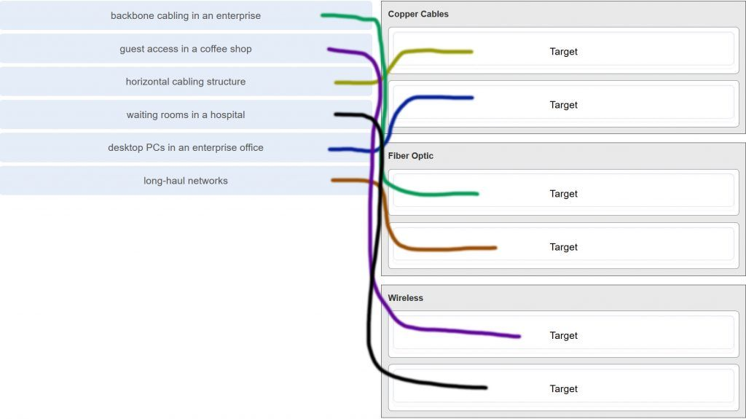

CCNA 1 v7.0 Modules 4 – 7 Exam Answers p5

6. A network administrator is measuring the transfer of bits across the company backbone for a mission critical financial application. The administrator notices that the network throughput appears lower than the bandwidth expected. Which three factors could influence the differences in throughput? (Choose three.)

**the amount of traffic that is currently crossing the network**  
the sophistication of the encapsulation method applied to the data  
**the type of traffic that is crossing the network  
the latency that is created by the number of network devices that the data is crossing**the bandwidth of the WAN connection to the Internet  
the reliability of the gigabit Ethernet infrastructure of the backbone

7. What are two characteristics of fiber-optic cable? (Choose two.)

**It is not affected by EMI or RFI.**  
Each pair of cables is wrapped in metallic foil.  
It combines the technique of cancellation, shielding, and twisting to protect data.  
It typically contains 4 pairs of fiber-optic wires.  
**It is more expensive than UTP cabling is**.

8. What is a primary role of the Physical layer in transmitting data on the network?

**create the signals that represent the bits in each frame on to the media**provide physical addressing to the devices  
determine the path packets take through the network  
control data access to the media

Explanation: The OSI physical layer provides the means to transport the bits that make up a frame across the network media. This layer accepts a complete frame from the data link layer and encodes it as a series of signals that are transmitted to the local media.

9. With the use of unshielded twisted-pair copper wire in a network, what causes crosstalk within the cable pairs?

**the magnetic field around the adjacent pairs of wire**the use of braided wire to shield the adjacent wire pairs  
the reflection of the electrical wave back from the far end of the cable  
the collision caused by two nodes trying to use the media simultaneously

Explanation: Crosstalk is a type of noise, or interference that occurs when signal transmission on one wire interferes with another wire. When current flows through a wire a magnetic field is produced. The produced magnetic field will interface the signal carried in the adjacent wire.

10. Refer to the graphic.

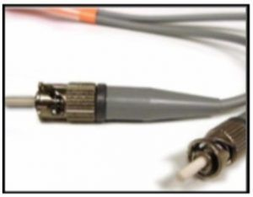

CCNA 1 v7.0 Modules 4 – 7 Exam Answers p10

What type of cabling is shown?

STP  
UTP  
coax  
**fiber**

Explanation: Network cabling include different types of cables:  
UTP cable consists of four pairs of color-coded wires that have been twisted together and then encased in a flexible plastic sheath.  
STP cable uses four pairs of wires, each wrapped in a foil shield, which are then wrapped in an overall metallic braid or foil.  
Coaxial cable uses a copper conductor and a layer of flexible plastic insulation surrounds the copper conductor.  
Fiber cable is a flexible, extremely thin, transparent strand of glass surrounded by plastic insulation.

11. In addition to the cable length, what two factors could interfere with the communication carried over UTP cables? (Choose two.)

**Crosstalk**bandwidth  
size of the network  
signal modulation technique  
**electromagnetic interference**

Explanation: Copper media is widely used in network communications. However, copper media is limited by distance and signal interference. Data is transmitted on copper cables as electrical pulses. The electrical pulses are susceptible to interference from two sources:  
Electromagnetic interference (EMI) or radio frequency interference (RFI) – EMI and RFI signals can distort and corrupt the data signals being carried by copper media.  
Crosstalk – Crosstalk is a disturbance caused by the electric or magnetic fields of a signal on one wire interfering with the signal in an adjacent wire.

12. Refer to the graphic.

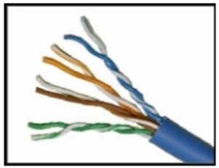

CCNA 1 v7.0 Modules 4 – 7 Exam Answers p12

What type of cabling is shown?

STP  
**UTP**  
coax  
fiber

13. Which two devices commonly affect wireless networks? (Choose two.)

Blu-ray players  
home theaters  
**cordless phones**  
**microwaves**  
incandescent light bulbs  
external hard drives

Explanation: Radio Frequency Interference (RFI) is the interference that is caused by radio transmitters and other devices that are transmitting in the same frequency.

14. Which two statements describe the services provided by the data link layer? (Choose two.)

It defines the end-to-end delivery addressing scheme.  
It maintains the path between the source and destination devices during the data transmission.  
**It manages the access of frames to the network media.**  
It provides reliable delivery through link establishment and flow control.  
It ensures that application data will be transmitted according to the prioritization.  
**It packages various Layer 3 PDUs into a frame format that is compatible with the network interface.**

Explanation: The data link layer is divided into two sub layers, namely Logical Link Control (LLC) and Media Access Control (MAC). LLC forms a frame from the network layer PDU into a format that conforms to the requirements of the network interface and media. A network layer PDU might be for IPv4 or IPv6. The MAC sub layer defines the media access processes performed by the hardware. It manages the frame access to the network media according to the physical signaling requirements (copper cable, fiber optic, wireless, etc.)

15. What is the function of the CRC value that is found in the FCS field of a frame?

**to verify the integrity of the received frame**  
to verify the physical address in the frame  
to verify the logical address in the frame  
to compute the checksum header for the data field in the frame

16. What is contained in the trailer of a data-link frame?

logical address  
physical address  
data  
**error detection**

17. Which statement describes a characteristic of the frame header fields of the data link layer?

They all include the flow control and logical connection fields.  
Ethernet frame header fields contain Layer 3 source and destination addresses.  
**They vary depending on protocols.**They include information on user applications.

Explanation: All data link layer protocols encapsulate the Layer 3 PDU within the data field of the frame. However, the structure of the frame and the fields that are contained in the header vary according to the protocol. Different data link layer protocols may use different fields, like priority/quality of service, logical connection control, physical link control, flow control, and congestion control.

18. A network team is comparing physical WAN topologies for connecting remote sites to a headquarters building. Which topology provides high availability and connects some, but not all, remote sites?

mesh  
**partial mesh**  
hub and spoke  
point-to-point

Explanation: Partial mesh topologies provide high availability by interconnecting multiple remote sites, but do not require a connection between all remote sites. A mesh topology requires point-to-point links with every system being connected to every other system. A point-to-point topology is where each device is connected to one other device. A hub and spoke uses a central device in a star topology that connects to other point-to-point devices.

19. Which two fields or features does Ethernet examine to determine if a received frame is passed to the data link layer or discarded by the NIC? (Choose two.)

auto-MDIX  
CEF  
**Frame Check Sequence**  
**minimum frame size**  
source MAC address

20. Which media communication type does not require media arbitration in the data link layer?

deterministic  
half-duplex  
**full-duplex**  
controlled access

Explanation: Half-duplex communication occurs when both devices can both transmit and receive on the medium but cannot do so simultaneously. Full-duplex communication occurs when both devices can transmit and receive on the medium at the same time and therefore does not require media arbitration. Half-duplex communication is typically contention-based, whereas controlled (deterministic) access is applied in technologies where devices take turns to access the medium.

21. Which statement describes an extended star topology?

**End devices connect to a central intermediate device, which in turn connects to other central intermediate devices.**  
End devices are connected together by a bus and each bus connects to a central intermediate device.  
Each end system is connected to its respective neighbor via an intermediate device.  
All end and intermediate devices are connected in a chain to each other.

Explanation: In an extended star topology, central intermediate devices interconnect other star topologies.

22. What is a characteristic of the LLC sublayer?

It provides the logical addressing required that identifies the device.  
It provides delimitation of data according to the physical signaling requirements of the medium.  
**It places information in the frame allowing multiple Layer 3 protocols to use the same network interface and media.**  
It defines software processes that provide services to the physical layer.

23. What are three ways that media access control is used in networking? (Choose three.)

**Ethernet utilizes CSMA/CD.**  
**Media access control provides placement of data frames onto the media.**  
Contention-based access is also known as deterministic.  
802.11 utilizes CSMA/CD.  
**Data link layer protocols define the rules for access to different media.**  
Networks with controlled access have reduced performance due to data collisions.

24. During the encapsulation process, what occurs at the data link layer for a PC connected to an Ethernet network?

An IP address is added.  
The logical address is added.  
**The physical address is added.**  
The process port number is added.

Explanation: The Ethernet frame includes the source and destination physical address. The trailer includes a CRC value in the Frame Check Sequence field to allow the receiving device to determine if the frame has been changed (has errors) during the transmission.

25. What three items are contained in an Ethernet header and trailer? (Choose three.)

source IP address  
**source MAC address**  
destination IP address  
**destination MAC address**  
**error-checking information**

Explanation: Layer 2 headers contain the following:  
Frame start and stop indicator flags at the beginning and end of a frame  
Addressing – for Ethernet networks this part of the header contains source and destination MAC addresses  
Type field to indicate what Layer 3 protocol is being used  
Error detection to determine if the frame arrived without error

26. What type of communication rule would best describe CSMA/CD?

**access method**  
flow control  
message encapsulation  
message encoding

Explanation: Carrier sense multiple access collision detection (CSMA/CD) is the access method used with Ethernet. The access method rule of communication dictates how a network device is able to place a signal on the carrier. CSMA/CD dictates those rules on an Ethernet network and CSMA/CA dictates those rules on an 802.11 wireless LAN.

27. Which three basic parts are common to all frame types supported by the data link layer? (Choose three.)

**heade**r  
type field  
MTU size  
**Data  
Tráiler**CRC value

Explanation: The data link protocol is responsible for NIC-to-NIC communications within the same network. Although there are many different data link layer protocols that describe data link layer frames, each frame type has three basic parts:  
Header  
Data  
Trailer

28. Which statement is true about the CSMA/CD access method that is used in Ethernet?

When a device hears a carrier signal and transmits, a collision cannot occur.  
A jamming signal causes only devices that caused the collision to execute a backoff algorithm.  
**All network devices must listen before transmitting.**  
Devices involved in a collision get priority to transmit after the backoff period.

29. What is the auto-MDIX feature on a switch?

the automatic configuration of an interface for 10/100/1000 Mb/s operation  
**the automatic configuration of an interface for a straight-through or a crossover Ethernet cable connection**  
the automatic configuration of full-duplex operation over a single Ethernet copper or optical cable  
the ability to turn a switch interface on or off accordingly if an active connection is detected

Explanation: The auto-MDIX enables a switch to use a crossover or a straight-through Ethernet cable to connect to a device regardless of the device on the other end of the connection.

30. Refer to the exhibit.

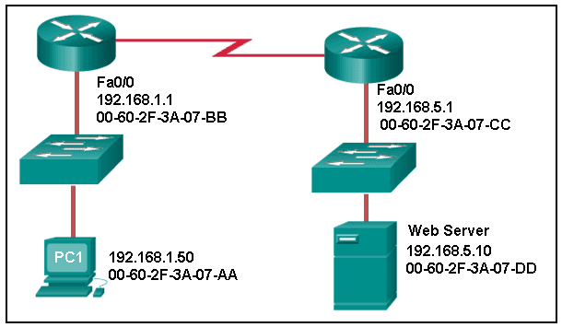

CCNA 1 v7.0 Modules 4 – 7 Exam Answers p30

What is the destination MAC address of the Ethernet frame as it leaves the web server if the final destination is PC1?

00-60-2F-3A-07-AA  
00-60-2F-3A-07-BB  
00**-60-2F-3A-07-CC**  
00-60-2F-3A-07-DD

Explanation: The destination MAC address is used for local delivery of Ethernet frames. The MAC (Layer 2) address changes at each network segment along the path. As the frame leaves the web server, it will be delivered by using the MAC address of the default gateway.

31. A Layer 2 switch is used to switch incoming frames from a 1000BASE-T port to a port connected to a 100Base-T network. Which method of memory buffering would work best for this task?

port-based buffering  
level 1 cache buffering  
**shared memory buffering**  
fixed configuration buffering

32. What are two examples of the cut-through switching method? (Choose two.)

store-and-forward switching  
**fast-forward switching**  
CRC switching  
**fragment-free switching**QOS switching

33. Which frame forwarding method receives the entire frame and performs a CRC check to detect errors before forwarding the frame?

cut-through switching  
**store-and-forward switching**  
fragment-free switching  
fast-forward switching

Explanation: Fast-forward and fragment-free switching are variations of cut-through switching, which begins to forward the frame before the entire frame is received.

34. What is the purpose of the FCS field in a frame?

to obtain the MAC address of the sending node  
to verify the logical address of the sending node  
to compute the CRC header for the data field  
**to determine if errors occurred in the transmission and reception**

Explanation: The FCS field in a frame is used to detect any errors in the transmission and receipt of a frame. This is done by comparing the CRC value within the frame against a computed CRC value of the frame. If the two values do not match, then the frame is discarded.

35. Which switching method has the lowest level of latency?

cut-through  
store-and-forward  
fragment-free  
**fast-forward**

Explanation: Fast-forward switching begins to forward a frame after reading the destination MAC address, resulting in the lowest latency. Fragment-free reads the first 64 bytes before forwarding. Store-and-forward has the highest latency because it reads the entire frame before beginning to forward it. Both fragment-free and fast-forward are types of cut-through switching.

36. A network administrator is connecting two modern switches using a straight-through cable. The switches are new and have never been configured. Which three statements are correct about the final result of the connection? (Choose three.)

**The link between the switches will work at the fastest speed that is supported by both switches.**  
**The link between switches will work as full-duplex.**  
If both switches support different speeds, they will each work at their own fastest speed.  
**The auto-MDIX feature will configure the interfaces eliminating the need for a crossover cable.**  
The connection will not be possible unless the administrator changes the cable to a crossover cable.  
The duplex capability has to be manually configured because it cannot be negotiated.

Explanation: Modern switches can negotiate to work in full-duplex mode if both switches are capable. They will negotiate to work using the fastest possible speed and the auto-MDIX feature is enabled by default, so a cable change is not needed.

37. Which advantage does the store-and-forward switching method have compared with the cut-through switching method?

collision detecting  
**frame error checking**  
faster frame forwarding  
frame forwarding using IPv4 Layer 3 and 4 information

Explanation: A switch using the store-and-forward switching method performs an error check on an incoming frame by comparing the FCS value against its own FCS calculations after the entire frame is received. In comparison, a switch using the cut-through switching method makes quick forwarding decisions and starts the forwarding process without waiting for the entire frame to be received. Thus a switch using cut-through switching may send invalid frames to the network. The performance of store-and-forward switching is slower compared to cut-through switching performance. Collision detection is monitored by the sending device. Store-and-forward switching does not use IPv4 Layer 3 and 4 information for its forwarding decisions.

38. When the store-and-forward method of switching is in use, what part of the Ethernet frame is used to perform an error check?

**CRC in the tráiler**  
source MAC address in the header  
destination MAC address in the header  
protocol type in the header

39. Which switching method uses the CRC value in a frame?

cut-through  
fast-forward  
fragment-free  
**store-and-forward**

Explanation: When the store-and-forward switching method is used, the switch receives the complete frame before forwarding it on to the destination. The cyclic redundancy check (CRC) part of the trailer is used to determine if the frame has been modified during transit.​​ In contrast, a cut-through switch forwards the frame once the destination Layer 2 address is read. Two types of cut-through switching methods are fast-forward and fragment-free.

40. What are two actions performed by a Cisco switch? (Choose two.)

building a routing table that is based on the first IP address in the frame header  
**using the source MAC addresses of frames to build and maintain a MAC address table**forwarding frames with unknown destination IP addresses to the default gateway  
**utilizing the MAC address table to forward frames via the destination MAC address**  
examining the destination MAC address to add new entries to the MAC address table

Explanation: Important actions that a switch performs are as follows:  
When a frame comes in, the switch examines the Layer 2 source address to build and maintain the Layer 2 MAC address table.  
It examines the Layer 2 destination address to determine how to forward the frame. When the destination address is in the MAC address table, then the frame is sent out a particular port. When the address is unknown, the frame is sent to all ports that have devices connected to that network.

41. Which two statements describe features or functions of the logical link control sublayer in Ethernet standards? (Choose two.)

**Logical link control is implemented in software.**  
Logical link control is specified in the IEEE 802.3 standard.  
The LLC sublayer adds a header and a trailer to the data.  
**The data link layer uses LLC to communicate with the upper layers of the protocol suite.**The LLC sublayer is responsible for the placement and retrieval of frames on and off the media.

Explanation: Logical link control is implemented in software and enables the data link layer to communicate with the upper layers of the protocol suite. Logical link control is specified in the IEEE 802.2 standard. IEEE 802.3 is a suite of standards that define the different Ethernet types. The MAC (Media Access Control) sublayer is responsible for the placement and retrieval of frames on and off the media. The MAC sublayer is also responsible for adding a header and a trailer to the network layer protocol data unit (PDU).

42. What is the auto-MDIX feature?

**It enables a device to automatically configure an interface to use a straight-through or a crossover cable.**  
It enables a device to automatically configure the duplex settings of a segment.  
It enables a device to automatically configure the speed of its interface.  
It enables a switch to dynamically select the forwarding method.

43. What is one advantage of using the cut-through switching method instead of the store-and-forward switching method?

has a positive impact on bandwidth by dropping most of the invalid frames  
makes a fast forwarding decision based on the source MAC address of the frame  
**has a lower latency appropriate for high-performance computing applications​**  
provides the flexibility to support any mix of Ethernet speeds

Explanation: Cut-through switching provides lower latency switching for high-performance computing (HPC) applications. Cut-through switching allows more invalid frames to cross the network than store-and-forward switching. The cut-through switching method can make a forwarding decision as soon as it looks up the destination MAC address of the frame.

44. Which is a multicast MAC address?

FF-FF-FF-FF-FF-FF  
5C-26-0A-4B-19-3E  
**01-00-5E-00-00-03**  
00-26-0F-4B-00-3E

45. Refer to the exhibit.

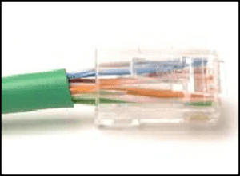

CCNA 1 v7.0 Modules 4 – 7 Exam Answers p45

What is wrong with the displayed termination?

The woven copper braid should not have been removed.  
The wrong type of connector is being used.  
**The untwisted length of each wire is too long.**The wires are too thick for the connector that is used.

Explanation: When a cable to an RJ-45 connector is terminated, it is important to ensure that the untwisted wires are not too long and that the flexible plastic sheath surrounding the wires is crimped down and not the bare wires. None of the colored wires should be visible from the bottom of the jack.

46. Refer to the exhibit.

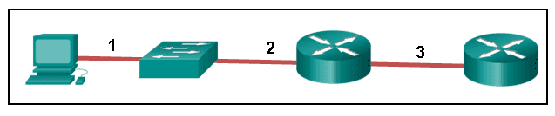

CCNA 1 v7.0 Modules 4 – 7 Exam Answers p46

The PC is connected to the console port of the switch. All the other connections are made through FastEthernet links. Which types of UTP cables can be used to connect the devices?​

1 – rollover, 2 – crossover, 3 – straight-through  
**1 – rollover, 2 – straight-through, 3 – crossover**  
1 – crossover, 2 – straight-through, 3 – rollover  
1 – crossover, 2 – rollover, 3 – straight-through

Explanation: A straight-through cable is commonly used to interconnect a host to a switch and a switch to a router. A crossover cable is used to interconnect similar devices together like switch to a switch, a host to a host, or a router to a router. If a switch has the MDIX capability, a crossover could be used to connect the switch to the router; however, that option is not available. A rollover cable is used to connect to a router or switch console port.

47. Open the PT Activity. Perform the tasks in the activity instructions and then answer the question.  
Which port does Switch0 use to send frames to the host with the IPv4 address 10.1.1.5?

Fa0/1  
Fa0/5  
Fa0/9  
Fa0/11

Explanation: Issuing the command ipconfig /all from the PC0 command prompt displays the IPv4 address and MAC address. When the IPv4 address 10.1.1.5 is pinged from PC0, the switch stores the source MAC address (from PC0) along with the port to which PC0 is connected. When the destination reply is received, the switch takes the destination MAC address and compares to MAC addresses stored in the MAC address table. Issuing the show mac-address-table on the PC0 Terminal application displays two dynamic MAC address entries. The MAC address and port entry that does not belong to PC0 must be the MAC address and port of the destination with the IPv4 address 10.1.1.5.

48. What does the term “attenuation” mean in data communication?

**loss of signal strength as distance increases**  
time for a signal to reach its destination  
leakage of signals from one cable pair to another  
strengthening of a signal by a networking device

Explanation: Data is transmitted on copper cables as electrical pulses. A detector in the network interface of a destination device must receive a signal that can be successfully decoded to match the signal sent. However, the farther the signal travels, the more it deteriorates. This is referred to as signal attenuation.

49. What makes fiber preferable to copper cabling for interconnecting buildings? (Choose three.)

**greater distances per cable run**  
lower installation cost  
**limited susceptibility to EMI/RFI**  
durable connections  
**greater bandwidth potential**  
easily terminated

Explanation: Optical fiber cable transmits data over longer distances and at higher bandwidths than any other networking media. Unlike copper wires, fiber-optic cable can transmit signals with less attenuation and is completely immune to EMI and RFI.

50. What OSI physical layer term describes the process by which one wave modifies another wave?

**Modulation**  
IEEE  
EIA/TIA  
air

51. What OSI physical layer term describes the capacity at which a medium can carry data?

**Bandwidth**  
IEEE  
EIA/TIA  
air

52. What OSI physical layer term describes the capacity at which a medium can carry data?

**Bandwidth**  
throughput  
latency  
goodput

53. What OSI physical layer term describes the measure of the transfer of bits across a medium over a given period of time?

**Throughput**  
bandwidth  
latency  
goodput

54. What OSI physical layer term describes the amount of time, including delays, for data to travel from one point to another?

**Latency**  
bandwidth  
throughput  
goodput

55. What OSI physical layer term describes the amount of time, including delays, for data to travel from one point to another?

**Latency**  
fiber-optic cable  
air  
copper cable

56. What OSI physical layer term describes the measure of usable data transferred over a given period of time?

**Goodput**  
fiber-optic cable  
air  
copper cable

57. What OSI physical layer term describes the physical medium which uses electrical pulses?

**copper cable**  
fiber-optic cable  
air  
goodput

58. What OSI physical layer term describes the physical medium that uses the propagation of light?

**fiber-optic cable**  
goodput  
latency  
throughput

59. What OSI physical layer term describes the physical medium for microwave transmissions?

**Air**  
goodput  
latency  
throughput

60. Which two functions are performed at the MAC sublayer of the OSI data link layer? (Choose two.)

**Implements a trailer to detect transmission errors.**  
**Controls the NIC responsible for sending and receiving data on the physical medium.**  
Places information in the frame that identifies which network layer protocol is being used for the frame.  
Adds Layer 2 control information to network protocol data.  
Enables IPv4 and IPv6 to utilize the same network interface and media.

61. Which two functions are performed at the LLC sublayer of the OSI data link layer? (Choose two.)

**Enables IPv4 and IPv6 to utilize the same network interface and media.**  
**Places information in the frame that identifies which network layer protocol is being used for the frame.**  
Integrates various physical technologies.  
Implements a process to delimit fields within a Layer 2 frame.  
Controls the NIC responsible for sending and receiving data on the physical medium.

62. Which two functions are performed at the MAC sublayer of the OSI data link layer? (Choose two.)

Provides a mechanism to allow multiple devices to communicate over a shared medium.  
**Controls the NIC responsible for sending and receiving data on the physical medium.  
Places information in the frame that identifies which network layer protocol is being used for the frame.**  
Adds Layer 2 control information to network protocol data.  
Communicates between the networking software at the upper layers and the device hardware at the lower layers.

63. Which two functions are performed at the MAC sublayer of the OSI data link layer? (Choose two.)

**Controls the NIC responsible for sending and receiving data on the physical medium.**  
**Integrates various physical technologies.**  
Communicates between the networking software at the upper layers and the device hardware at the lower layers.  
Adds Layer 2 control information to network protocol data.  
Places information in the frame that identifies which network layer protocol is being used for the frame.

64. Which two functions are performed at the LLC sublayer of the OSI data link layer? (Choose two.)

**Adds Layer 2 control information to network protocol data.**  
**Places information in the frame that identifies which network layer protocol is being used for the frame.**  
Performs data encapsulation.  
Controls the NIC responsible for sending and receiving data on the physical medium.  
Integrates various physical technologies.

65. Which two functions are performed at the MAC sublayer of the OSI data link layer? (Choose two.)

Provides synchronization between source and target nodes.  
**Integrates various physical technologies.**  
**Communicates between the networking software at the upper layers and the device hardware at the lower layers.**  
Adds Layer 2 control information to network protocol data.  
Enables IPv4 and IPv6 to utilize the same network interface and media.

66. Which two functions are performed at the LLC sublayer of the OSI data link layer? (Choose two.)

Adds Layer 2 control information to network protocol data.  
Enables IPv4 and IPv6 to utilize the same network interface and media.  
Provides data link layer addressing.  
Implements a trailer to detect transmission errors.  
Provides synchronization between source and target nodes.

67. Which two functions are performed at the MAC sublayer of the OSI data link layer? (Choose two.)

Implements a trailer to detect transmission errors.  
Provides synchronization between source and target nodes.  
Places information in the frame that identifies which network layer protocol is being used for the frame.  
Enables IPv4 and IPv6 to utilize the same network interface and media.  
Adds Layer 2 control information to network protocol data.

68. Which two functions are performed at the LLC sublayer of the OSI data link layer? (Choose two.)

Enables IPv4 and IPv6 to utilize the same network interface and media.  
Adds Layer 2 control information to network protocol data.  
Integrates various physical technologies.  
Implements a trailer to detect transmission errors.  
Provides synchronization between source and target nodes.

69. Which two functions are performed at the MAC sublayer of the OSI data link layer? (Choose two.)

Provides a mechanism to allow multiple devices to communicate over a shared medium.  
Controls the NIC responsible for sending and receiving data on the physical medium.  
Places information in the frame that identifies which network layer protocol is being used for the frame.  
Adds Layer 2 control information to network protocol data.  
Enables IPv4 and IPv6 to utilize the same network interface and media.

70. What action will occur if a switch receives a frame and does have the source MAC address in the MAC table?

**The switch refreshes the timer on that entry.**  
The switch shares the MAC address table entry with any connected switches.  
The switch does not forward the frame.  
The switch sends the frame to a connected router because the destination MAC address is not local.

71. What action will occur if a switch receives a frame with the destination MAC address FF:FF:FF:FF:FF:FF?

**The switch forwards it out all ports except the ingress port.**  
The switch shares the MAC address table entry with any connected switches.  
The switch does not forward the frame.  
The switch sends the frame to a connected router because the destination MAC address is not local.

72. What action will occur if a host receives a frame with a destination MAC address it does not recognize?

**The host will discard the frame**.  
The host sends the frame to the switch to update the MAC address table.  
The host forwards the frame to the router.  
The host forwards the frame to all other hosts.

73. What action will occur if a switch receives a frame with the destination MAC address 01:00:5E:00:00:D9?

**The switch forwards it out all ports except the ingress port.**  
The switch does not forward the frame.  
The switch sends the frame to a connected router because the destination MAC address is not local.  
The switch shares the MAC address table entry with any connected switches.

74. What action will occur if a host receives a frame with a destination MAC address of FF:FF:FF:FF:FF:FF?

**The host will process the frame.**  
The host forwards the frame to the router.  
The host sends the frame to the switch to update the MAC address table.  
The host forwards the frame to all other hosts.

75. What action will occur if a switch receives a frame and does have the source MAC address in the MAC table?

**The switch refreshes the timer on that entry.**  
The switch adds it to its MAC address table associated with the port number.  
The switch forwards the frame to the associated port.  
The switch sends the frame to a connected router because the destination MAC address is not local.

76. What action will occur if a host receives a frame with a destination MAC address of FF:FF:FF:FF:FF:FF?

**The host will process the frame.**  
The host returns the frame to the switch.  
The host replies to the switch with its own IP address.  
The host forwards the frame to all other hosts.

77. What action will occur if a switch receives a frame and does have the source MAC address in the MAC table?

**The switch refreshes the timer on that entry.**  
The switch shares the MAC address table entry with any connected switches.  
The switch does not forward the frame.  
The switch adds it to its MAC address table associated with the port number.

78. What action will occur if a host receives a frame with a destination MAC address it does not recognize?

**The host will discard the frame.**  
The host replies to the switch with its own IP address.  
The host forwards the frame to all other hosts.  
The host returns the frame to the switch.

79. What action will occur if a switch receives a frame with the destination MAC address FF:FF:FF:FF:FF:FF?

**The switch forwards it out all ports except the ingress port.**  
The switch refreshes the timer on that entry.  
The switch does not forward the frame.  
The switch sends the frame to a connected router because the destination MAC address is not local.

Modules 4 – 7: Ethernet Concepts Exam Answers (Additional)

1. What is the purpose of the OSI physical layer?

controlling access to media  
transmitting bits across the local media  
performing error detection on received frames  
exchanging frames between nodes over physical network media

2. Why are two strands of fiber used for a single fiber optic connection?

The two strands allow the data to travel for longer distances without degrading.  
They prevent crosstalk from causing interference on the connection.  
They increase the speed at which the data can travel.  
They allow for full-duplex connectivity.

3. Which characteristic describes crosstalk?

the distortion of the network signal from fluorescent lighting  
the distortion of the transmitted messages from signals carried in adjacent wires  
the weakening of the network signal over long cable lengths  
the loss of wireless signal over excessive distance from the access point

4. Which procedure is used to reduce the effect of crosstalk in copper cables?

requiring proper grounding connections  
twisting opposing circuit wire pairs together  
wrapping the bundle of wires with metallic shielding  
designing a cable infrastructure to avoid crosstalk interference  
avoiding sharp bends during installation

5. Which type of UTP cable is used to connect a PC to a switch port?

console  
rollover  
crossover  
straight-through

6. What is the definition of bandwidth?

the measure of the transfer of bits across the media over a given period of time  
the speed at which bits travel on the network  
the amount of data that can flow from one place to another in a given amount of time  
the measure of usable data transferred over a given period of time

7. Which statement correctly describes frame encoding?

It uses the characteristic of one wave to modify another wave.  
It transmits data signals along with a clock signal which occurs at evenly spaced time durations.  
It generates the electrical, optical, or wireless signals that represent the binary numbers of the frame.  
It converts bits into a predefined code in order to provide a predictable pattern to help distinguish data bits from control bits.

8. What is a characteristic of UTP cabling?

Cancellation  
cladding  
immunity to electrical hazards  
woven copper braid or metallic foil

9. A wireless LAN is being deployed inside the new one room office that is occupied by the park ranger. The office is located at the highest part of the national park. After network testing is complete, the technicians report that the wireless LAN signal is occasionally affected by some type of interference. What are two possible causes of the signal distortion? (Choose two.)

the microwave oven  
the large number of trees that surround the office  
the cellular phones that are used by the employees  
the elevated location where the wireless LAN was installed  
the number of wireless devices that are used in the wireless LAN

10. What is indicated by the term throughput?

the guaranteed data transfer rate offered by an ISP  
the capacity of a particular medium to carry data  
the measure of the usable data transferred across the media  
the measure of the bits transferred across the media over a given period of time  
the time it takes for a message to get from sender to receiver

11. What is one advantage of using fiber optic cabling rather than copper cabling?

It is usually cheaper than copper cabling.  
It is able to be installed around sharp bends.  
It is easier to terminate and install than copper cabling.  
It is able to carry signals much farther than copper cabling.

12. Which standards organization oversees development of wireless LAN standards?

IANA  
IEEE  
ISO  
TIA

13. A network administrator is designing a new network infrastructure that includes both wired and wireless connectivity. Under which situation would a wireless connection be recommended?

The end-user device only has an Ethernet NIC.  
The end-user device requires a dedicated connection because of performance requirements.  
The end-user device needs mobility when connecting to the network.  
The end-user device area has a high concentration of RFI.

14. A network administrator is troubleshooting connectivity issues on a server. Using a tester, the administrator notices that the signals generated by the server NIC are distorted and not usable. In which layer of the OSI model is the error categorized?

presentation layer  
network layer  
physical layer  
data link layer

15. What type of cable is used to connect a workstation serial port to a Cisco router console port?

crossover  
rollover  
straight-through  
coaxial

16. What is the binary representation for the decimal number 173?

10100111  
10100101  
10101101  
10110101

17. Given the binary address of 11101100 00010001 00001100 00001010, which address does this represent in dotted decimal format?

234.17.10.9  
234.16.12.10  
236.17.12.6  
236.17.12.10

18. How many binary bits exist within an IPv6 address?

32  
48  
64  
128  
256

19. What is the binary equivalent of the decimal number 232?

11101000  
11000110  
10011000  
11110010

20. Which two statements are correct about IPv4 and IPv6 addresses? (Choose two.)

IPv6 addresses are represented by hexadecimal numbers.  
IPv4 addresses are represented by hexadecimal numbers.  
IPv6 addresses are 32 bits in length.  
IPv4 addresses are 32 bits in length.  
IPv4 addresses are 128 bits in length.  
IPv6 addresses are 64 bits in length.

21. Which IPv4 address format was created for ease of use by people and is expressed as 201.192.1.14?

binary  
dotted decimal  
hexadecimal  
ASCII

22. What is the dotted decimal representation of the IPv4 address 11001011.00000000.01110001.11010011?

192.0.2.199  
198.51.100.201  
203.0.113.211  
209.165.201.223

23. What is the decimal equivalent of the binary number 10010101?

149  
157  
168  
192

24. What is the decimal equivalent of the hex number 0x3F?

63  
77  
87  
93

25. What is the dotted decimal representation of the IPv4 address which is represented as the binary string 00001010.01100100.00010101.00000001?

10.100.21.1  
10.10.20.1  
100.10.11.1  
100.21.10.1

26. What is the decimal equivalent of 0xC9?

185  
200  
201  
199

27. Which is a valid hexadecimal number?

F  
g  
h  
j

28. What is the binary representation of 0xCA?

10111010  
11010101  
11001010  
11011010

29. How many bits are in an IPv4 address?

32  
64  
128  
256

30. What identifier is used at the data link layer to uniquely identify an Ethernet device?

IP address  
MAC address  
sequence number  
TCP port number  
UDP port number

31. Which two engineering organizations define open standards and protocols that apply to the data link layer? (Choose two.)

International Organization for Standardization (ISO)  
Internet Assigned Numbers Authority (IANA)  
International Telecommunication Union (ITU)  
Electronic Industries Alliance (EIA)  
Internet Society (ISOC)

32. Which layer of the OSI model is responsible for specifying the encapsulation method used for specific types of media?

application  
transport  
data link  
physical

33. What is true concerning physical and logical topologies?

The logical topology is always the same as the physical topology.  
Physical topologies are concerned with how a network transfers frames.  
Physical topologies display the IP addressing scheme of each network.  
Logical topologies refer to how a network transfers data between devices.

34. What type of physical topology can be created by connecting all Ethernet cables to a central device?

bus  
ring  
star  
mesh

35. A technician has been asked to develop a physical topology for a network that provides a high level of redundancy. Which physical topology requires that every node is attached to every other node on the network?

bus  
hierarchical  
mesh  
ring  
star

36. Which statement describes the half-duplex mode of data transmission?

Data that is transmitted over the network can only flow in one direction.  
Data that is transmitted over the network flows in one direction at a time.  
Data that is transmitted over the network flows in one direction to many different destinations simultaneously.  
Data that is transmitted over the network flows in both directions at the same time.

37. Which is a function of the Logical Link Control (LLC) sublayer?

to define the media access processes that are performed by the hardware  
to provide data link layer addressing  
to identify which network layer protocol is being used  
to accept segments and package them into data units that are called packets

38. Which data link layer media access control method does Ethernet use?

CSMA/CD  
determinism  
turn taking  
token passing

39. What are the two sublayers of the OSI model data link layer? (Choose two.)

internet  
physical  
LLC  
transport  
MAC  
network access

40. What method is used to manage contention-based access on a wireless network?

CSMA/CD  
priority ordering  
CSMA/CA  
token passing

41. What are two services performed by the data link layer of the OSI model? (Choose two.)

It encrypts data packets.  
It determines the path to forward packets.  
It accepts Layer 3 packets and encapsulates them into frames.  
It provides media access control and performs error detection.  
It monitors the Layer 2 communication by building a MAC address table.

42. What does a router do after de-encapsulating a received frame?

determines the best path  
de-encapsulates the frame  
re-encapsulates the packet into a new frame  
forwards the new frame onto the network medium

43. What attribute of a NIC would place it at the data link layer of the OSI model?

attached Ethernet cable  
IP address  
MAC address  
RJ-45 port  
TCP/IP protocol stack

44. Although CSMA/CD is still a feature of Ethernet, why is it no longer necessary?

the virtually unlimited availability of IPv6 addresses  
the use of CSMA/CA  
the use of full-duplex capable Layer 2 switches  
the development of half-duplex switch operation  
the use of Gigabit Ethernet speeds

45. Which network device makes forwarding decisions based on the destination MAC address that is contained in the frame?

repeater  
hub  
switch  
router

46. Which network device has the primary function to send data to a specific destination based on the information found in the MAC address table?

hub  
router  
switch  
modem

47. Which function or operation is performed by the LLC sublayer?

It performs data encapsulation.  
It communicates with upper protocol layers.  
It is responsible for media access control.  
It adds a header and trailer to a packet to form an OSI Layer 2 PDU.

48. Which statement is true about MAC addresses?

MAC addresses are implemented by software.  
A NIC only needs a MAC address if connected to a WAN.  
The first three bytes are used by the vendor assigned OUI.  
The ISO is responsible for MAC addresses regulations.

49. What happens to runt frames received by a Cisco Ethernet switch?

The frame is dropped.  
The frame is returned to the originating network device.  
The frame is broadcast to all other devices on the same network.  
The frame is sent to the default gateway.

50. What are the two sizes (minimum and maximum) of an Ethernet frame? (Choose two.)

56 bytes  
64 bytes  
128 bytes  
1024 bytes  
1518 bytes

51. What addressing information is recorded by a switch to build its MAC address table?

the destination Layer 3 address of incoming packets  
the destination Layer 2 address of outgoing frames  
the source Layer 3 address of outgoing packets  
the source Layer 2 address of incoming frames

52. Which two characteristics describe Ethernet technology? (Choose two.)

It is supported by IEEE 802.3 standards.  
It is supported by IEEE 802.5 standards.  
It typically uses an average of 16 Mb/s for data transfer rates.  
It uses the CSMA/CD access control method.  
It uses a ring topology.

53. What statement describes a characteristic of MAC addresses?

They must be globally unique.  
They are only routable within the private network.  
They are added as part of a Layer 3 PDU.  
They have a 32-bit binary value.

54. What is the special value assigned to the first 24 bits of a multicast MAC address?

01-5E-00  
FF-00-5E  
FF-FF-FF  
01-00-5E

55. What will a host on an Ethernet network do if it receives a frame with a destination MAC address that does not match its own MAC address?

It will discard the frame.  
It will forward the frame to the next host.  
It will remove the frame from the media.  
It will strip off the data-link frame to check the destination IP address.

56. What is auto-MDIX?

a type of Cisco switch  
an Ethernet connector type  
a type of port on a Cisco switch  
a feature that detects Ethernet cable typ​e

57. Which two functions or operations are performed by the MAC sublayer? (Choose two.)

It is responsible for Media Access Control.  
It performs the function of NIC driver software.  
It adds a header and trailer to form an OSI Layer 2 PDU.  
It handles communication between upper and lower layers.  
It adds control information to network protocol layer data.

58. What type of address is 01-00-5E-0A-00-02?

an address that reaches every host inside a local subnet  
an address that reaches one specific host  
an address that reaches every host in the network  
an address that reaches a specific group of hosts

[HOME](https://www.ccnaexam.net/)

[CCNA 1 V7.0](https://www.ccnaexam.net/category/ccna-1-v7-0)

CCNA 1 V7 Modules 8 – 10 Free Exam Answers

[CCNA 1 V7.0](https://www.ccnaexam.net/category/ccna-1-v7-0)

CCNA 1 v7 Modules 8 – 10 Free Exam Answers

[CCNAv7](https://www.ccnaexam.net/author/ccnav7) December 30, 2019

CCNA 1 v7 Modules 8 – 10: Communicating Between Networks Exam Answers

1. Which information is used by routers to forward a data packet toward its destination?

source IP address  
**destination IP address**  
source data-link address  
destination data-link address

2. A computer has to send a packet to a destination host in the same LAN. How will the packet be sent?

The packet will be sent to the default gateway first, and then, depending on the response from the gateway, it may be sent to the destination host.  
**The packet will be sent directly to the destination host.**  
The packet will first be sent to the default gateway, and then from the default gateway it will be sent directly to the destination host.  
The packet will be sent only to the default gateway.

3. A router receives a packet from the Gigabit 0/0 interface and determines that the packet needs to be forwarded out the Gigabit 0/1 interface. What

will the router do next?  
route the packet out the Gigabit 0/1 interface  
**create a new Layer 2 Ethernet frame to be sent to the destination**  
look into the ARP cache to determine the destination IP address  
look into the routing table to determine if the destination network is in the routing table

4. Which IPv4 address can a host use to ping the loopback interface?

126.0.0.1  
127.0.0.0  
126.0.0.0  
**127.0.0.1**

5. A computer can access devices on the same network but cannot access devices on other networks. What is the probable cause of this problem?

The cable is not connected properly to the NIC.  
The computer has an invalid IP address.  
The computer has an incorrect subnet mask.  
**The computer has an invalid default gateway address**.

6. Which statement describes a feature of the IP protocol?

IP encapsulation is modified based on network media.  
IP relies on Layer 2 protocols for transmission error control.  
MAC addresses are used during the IP packet encapsulation.  
**IP relies on upper layer services to handle situations of missing or out-of-order packets**.

Explanation: IP protocol is a connection-less protocol, considered unreliable in terms of end-to-end delivery. It does not provide error control in the cases where receiving packets are out-of-order or in cases of missing packets. It relies on upper layer services, such as TCP, to resolve these issues.

7. Why is NAT not needed in IPv6?​

Because IPv6 has integrated security, there is no need to hide the IPv6 addresses of internal networks.​  
**Any host or user can get a public IPv6 network address because the number of available IPv6 addresses is extremely large.​**  
The problems that are induced by NAT applications are solved because the IPv6 header improves packet handling by intermediate routers.​  
The end-to-end connectivity problems that are caused by NAT are solved because the number of routes increases with the number of nodes that are connected to the Internet.

8. Which parameter does the router use to choose the path to the destination when there are multiple routes available?

**the lower metric value that is associated with the destination network**  
the lower gateway IP address to get to the destination network  
the higher metric value that is associated with the destination network  
the higher gateway IP address to get to the destination network

9. What are two services provided by the OSI network layer? (Choose two.)

performing error detection  
**routing packets toward the destination**  
**encapsulating PDUs from the transport layer**  
placement of frames on the media  
collision detection

Explanation: The OSI network layer provides several services to allow communication between devices:  
addressing  
encapsulation  
routing  
de-encapsulation  
Error detection, placing frames on the media, and collision detection are all functions of the data ink layer.

10. Within a production network, what is the purpose of configuring a switch with a default gateway address?

Hosts that are connected to the switch can use the switch default gateway address to forward packets to a remote destination.  
A switch must have a default gateway to be accessible by Telnet and SSH.  
**The default gateway address is used to forward packets originating from the switch to remote networks.**  
It provides a next-hop address for all traffic that flows through the switch.

Explanation: A default gateway address allows a switch to forward packets that originate on the switch to remote networks. A default gateway address on a switch does not provide Layer 3 routing for PCs that are connected on that switch. A switch can still be accessible from Telnet as long as the source of the Telnet connection is on the local network.

11. What is a basic characteristic of the IP protocol?

**Connectionless**media dependent  
user data segmentation  
reliable end-to-end delivery

Explanation: Internet Protocol (IP) is a network layer protocol that does not require initial exchange of control information to establish an end-to-end connection before packets are forwarded. Thus, IP is connectionless and does not provide reliable end-to-end delivery by itself. IP is media independent. User data segmentation is a service provided at the transport layer.

12. Which field in the IPv4 header is used to prevent a packet from traversing a network endlessly?

**Time-to-Live**  
Sequence Number  
Acknowledgment Number  
Differentiated Services

Explanation: The value of the Time-to-Live (TTL) field in the IPv4 header is used to limit the lifetime of a packet. The sending host sets the initial TTL value; which is decreased by one each time the packet is processed by a router. If the TTL field decrements to zero, the router discards the packet and sends an Internet Control Message Protocol (ICMP) Time Exceeded message to the source IP address. The Differentiated Services (DS) field is used to determine the priority of each packet. Sequence Number and Acknowledgment Number are two fields in the TCP header.

13. What is one advantage that the IPv6 simplified header offers over IPv4?

smaller-sized header  
little requirement for processing checksums  
smaller-sized source and destination IP addresses  
**efficient packet handling**

Explanation: The IPv6 simplified header offers several advantages over IPv4:  
Better routing efficiency and efficient packet handling for performance and forwarding-rate scalability  
No requirement for processing checksums  
Simplified and more efficient extension header mechanisms (as opposed to the IPv4 Options field)  
A Flow Label field for per-flow processing with no need to open the transport inner packet to identify the various traffic flows

14. What IPv4 header field identifies the upper layer protocol carried in the packet?

**Protocol**  
Identification  
Version  
Differentiated Services

Explanation: It is the Protocol field in the IP header that identifies the upper-layer protocol the packet is carrying. The Version field identifies the IP version. The Differential Services field is used for setting packet priority. The Identification field is used to reorder fragmented packets.

15. Refer to the exhibit. Match the packets with their destination IP address to the exiting interfaces on the router. (Not all targets are used.)

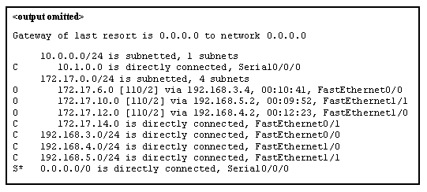

CCNA 1 v7.0 Modules 8 – 10 Exam Answers p15-1

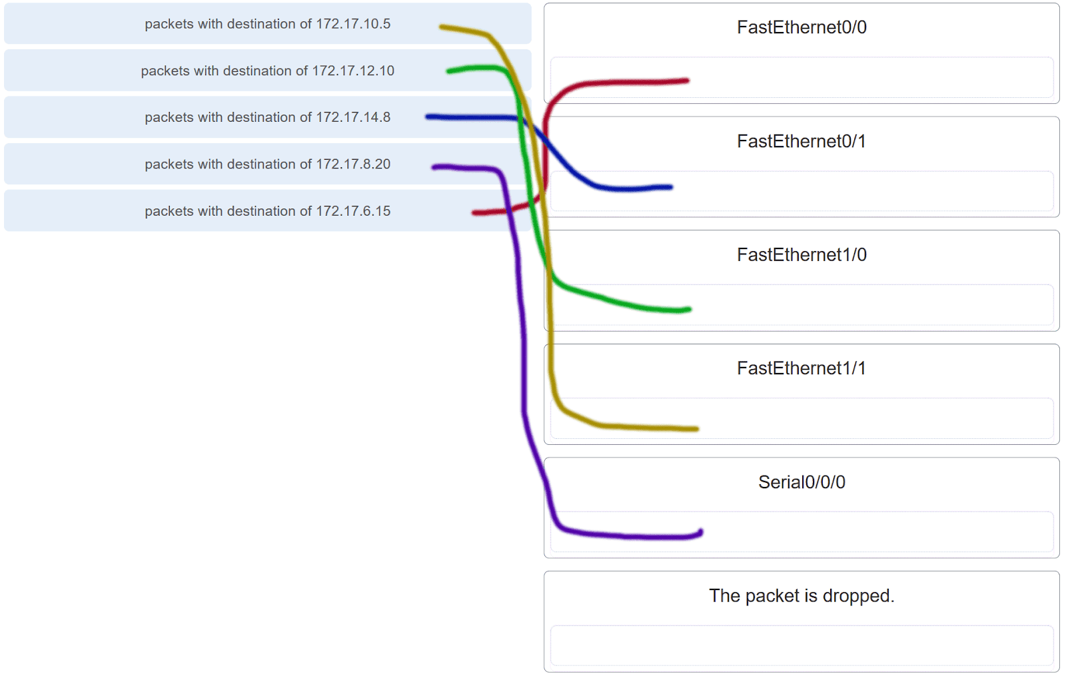

CCNA 1 v7.0 Modules 8 – 10 Exam Answers p15-2

Explanation: Packets with a destination of 172.17.6.15 are forwarded through Fa0/0. Packets with a destination of 172.17.10.5 are forwarded through Fa1/1. Packets with a destination of 172.17.12.10 are forwarded through Fa1/0. Packets with a destination of 172.17.14.8 are forwarded through Fa0/1. Because network 172.17.8.0 has no entry in the routing table, it will take the gateway of last resort, which means that packets with a destination of 172.17.8.20 are forwarded through Serial0/0/0. Because a gateway of last resort exists, no packets will be dropped.

16. What information does the loopback test provide?

**The TCP/IP stack on the device is working correctly.**  
The device has end-to-end connectivity.  
DHCP is working correctly.  
The Ethernet cable is working correctly.  
The device has the correct IP address on the network.

17. What routing table entry has a next hop address associated with a destination network?

directly-connected routes  
local routes  
**remote routes**  
C and L source routes

18. How do hosts ensure that their packets are directed to the correct network destination?

**They have to keep their own local routing table that contains a route to the loopback interface, a local network route, and a remote default route.​**They always direct their packets to the default gateway, which will be responsible for the packet delivery.  
They search in their own local routing table for a route to the network destination address and pass this information to the default gateway.  
They send a query packet to the default gateway asking for the best route.

19. When transporting data from real-time applications, such as streaming audio and video, which field in the IPv6 header can be used to inform the routers and switches to maintain the same path for the packets in the same conversation?

Next Header  
**Flow Label**  
Traffic Class  
Differentiated Services

Explanation: The Flow Label in IPv6 header is a 20-bit field that provides a special service for real-time applications. This field can be used to inform routers and switches to maintain the same path for the packet flow so that packets will not be reordered.

20. What statement describes the function of the Address Resolution Protocol?

ARP is used to discover the IP address of any host on a different network.  
ARP is used to discover the IP address of any host on the local network.  
ARP is used to discover the MAC address of any host on a different network.  
**ARP is used to discover the MAC address of any host on the local network.**

21. Under which two circumstances will a switch flood a frame out of every port except the port that the frame was received on? (Choose two.)

**The frame has the broadcast address as the destination address.**  
**The destination address is unknown to the switch.**  
The source address in the frame header is the broadcast address.  
The source address in the frame is a multicast address.  
The destination address in the frame is a known unicast address.

Explanation: A switch will flood a frame out of every port, except the one that the frame was received from, under two circumstances. Either the frame has the broadcast address as the destination address, or the destination address is unknown to the switch.

22. Which statement describes the treatment of ARP requests on the local link?

They must be forwarded by all routers on the local network.  
**They are received and processed by every device on the local network.**  
They are dropped by all switches on the local network.  
They are received and processed only by the target device.

Explanation: One of the negative issues with ARP requests is that they are sent as a broadcast. This means all devices on the local link must receive and process the request.

23. Which destination address is used in an ARP request frame?

0.0.0.0  
255.255.255.255  
**FFFF.FFFF.FFFF**  
AAAA.AAAA.AAAA  
the physical address of the destination host

Explanation: The purpose of an ARP request is to find the MAC address of the destination host on an Ethernet LAN. The ARP process sends a Layer 2 broadcast to all devices on the Ethernet LAN. The frame contains the IP address of the destination and the broadcast MAC address, FFFF.FFFF.FFFF. The host with the IP address that matches the IP address in the ARP request will reply with a unicast frame that includes the MAC address of the host. Thus the original sending host will obtain the destination IP and MAC address pair to continue the encapsulation process for data transmission.

24. A network technician issues the arp -d command on a PC after the router that is connected to the LAN is reconfigured. What is the result after this command is issued?

**The ARP cache is cleared.**  
The current content of the ARP cache is displayed.  
The detailed information of the ARP cache is displayed.  
The ARP cache is synchronized with the router interface.

Explanation: Issuing the arp –d  command on a PC will clear the ARP cache content. This is helpful when a network technician wants to ensure the cache is populated with updated information.

25. Refer to the exhibit.

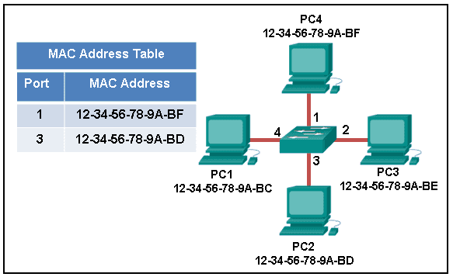

CCNA 1 v7.0 Modules 8 – 10 Exam Answers p25

The exhibit shows a small switched network and the contents of the MAC address table of the switch. PC1 has sent a frame addressed to PC3. What will the switch do with the frame?

The switch will discard the frame.  
The switch will forward the frame only to port 2.  
**The switch will forward the frame to all ports except port 4.**The switch will forward the frame to all ports.  
The switch will forward the frame only to ports 1 and 3.

Explanation: The MAC address of PC3 is not present in the MAC table of the switch. Because the switch does not know where to send the frame that is addressed to PC3, it will forward the frame to all the switch ports, except for port 4, which is the incoming port.

26. Which two types of IPv6 messages are used in place of ARP for address resolution?

anycast  
broadcast  
echo reply  
echo request  
**neighbor solicitation  
neighbor advertisement**

Explanation: IPv6 does not use ARP. Instead, ICMPv6 neighbor discovery is used by sending neighbor solicitation and neighbor advertisement messages.

27. What is the aim of an ARP spoofing attack?

to flood the network with ARP reply broadcasts  
to fill switch MAC address tables with bogus addresses  
**to associate IP addresses to the wrong MAC address**  
to overwhelm network hosts with ARP requests

28. Refer to the exhibit.

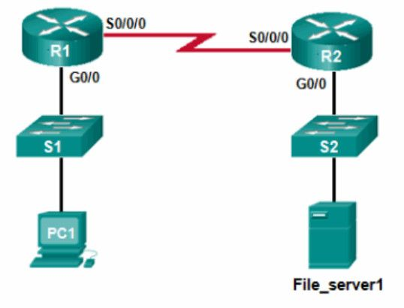

CCNA 1 v7.0 Modules 8 – 10 Exam Answers p28

PC1 attempts to connect to File_server1 and sends an ARP request to obtain a destination MAC address. Which MAC address will PC1 receive in the ARP reply?

the MAC address of S1  
the MAC address of the G0/0 interface on R1  
the MAC address of the G0/0 interface on R2  
the MAC address of S2  
the MAC address of File_server1

29. Where are IPv4 address to Layer 2 Ethernet address mappings maintained on a host computer?

neighbor table  
A**RP cache**  
routing table  
MAC address table

30. What important information is examined in the Ethernet frame header by a Layer 2 device in order to forward the data onward?

source MAC address  
source IP address  
**destination MAC address**  
Ethernet type  
destination IP address

Explanation: The Layer 2 device, such as a switch, uses the destination MAC address to determine which path (interface or port) should be used to send the data onward to the destination device.

31. Match the commands to the correct actions. (Not all options are used.)

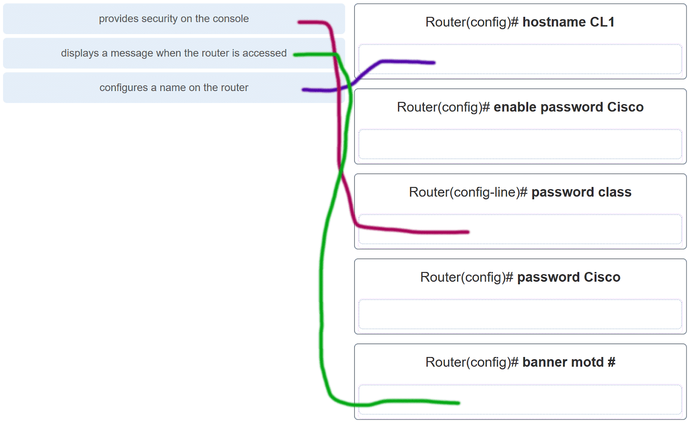

CCNA 1 v7.0 Modules 8 – 10 Exam Answers p31

32. A new network administrator has been asked to enter a banner message on a Cisco device. What is the fastest way a network administrator could test whether the banner is properly configured?

Reboot the device.  
Enter CTRL-Z at the privileged mode prompt.  
Exit global configuration mode.  
Power cycle the device.  
**Exit privileged EXEC mode and press Enter.**

Explanation: While at the privileged mode prompt such as Router#, type exit,press Enter, and the banner message appears. Power cycling a network device that has had the banner motd command issued will also display the banner message, but this is not a quick way to test the configuration.

33. A network administrator requires access to manage routers and switches locally and remotely. Match the description to the access method. (Not all options are used.)

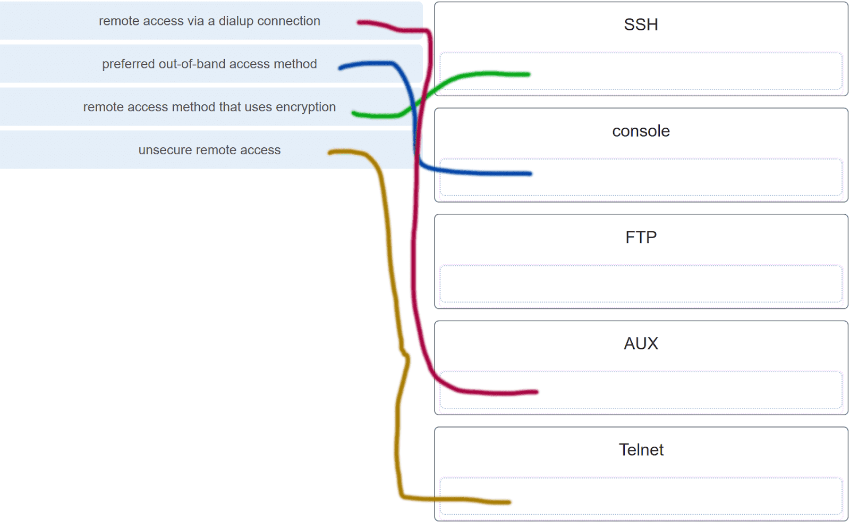

CCNA 1 v7.0 Modules 8 – 10 Exam Answers p33

Explanation: Both the console and AUX ports can be used to directly connect to a Cisco network device for management purposes. However, it is more common to use the console port. The AUX port is more often used for remote access via a dial up connection. SSH and Telnet are both remote access methods that depend on an active network connection. SSH uses a stronger password authentication than Telnet uses and also uses encryption on transmitted data.

34. Match the phases to the functions during the boot up process of a Cisco router. (Not all options are used.)

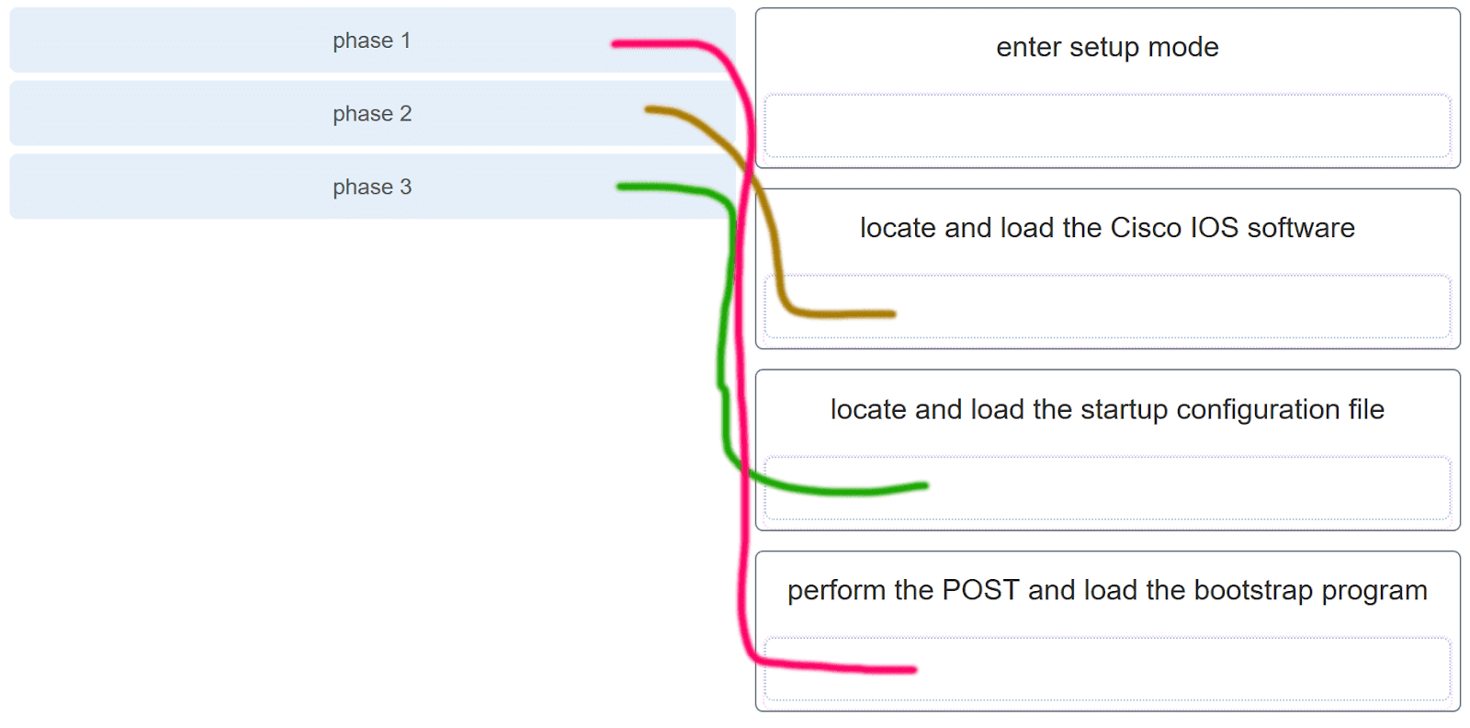

CCNA 1 v7.0 Modules 8 – 10 Exam Answers p34

Explanation: There are three major phases to the bootup process of a Cisco router:  
1. Perform the POST and load the bootstrap program.  
2. Locate and load the Cisco IOS software.  
3. Locate and load the startup configuration file  
If a startup configuration file cannot be located, the router will enter setup mode by displaying the setup mode prompt.

35. Match the command with the device mode at which the command is entered. (Not all options are used.)

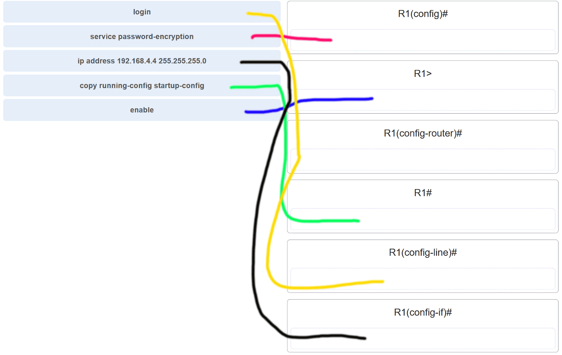

CCNA 1 v7.0 Modules 8 – 10 Exam Answers p35

Explanation: The enable command is entered in R1> mode. The login command is entered in R1(config-line)# mode. The copy running-config startup-config command is entered in R1# mode. The ip address 192.168.4.4 255.255.255.0 command is entered in R1(config-if)# mode. The service password-encryption command is entered in global configuration mode.

36. What are two functions of NVRAM? (Choose two.)

to store the routing table  
**to retain contents when power is removed**  
**to store the startup configuration file**  
to contain the running configuration file  
to store the ARP table

Explanation: NVRAM is permanent memory storage, so the startup configuration file is preserved even if the router loses power.

37. A router boots and enters setup mode. What is the reason for this?

The IOS image is corrupt.  
Cisco IOS is missing from flash memory.  
**The configuration file is missing from NVRAM**.  
The POST process has detected hardware failure.

38. The global configuration command ip default-gateway 172.16.100.1 is applied to a switch. What is the effect of this command?

The switch will have a management interface with the address 172.16.100.1.  
**The switch can be remotely managed from a host on another network.**  
The switch can communicate with other hosts on the 172.16.100.0 network.  
The switch is limited to sending and receiving frames to and from the gateway 172.16.100.1.

Explanation: A default gateway address is typically configured on all devices to allow them to communicate beyond just their local network.In a switch this is achieved using the command ip default-gateway .

39. What happens when the transport input ssh command is entered on the switch vty lines?

The SSH client on the switch is enabled.  
**Communication between the switch and remote users is encrypted.**The switch requires a username/password combination for remote access.  
The switch requires remote connections via a proprietary client software.

Explanation: The transport input ssh command when entered on the switch vty (virtual terminal lines) will encrypt all inbound controlled telnet connections.

40. Refer to the exhibit.

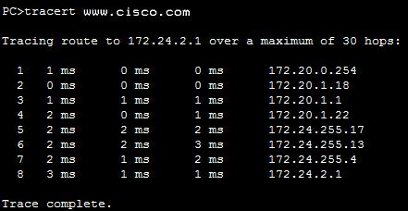

CCNA 1 v7.0 Modules 8 – 10 Exam Answers p40

A user PC has successfully transmitted packets to www.cisco.com. Which IP address does the user PC target in order to forward its data off the local network?

172.24.255.17  
172.24.1.22  
**172.20.0.254**  
172.24.255.4  
172.20.1.18

41. Match the configuration mode with the command that is available in that mode. (Not all options are used.)

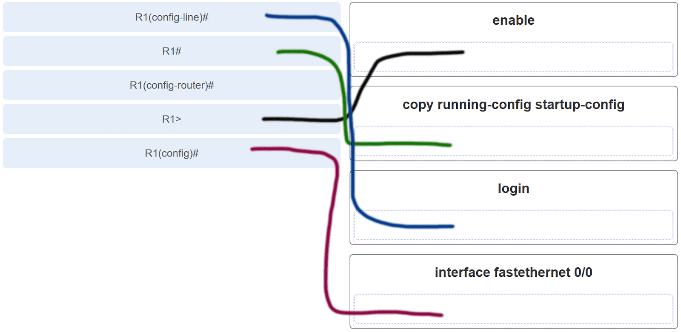

CCNA 1 v7.0 Modules 8 – 10 Exam Answers p41

Explanation: The enable command is entered at the R1> prompt. The login command is entered at the R1(config-line)# prompt. The copy running-config startup-config command is entered at the R1# prompt. The interface fastethernet 0/0 command is entered at the R1(config)# prompt.

42. Which three commands are used to set up secure access to a router through a connection to the console interface? (Choose three.)

interface fastethernet 0/0  
line vty 0 4  
**line console 0**  
enable secret cisco  
**login**  
 **password cisco**

Explanation: The three commands needed to password protect the console port are as follows:  
line console 0  
password cisco  
login  
The interface fastethernet 0/0 command is commonly used to access the configuration mode used to apply specific parameters such as the IP address to the Fa0/0 port. The line vty 0 4 command is used to access the configuration mode for Telnet. The0and 4 parameters specify ports 0 through 4, or a maximum of five simultaneous Telnet connections. The enable secret command is used to apply a password used on the router to access the privileged mode.

43. Refer to the exhibit.

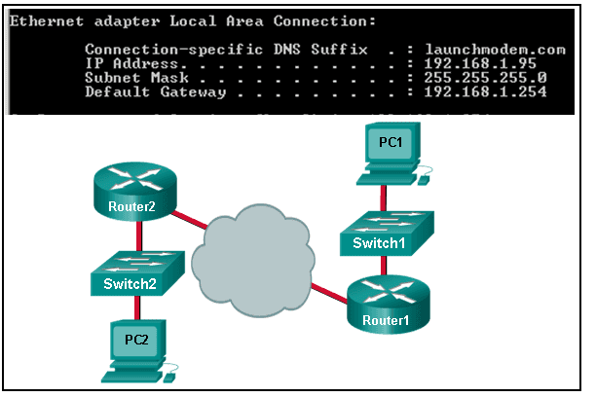

CCNA 1 v7.0 Modules 8 – 10 Exam Answers p43

Consider the IP address configuration shown from PC1. What is a description of the default gateway address?

It is the IP address of the Router1 interface that connects the company to the Internet.  
It is the IP address of the Router1 interface that connects the PC1 LAN to Router1.  
It is the IP address of Switch1 that connects PC1 to other devices on the same LAN.  
It is the IP address of the ISP network device located in the cloud.

44. Which two functions are primary functions of a router? (Choose two.)

**packet forwarding**  
microsegmentation  
domain name resolution  
**path selection**  
flow control

Explanation: A router accepts a packet and accesses its routing table to determine the appropriate exit interface based on the destination address. The router then forwards the packet out of that interface.

45. What is the effect of using the Router# copy running-config startup-config command on a router?

The contents of ROM will change.  
The contents of RAM will change.  
**The contents of NVRAM will change.**  
The contents of flash will change.

Explanation: The command copy running-config startup-config copies the running-configuration file from RAM into NVRAM and saves it as the startup-configuration file. Since NVRAM is none-volatile memory it will be able to retain the configuration details when the router is powered off.

46. What will happen if the default gateway address is incorrectly configured on a host?

The host cannot communicate with other hosts in the local network.  
The switch will not forward packets initiated by the host.  
The host will have to use ARP to determine the correct address of the default gateway.  
**The host cannot communicate with hosts in other networks.**  
A ping from the host to 127.0.0.1 would not be successful.

Explanation: When a host needs to send a message to another host located on the same network, it can forward the message directly. However, when a host needs to send a message to a remote network, it must use the router, also known as the default gateway. This is because the data link frame address of the remote destination host cannot be used directly. Instead, the IP packet has to be sent to the router (default gateway) and the router will forward the packet toward its destination. Therefore, if the default gateway is incorrectly configured, the host can communicate with other hosts on the same network, but not with hosts on remote networks.

47. What are two potential network problems that can result from ARP operation? (Choose two.)

Manually configuring static ARP associations could facilitate ARP poisoning or MAC address spoofing.  
**On large networks with low bandwidth, multiple ARP broadcasts could cause data communication delays.**  
**Network attackers could manipulate MAC address and IP address mappings in ARP messages with the intent of intercepting network traffic.**  
Large numbers of ARP request broadcasts could cause the host MAC address table to overflow and prevent the host from communicating on the network.  
Multiple ARP replies result in the switch MAC address table containing entries that match the MAC addresses of hosts that are connected to the relevant switch port.

Explanation: Large numbers of ARP broadcast messages could cause momentary data communications delays. Network attackers could manipulate MAC address and IP address mappings in ARP messages with the intent to intercept network traffic. ARP requests and replies cause entries to be made into the ARP table, not the MAC address table. ARP table overflows are very unlikely. Manually configuring static ARP associations is a way to prevent, not facilitate, ARP poisoning and MAC address spoofing. Multiple ARP replies resulting in the switch MAC address table containing entries that match the MAC addresses of connected nodes and are associated with the relevant switch port are required for normal switch frame forwarding operations. It is not an ARP caused network problem.

48. Open the PT activity. Perform the tasks in the activity instructions and then answer the question.  
Which interfaces in each router are active and operational?

R1: G0/0 and S0/0/0  
R2: G0/0 and S0/0/0

R1: G0/1 and S0/0/1  
R2: G0/0 and S0/0/1

R1: G0/0 and S0/0/0  
R2: G0/1 and S0/0/0

R1: G0/0 and S0/0/1  
R2: G0/1 and S0/0/1

Explanation: The command to use for this activity is show ip interface brief in each router. The active and operational interfaces are represented by the value “up” in the “Status” and “Protocol” columns. The interfaces in R1 with these characteristics are G0/0 and S0/0/0. In R2 they are G0/1 and S0/0/0.

49. Which term describes a field in the IPv4 packet header used to identify the next level protocol?

**Protocol**  
destination IPv4 address  
source IPv4 address  
TTL

50. Which term describes a field in the IPv4 packet header that contains an 8-bit binary value used to determine the priority of each packet?

**differentiated services**  
destination IPv4 address  
source IPv4 address  
protocol

51. Which term describes a field in the IPv4 packet header that contains a 32-bit binary value associated with an interface on the sending device?

**source IPv4 address**  
destination IPv4 address  
protocol  
TTL

52. Which term describes a field in the IPv4 packet header used to detect corruption in the IPv4 header?

**header checksum**  
source IPv4 address  
protocol  
TTL

53.

RTR1(config)# interface gi0/1

RTR1(config-if)# description Connects to the Marketing LAN

RTR1(config-if)# ip address 10.27.15.17 255.255.255.0

RTR1(config-if)# no shutdown

RTR1(config-if)# interface gi0/0

RTR1(config-if)# description Connects to the Payroll LAN

RTR1(config-if)# ip address 10.27.14.148 255.255.255.0

RTR1(config-if)# no shutdown

RTR1(config-if)# interface s0/0/0

RTR1(config-if)# description Connects to the ISP

RTR1(config-if)# ip address 10.14.15.254 255.255.255.0

RTR1(config-if)# no shutdown

RTR1(config-if)# interface s0/0/1

RTR1(config-if)# description Connects to the Head Office WAN

RTR1(config-if)# ip address 203.0.113.39 255.255.255.0

RTR1(config-if)# no shutdown

RTR1(config-if)# end

Refer to the exhibit. A network administrator is connecting a new host to the Payroll LAN. The host needs to communicate with remote networks. What IP address would be configured as the default gateway on the new host?

10.27.14.148  
10.27.14.1  
10.14.15.254  
203.0.113.39  
10.27.15.17

54. Which term describes a field in the IPv4 packet header that contains a unicast, multicast, or broadcast address?

**destination IPv4 address**  
protocol  
TTL  
header checksum

55. Which term describes a field in the IPv4 packet header used to limit the lifetime of a packet?

**TTL**  
source IPv4 address  
protocol  
header checksum

56. Which term describes a field in the IPv4 packet header that contains a 4-bit binary value set to 0100?

**Versión**  
source IPv4 address  
protocol  
TTL

57. Which term describes a field in the IPv4 packet header used to identify the next level protocol?

**Protocol**  
version  
differentiated services  
header checksum

58. Which term describes a field in the IPv4 packet header that contains a 4-bit binary value set to 0100?

**Versión**  
differentiated services  
header checksum  
TTL

59.

What property of ARP causes cached IP-to-MAC mappings to remain in memory longer?

**Entries in an ARP table are time-stamped and are purged after the timeout expires.**  
A static IP-to-MAC address entry can be entered manually into an ARP table.  
The type field 0x806 appears in the header of the Ethernet frame.  
The port-to-MAC address table on a switch has the same entries as the ARP table on the switch.

60. What property of ARP allows MAC addresses of frequently used servers to be fixed in the ARP table?

**A static IP-to-MAC address entry can be entered manually into an ARP table.**  
Entries in an ARP table are time-stamped and are purged after the timeout expires.  
The type field 0x806 appears in the header of the Ethernet frame.  
The port-to-MAC address table on a switch has the same entries as the ARP table on the switch.

61. What property of ARP allows MAC addresses of frequently used servers to be fixed in the ARP table?

**A static IP-to-MAC address entry can be entered manually into an ARP table.**  
The destination MAC address FF-FF-FF-FF-FF-FF appears in the header of the Ethernet frame.  
The source MAC address appears in the header of the Ethernet frame.  
The port-to-MAC address table on a switch has the same entries as the ARP table on the switch.

62. What property of ARP allows hosts on a LAN to send traffic to remote networks?

**Local hosts learn the MAC address of the default gateway**.  
The destination MAC address FF-FF-FF-FF-FF-FF appears in the header of the Ethernet frame.  
The source MAC address appears in the header of the Ethernet frame.  
The port-to-MAC address table on a switch has the same entries as the ARP table on the switch.

63.

Floor(config)# interface gi0/1

Floor(config-if)# description Connects to the Registrar LAN

Floor(config-if)# ip address 192.168.235.234 255.255.255.0

Floor(config-if)# no shutdown

Floor(config-if)# interface gi0/0

Floor(config-if)# description Connects to the Manager LAN

Floor(config-if)# ip address 192.168.234.114 255.255.255.0

Floor(config-if)# no shutdown

Floor(config-if)# interface s0/0/0

Floor(config-if)# description Connects to the ISP

Floor(config-if)# ip address 10.234.235.254 255.255.255.0

Floor(config-if)# no shutdown

Floor(config-if)# interface s0/0/1

Floor(config-if)# description Connects to the Head Office WAN

Floor(config-if)# ip address 203.0.113.3 255.255.255.0

Floor(config-if)# no shutdown

Floor(config-if)# end

Refer to the exhibit. A network administrator is connecting a new host to the Registrar LAN. The host needs to communicate with remote networks. What IP address would be configured as the default gateway on the new host?

192.168.235.234  
192.168.235.1  
10.234.235.254  
203.0.113.3  
192.168.234.114

64. What property of ARP forces all Ethernet NICs to process an ARP request?

**The destination MAC address FF-FF-FF-FF-FF-FF appears in the header of the Ethernet frame.**  
The source MAC address appears in the header of the Ethernet frame.  
The type field 0x806 appears in the header of the Ethernet frame.  
ARP replies are broadcast on the network when a host receives an ARP request.

65. What property of ARP causes a reply only to the source sending an ARP request?

**The source MAC address appears in the header of the Ethernet frame.**  
The destination MAC address FF-FF-FF-FF-FF-FF appears in the header of the Ethernet frame.  
The type field 0x806 appears in the header of the Ethernet frame.  
ARP replies are broadcast on the network when a host receives an ARP request.

66. What property of ARP causes the request to be flooded out all ports of a switch except for the port receiving the ARP request?

**The destination MAC address FF-FF-FF-FF-FF-FF appears in the header of the Ethernet frame.**  
The type field 0x806 appears in the header of the Ethernet frame.  
Entries in an ARP table are time-stamped and are purged after the timeout expires.  
ARP replies are broadcast on the network when a host receives an ARP request.

67. What property of ARP causes the NICs receiving an ARP request to pass the data portion of the Ethernet frame to the ARP process?

**The type field 0x806 appears in the header of the Ethernet frame.**The destination MAC address FF-FF-FF-FF-FF-FF appears in the header of the Ethernet frame.  
Entries in an ARP table are time-stamped and are purged after the timeout expires.  
ARP replies are broadcast on the network when a host receives an ARP request.

68. What property of ARP causes the NICs receiving an ARP request to pass the data portion of the Ethernet frame to the ARP process?

**The type field 0x806 appears in the header of the Ethernet frame.**  
The destination MAC address FF-FF-FF-FF-FF-FF appears in the header of the Ethernet frame.  
Entries in an ARP table are time-stamped and are purged after the timeout expires.  
The port-to-MAC address table on a switch has the same entries as the ARP table on the switch.

69.

Main(config)# interface gi0/1

Main(config-if)# description Connects to the Service LAN

Main(config-if)# ip address 172.29.157.156 255.255.255.0

Main(config-if)# no shutdown

Main(config-if)# interface gi0/0

Main(config-if)# description Connects to the Engineering LAN

Main(config-if)# ip address 172.29.156.36 255.255.255.0

Main(config-if)# no shutdown

Main(config-if)# interface s0/0/0

Main(config-if)# description Connects to the ISP

Main(config-if)# ip address 10.156.157.254 255.255.255.0

Main(config-if)# no shutdown

Main(config-if)# interface s0/0/1

Main(config-if)# description Connects to the Head Office WAN

Main(config-if)# ip address 198.51.100.177 255.255.255.0

Main(config-if)# no shutdown

Main(config-if)# end

Refer to the exhibit. A network administrator is connecting a new host to the Service LAN. The host needs to communicate with remote networks. What IP address would be configured as the default gateway on the new host?

172.29.157.156  
172.29.157.1  
10.156.157.254  
198.51.100.177  
172.29.156.36

70.

BldgA(config)# interface gi0/1

BldgA(config-if)# description Connects to the Medical LAN

BldgA(config-if)# ip address 192.168.191.189 255.255.255.0

BldgA(config-if)# no shutdown

BldgA(config-if)# interface gi0/0

BldgA(config-if)# description Connects to the Client LAN

BldgA(config-if)# ip address 192.168.190.70 255.255.255.0

BldgA(config-if)# no shutdown

BldgA(config-if)# interface s0/0/0

BldgA(config-if)# description Connects to the ISP

BldgA(config-if)# ip address 10.190.191.254 255.255.255.0

BldgA(config-if)# no shutdown

BldgA(config-if)# interface s0/0/1

BldgA(config-if)# description Connects to the Head Office WAN

BldgA(config-if)# ip address 198.51.100.213 255.255.255.0

BldgA(config-if)# no shutdown

BldgA(config-if)# end

Refer to the exhibit. A network administrator is connecting a new host to the Medical LAN. The host needs to communicate with remote networks. What IP address would be configured as the default gateway on the new host?

192.168.191.189  
192.168.191.1  
10.190.191.254  
198.51.100.213  
192.168.190.70

71.

Floor(config)# interface gi0/1

Floor(config-if)# description Connects to the Registrar LAN

Floor(config-if)# ip address 192.168.225.223 255.255.255.0

Floor(config-if)# no shutdown

Floor(config-if)# interface gi0/0

Floor(config-if)# description Connects to the Manager LAN

Floor(config-if)# ip address 192.168.224.103 255.255.255.0

Floor(config-if)# no shutdown

Floor(config-if)# interface s0/0/0

Floor(config-if)# description Connects to the ISP

Floor(config-if)# ip address 10.224.225.254 255.255.255.0

Floor(config-if)# no shutdown

Floor(config-if)# interface s0/0/1

Floor(config-if)# description Connects to the Head Office WAN

Floor(config-if)# ip address 203.0.113.246 255.255.255.0

Floor(config-if)# no shutdown

Floor(config-if)# end

Refer to the exhibit. A network administrator is connecting a new host to the Registrar LAN. The host needs to communicate with remote networks. What IP address would be configured as the default gateway on the new host?

192.168.225.223  
192.168.225.1  
10.224.225.254  
203.0.113.246  
192.168.224.103

72.

Floor(config)# interface gi0/1

Floor(config-if)# description Connects to the Registrar LAN

Floor(config-if)# ip address 10.118.63.65 255.255.255.0

Floor(config-if)# no shutdown

Floor(config-if)# interface gi0/0

Floor(config-if)# description Connects to the Manager LAN

Floor(config-if)# ip address 10.118.62.196 255.255.255.0

Floor(config-if)# no shutdown

Floor(config-if)# interface s0/0/0

Floor(config-if)# description Connects to the ISP

Floor(config-if)# ip address 10.62.63.254 255.255.255.0

Floor(config-if)# no shutdown

Floor(config-if)# interface s0/0/1

Floor(config-if)# description Connects to the Head Office WAN

Floor(config-if)# ip address 209.165.200.87 255.255.255.0

Floor(config-if)# no shutdown

Floor(config-if)# end

Refer to the exhibit. A network administrator is connecting a new host to the Manager LAN. The host needs to communicate with remote networks. What IP address would be configured as the default gateway on the new host?

10.118.62.196  
10.118.62.1  
10.62.63.254  
209.165.200.87  
10.118.63.65

73.

HQ(config)# interface gi0/1

HQ(config-if)# description Connects to the Branch LAN

HQ(config-if)# ip address 172.19.99.99 255.255.255.0

HQ(config-if)# no shutdown

HQ(config-if)# interface gi0/0

HQ(config-if)# description Connects to the Store LAN

HQ(config-if)# ip address 172.19.98.230 255.255.255.0

HQ(config-if)# no shutdown

HQ(config-if)# interface s0/0/0

HQ(config-if)# description Connects to the ISP

HQ(config-if)# ip address 10.98.99.254 255.255.255.0

HQ(config-if)# no shutdown

HQ(config-if)# interface s0/0/1

HQ(config-if)# description Connects to the Head Office WAN

HQ(config-if)# ip address 209.165.200.120 255.255.255.0

HQ(config-if)# no shutdown

HQ(config-if)# end

Refer to the exhibit. A network administrator is connecting a new host to the Store LAN. The host needs to communicate with remote networks. What IP address would be configured as the default gateway on the new host?

172.19.98.230  
172.19.98.1  
10.98.99.254  
209.165.200.120  
172.19.99.99

74.

HQ(config)# interface gi0/1

HQ(config-if)# description Connects to the Branch LAN

HQ(config-if)# ip address 172.20.133.132 255.255.255.0

HQ(config-if)# no shutdown

HQ(config-if)# interface gi0/0

HQ(config-if)# description Connects to the Store LAN

HQ(config-if)# ip address 172.20.132.13 255.255.255.0

HQ(config-if)# no shutdown

HQ(config-if)# interface s0/0/0

HQ(config-if)# description Connects to the ISP

HQ(config-if)# ip address 10.132.133.254 255.255.255.0

HQ(config-if)# no shutdown

HQ(config-if)# interface s0/0/1

HQ(config-if)# description Connects to the Head Office WAN

HQ(config-if)# ip address 198.51.100.156 255.255.255.0

HQ(config-if)# no shutdown

HQ(config-if)# end

Refer to the exhibit. A network administrator is connecting a new host to the Store LAN. The host needs to communicate with remote networks. What IP address would be configured as the default gateway on the new host?

172.20.132.13  
172.20.132.1  
10.132.133.254  
198.51.100.156  
172.20.133.132

75.

Main(config)# interface gi0/1

Main(config-if)# description Connects to the Service LAN

Main(config-if)# ip address 192.168.167.166 255.255.255.0

Main(config-if)# no shutdown

Main(config-if)# interface gi0/0

Main(config-if)# description Connects to the Engineering LAN

Main(config-if)# ip address 192.168.166.46 255.255.255.0

Main(config-if)# no shutdown

Main(config-if)# interface s0/0/0

Main(config-if)# description Connects to the ISP

Main(config-if)# ip address 10.166.167.254 255.255.255.0

Main(config-if)# no shutdown

Main(config-if)# interface s0/0/1

Main(config-if)# description Connects to the Head Office WAN

Main(config-if)# ip address 198.51.100.189 255.255.255.0

Main(config-if)# no shutdown

Main(config-if)# end

Refer to the exhibit. A network administrator is connecting a new host to the Service LAN. The host needs to communicate with remote networks. What IP address would be configured as the default gateway on the new host?

192.168.167.166  
192.168.167.1  
10.166.167.254  
198.51.100.189  
192.168.166.46

76.

BldgA(config)# interface gi0/1

BldgA(config-if)# description Connects to the Medical LAN

BldgA(config-if)# ip address 192.168.201.200 255.255.255.0

BldgA(config-if)# no shutdown

BldgA(config-if)# interface gi0/0

BldgA(config-if)# description Connects to the Client LAN

BldgA(config-if)# ip address 192.168.200.80 255.255.255.0

BldgA(config-if)# no shutdown

BldgA(config-if)# interface s0/0/0

BldgA(config-if)# description Connects to the ISP

BldgA(config-if)# ip address 10.200.201.254 255.255.255.0

BldgA(config-if)# no shutdown

BldgA(config-if)# interface s0/0/1

BldgA(config-if)# description Connects to the Head Office WAN

BldgA(config-if)# ip address 203.0.113.222 255.255.255.0

BldgA(config-if)# no shutdown

BldgA(config-if)# end

Refer to the exhibit. A network administrator is connecting a new host to the Medical LAN. The host needs to communicate with remote networks. What IP address would be configured as the default gateway on the new host?

192.168.201.200  
192.168.201.1  
10.200.201.254  
203.0.113.222  
192.168.200.80

77. Open the PT activity. Perform the tasks in the activity instructions and then answer the question.

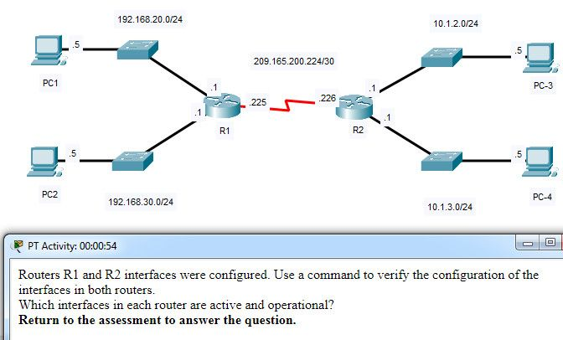

CCNA 1 v7.0 Modules 8 – 10 Exam Answers p77

Which interfaces in each router are active and operational?

R1: G0/0 and S0/0/1  
R2: G0/1 and S0/0/1

R1: G0/1 and S0/0/1  
R2: G0/0 and S0/0/1

R1: G0/0 and S0/0/0  
R2: G0/1 and S0/0/0

R1: G0/0 and S0/0/0  
R2: G0/0 and S0/0/0

CCNA1 v7 – ITN – Modules 8 – 10: Communicating Between Networks Exam Answers (Additional)

1. Which information is used by routers to forward a data packet toward its destination?

source IP address  
destination IP address  
source data-link address  
destination data-link address

2. A computer has to send a packet to a destination host in the same LAN. How will the packet be sent?

The packet will be sent to the default gateway first, and then, depending on the response from the gateway, it may be sent to the destination host.  
The packet will be sent directly to the destination host.  
The packet will first be sent to the default gateway, and then from the default gateway it will be sent directly to the destination host.  
The packet will be sent only to the default gateway.

3. A router receives a packet from the Gigabit 0/0 interface and determines that the packet needs to be forwarded out the Gigabit 0/1 interface. What will the router do next?

route the packet out the Gigabit 0/1 interface  
create a new Layer 2 Ethernet frame to be sent to the destination  
look into the ARP cache to determine the destination IP address  
look into the routing table to determine if the destination network is in the routing table

4. Which IPv4 address can a host use to ping the loopback interface?

126.0.0.1  
127.0.0.0  
126.0.0.0  
127.0.0.1

5. When a connectionless protocol is in use at a lower layer of the OSI model, how is missing data detected and retransmitted if necessary?

Connectionless acknowledgements are used to request retransmission.  
Upper-layer connection-oriented protocols keep track of the data received and can request retransmission from the upper-level protocols on the sending host.  
Network layer IP protocols manage the communication sessions if connection-oriented transport services are not available.  
The best-effort delivery process guarantees that all packets that are sent are received.

6. What was the reason for the creation and implementation of IPv6?

to make reading a 32-bit address easier  
to relieve IPv4 address depletion  
to provide more address space in the Internet Names Registry  
to allow NAT support for private addressing

7. Which statement accurately describes a characteristic of IPv4?

All IPv4 addresses are assignable to hosts.​  
IPv4 has a 32-bit address space.​  
An IPv4 header has fewer fields than an IPv6 header has.​  
IPv4 natively supports IPsec.​

8. Which field in an IPv4 packet header will typically stay the same during its transmission?

Flag  
Time-to-Live  
Packet Length  
Destination Address

9. When a router receives a packet, what information must be examined in order for the packet to be forwarded to a remote destination?

destination MAC address  
source IP address  
destination IP address  
source MAC address

10. Which field in an IPv6 packet is used by the router to determine if a packet has expired and should be dropped?

TTL  
Hop Limit  
Address Unreachable  
No Route to Destination

11. Which command can be used on a Windows host to display the routing table?

netstat –s  
show ip route  
netstat –r  
tracert

12. What information is added during encapsulation at OSI Layer 3?

source and destination MAC  
source and destination application protocol  
source and destination port number  
source and destination IP address

13. How does the network layer use the MTU value?

The network layer depends on the higher level layers to determine the MTU.  
The network layer depends on the data link layer to set the MTU, and adjusts the speed of transmission to accommodate it.  
The MTU is passed to the network layer by the data link layer.  
To increase speed of delivery, the network layer ignores the MTU.

14. Which characteristic describes an IPv6 enhancement over IPv4?​

IPv6 addresses are based on 128-bit flat addressing as opposed to IPv4 which is based on 32-bit hierarchical addressing.  
The IPv6 header is simpler than the IPv4 header is, which improves packet handling.  
Both IPv4 and IPv6 support authentication, but only IPv6 supports privacy capabilities.  
The IPv6 address space is four times bigger than the IPv4 address space.​

15. When an IP packet is sent to a host on a remote network, what information is provided by ARP?

the IP address of the destination host  
the IP address of the default gateway  
the MAC address of the router interface closest to the sending host  
the MAC address of the switch port that connects to the sending host

16. How does the ARP process use an IP address?

to determine the MAC address of the remote destination host  
to determine the MAC address of a device on the same network  
to determine the amount of time a packet takes when traveling from source to destination  
to determine the network number based on the number of bits in the IP address

17. The ARP table in a switch maps which two types of address together?

Layer 3 address to a Layer 2 address  
Layer 3 address to a Layer 4 address  
Layer 4 address to a Layer 2 address  
Layer 2 address to a Layer 4 address

18. What is one function of the ARP protocol?

obtaining an IPv4 address automatically  
mapping a domain name to its IP address  
resolving an IPv4 address to a MAC address  
maintaining a table of domain names with their resolved IP addresses

19. Which router component holds the routing table, ARP cache, and running configuration file?

RAM  
Flash  
NVRAM  
ROM

20. What type of information is contained in an ARP table?

switch ports associated with destination MAC addresses  
domain name to IP address mappings  
routes to reach destination networks  
IP address to MAC address mappings

21. A PC is configured to obtain an IP address automatically from network 192.168.1.0/24. The network administrator issues the arp –a command and notices an entry of 192.168.1.255 ff-ff-ff-ff-ff-ff. Which statement describes this entry?

This is a static map entry.  
This is a dynamic map entry.  
This entry refers to the PC itself.  
This entry maps to the default gateway.

22. A cybersecurity analyst believes an attacker is spoofing the MAC address of the default gateway to perform a man-in-the-middle attack. Which command should the analyst use to view the MAC address a host is using to reach the default gateway?

ipconfig /all  
route print  
netstat -r  
arp –a

23. What is a function of ARP?

resolving MAC addresses to IPv4 addresses  
resolving port addresses to MAC addresses  
resolving MAC addresses to port addresses  
resolving IPv4 addresses to MAC addresses

24. What is the purpose of ARP in an IPv4 network?

to forward data onward based on the destination IP address  
to obtain a specific MAC address when an IP address is known  
to forward data onward based on the destination MAC address.  
to build the MAC address table in a switch from the information that is gathered

25. Which action is taken by a Layer 2 switch when it receives a Layer 2 broadcast frame?

It drops the frame.  
It sends the frame to all ports except the port on which it received the frame.  
It sends the frame to all ports that are registered to forward broadcasts.  
It sends the frame to all ports.

26. Which destination address is used in an ARP request frame?

0.0.0.0  
255.255.255.255  
FFFF.FFFF.FFFF  
127.0.0.1  
01-00-5E-00-AA-23

27. What addresses are mapped by ARP?

destination MAC address to a destination IPv4 address  
destination IPv4 address to the source MAC address  
destination IPv4 address to the destination host name  
destination MAC address to the source IPv4 address

28. What will a Layer 2 switch do when the destination MAC address of a received frame is not in the MAC table?

It initiates an ARP request.  
It broadcasts the frame out of all ports on the switch.  
It notifies the sending host that the frame cannot be delivered.  
It forwards the frame out of all ports except for the port at which the frame was received.

29. Which two ICMPv6 messages are used during the Ethernet MAC address resolution process? (Choose two.)

router solicitation  
router advertisement  
neighbor solicitation  
neighbor advertisement  
echo request

30. A router boots and enters setup mode. What is the reason for this?

The IOS image is corrupt.  
Cisco IOS is missing from flash memory.  
The configuration file is missing from NVRAM.  
The POST process has detected hardware failure.

31. Which command is used to encrypt all passwords in a router configuration file?

Router_A (config) # enable secret  
Router_A (config) # service password-encryption  
Router_A (config) # enable password  
Router_A (config) # encrypt password

32. Company policy requires using the most secure method to safeguard access to the privileged exec and configuration mode on the routers. The privileged exec password is trustknow1. Which of the following router commands achieves the goal of providing the highest level of security?

secret password trustknow1  
enable password trustknow1  
service password-encryption  
enable secret trustknow1

33. What will be the response from the router after the command, “router(config)# hostname portsmouth” is entered?

portsmouth#  
portsmouth(config)#  
invalid input detected  
router(config-host)#  
hostname = portsmouth  
portsmouth#  
? command not recognized  
router(config)#

34. An administrator is configuring a new router to permit out-of-band management access. Which set of commands will allow the required login using a password of cisco?

Router(config)# line vty 0 4  
Router(config-line)# password manage  
Router(config-line)# exit  
Router(config)# enable password cisco

Router(config)# line vty 0 4  
Router(config-line)# password cisco  
Router(config-line)# login

Router(config)# line console 0  
Router(config-line)# password cisco  
Router(config-line)# login

Router(config)# line console 0  
Router(config-line)# password cisco  
Router(config-line)# exit  
Router(config)# service password-encryption

35. Which command can be used on a Cisco router to display all interfaces, the IPv4 address assigned, and the current status?

show ip interface brief  
ping  
show ip route  
show interface fa0/1

36. Which CLI mode allows users to access all device commands, such as those used for configuration, management, and troubleshooting?

user EXEC mode  
privileged EXEC mode  
global configuration mode  
interface configuration mode

37. What is the purpose of the startup configuration file on a Cisco router?

to facilitate the basic operation of the hardware components of a device  
to contain the commands that are used to initially configure a router on startup  
to contain the configuration commands that the router IOS is currently using  
to provide a limited backup version of the IOS, in case the router cannot load the full featured IOS

38. Which characteristic describes the default gateway of a host computer?

the logical address of the router interface on the same network as the host computer  
the physical address of the switch interface connected to the host computer  
the physical address of the router interface on the same network as the host computer  
the logical address assigned to the switch interface connected to the router

39. What is the purpose of the banner motd command?

It configures a message that will identify printed documents to LAN users.  
It is a way that routers communicate the status of their links with one another.  
It provides an easy way of communicating with any user attached to a router’s LANs.  
It provides a way to make announcements to those who log in to a router.

40. A technician is configuring a router to allow for all forms of management access. As part of each different type of access, the technician is trying to type the command login. Which configuration mode should be entered to do this task?

user executive mode  
global configuration mode  
any line configuration mode  
privileged EXEC mode

41. What is stored in the NVRAM of a Cisco router?

the Cisco IOS  
the running configuration  
the bootup instructions  
the startup configuration

42. Which statement regarding the service password-encryption command is true?

It is configured in privileged EXEC mode.  
It encrypts only line mode passwords.  
As soon as the service password-encryption command is entered, all currently set passwords formerly displayed in plain text are encrypted.  
To see the passwords encrypted by the service password-encryption command in plain text, issue the no service password-encryption command.

. What is the prefix length notation for the subnet mask 255.255.255.224?

/25  
/26  
/27  
/28

Explanation: The binary format for 255.255.255.224 is 11111111.11111111.11111111.11100000. The prefix length is the number of consecutive 1s in the subnet mask. Therefore, the prefix length is /27.

2. How many valid host addresses are available on an IPv4 subnet that is configured with a /26 mask?

254  
190  
192  
62  
64

3. Which subnet mask would be used if 5 host bits are available?

255.255.255.0  
255.255.255.128  
255.255.255.224​  
255.255.255.240

4. A network administrator subnets the 192.168.10.0/24 network into subnets with /26 masks. How many equal-sized subnets are created?

1  
2  
4  
8  
16  
64

5. Match the subnetwork to a host address that would be included within the subnetwork. (Not all options are used.)

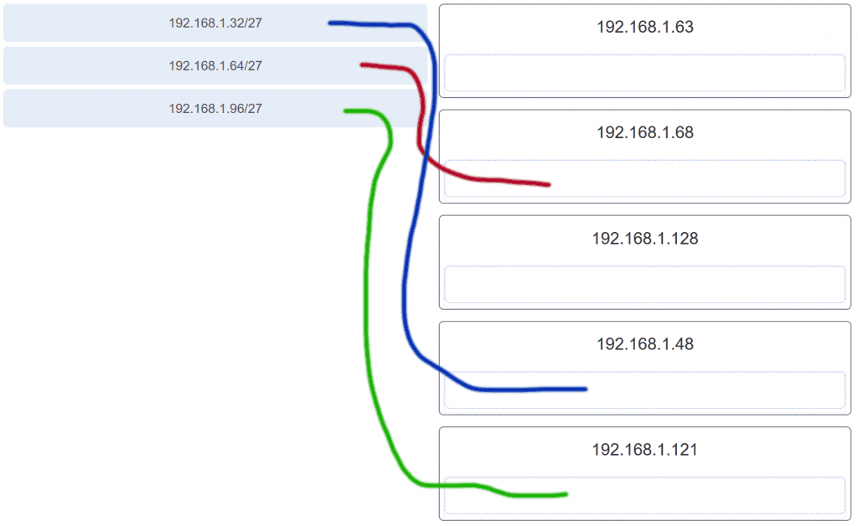

6. An administrator wants to create four subnetworks from the network address 192.168.1.0/24. What is the network address and subnet mask of the second useable subnet?

subnetwork 192.168.1.64  
subnet mask 255.255.255.192

subnetwork 192.168.1.32  
subnet mask 255.255.255.240

subnetwork 192.168.1.64  
subnet mask 255.255.255.240

subnetwork 192.168.1.128  
subnet mask 255.255.255.192

subnetwork 192.168.1.8  
subnet mask 255.255.255.224

7. How many bits must be borrowed from the host portion of an address to accommodate a router with five connected networks?

two  
three  
four  
five

Explanation: Each network that is directly connected to an interface on a router requires its own subnet. The formula 2n, where n is the number of bits borrowed, is used to calculate the available number of subnets when borrowing a specific number of bits.

8. How many host addresses are available on the 192.168.10.128/26 network?

30  
32  
60  
62  
64

Explanation: A /26 prefix gives 6 host bits, which provides a total of 64 addresses, because 26 = 64. Subtracting the network and broadcast addresses leaves 62 usable host addresses.

9. How many host addresses are available on the network 172.16.128.0 with a subnet mask of 255.255.252.0?

510  
512  
1022  
1024  
2046  
2048

Explanation: A mask of 255.255.252.0 is equal to a prefix of /22. A /22 prefix provides 22 bits for the network portion and leaves 10 bits for the host portion. The 10 bits in the host portion will provide 1022 usable IP addresses (210 – 2 = 1022).

10. Match each IPv4 address to the appropriate address category. (Not all options are used.)

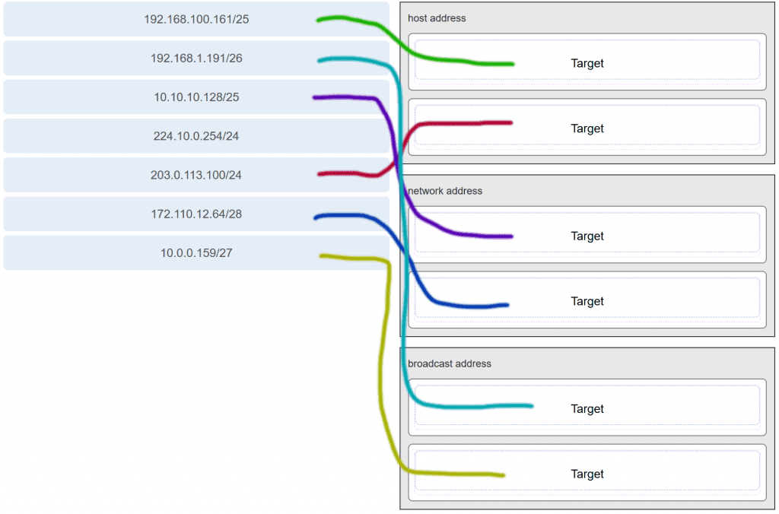

11. What three blocks of addresses are defined by RFC 1918 for private network use? (Choose three.)

10.0.0.0/8  
172.16.0.0/12  
192.168.0.0/16  
100.64.0.0/14  
169.254.0.0/16  
239.0.0.0/8

Explanation: RFC 1918, Address Allocation for Private Internets, defines three blocks of IPv4 address for private networks that should not be routable on the public Internet.  
10.0.0.0/8  
172.16.0.0/12  
192.168.0.0/16

12. Refer to the exhibit.

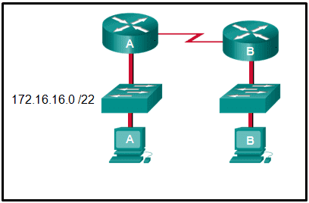

An administrator must send a message to everyone on the router A network. What is the broadcast address for network 172.16.16.0/22?

172.16.16.255  
172.16.20.255  
172.16.19.255  
172.16.23.255  
172.16.255.255

Explanation: The 172.16.16.0/22 network has 22 bits in the network portion and 10 bits in the host portion. Converting the network address to binary yields a subnet mask of 255.255.252.0. The range of addresses in this network will end with the last address available before 172.16.20.0. Valid host addresses for this network range from 172.16.16.1-172.16.19.254, making 172.16.19.255 the broadcast address.

13. A site administrator has been told that a particular network at the site must accommodate 126 hosts. Which subnet mask would be used that contains the required number of host bits?

255.255.255.0  
255.255.255.128  
255.255.255.224  
255.255.255.240

Explanation: The subnet mask of 255.255.255.0 has 8 host bits. The mask of 255.255.255.128 results in 7 host bits. The mask of 255.255.255.224 has 5 host bits. Finally, 255.255.255.240 represents 4 host bits.

14. Refer to the exhibit.

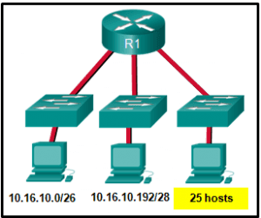

Considering the addresses already used and having to remain within the 10.16.10.0/24 network range, which subnet address could be assigned to the network containing 25 hosts?

10.16.10.160/26  
10.16.10.128/28  
10.16.10.64/27  
10.16.10.224/26  
10.16.10.240/27  
10.16.10.240/28

Explanation: Addresses 10.16.10.0 through 10.16.10.63 are taken for the leftmost network. Addresses 10.16.10.192 through 10.16.10.207 are used by the center network.The address space from 208-255 assumes a /28 mask, which does not allow enough host bits to accommodate 25 host addresses.The address ranges that are available include 10.16.10.64/26 and10.16.10.128/26. To accommodate 25 hosts, 5 host bits are needed, so a /27 mask is necessary. Four possible /27 subnets could be created from the available addresses between 10.16.10.64 and 10.16.10.191:  
10.16.10.64/27  
10.16.10.96/27  
10.16.10.128/27  
10.16.10.160/27

15. What is the usable number of host IP addresses on a network that has a /26 mask?

256  
254  
64  
62  
32  
16

Explanation: A /26 mask is the same as 255.255.255.192. The mask leaves 6 host bits. With 6 host bits, 64 IP addresses are possible. One address represents the subnet number and one address represents the broadcast address, which means that 62 addresses can then be used to assign to network devices.

16. Which address prefix range is reserved for IPv4 multicast?

240.0.0.0 – 254.255.255.255  
224.0.0.0 – 239.255.255.255  
169.254.0.0 – 169.254.255.255  
127.0.0.0 – 127.255.255.255

17. Refer to the exhibit.

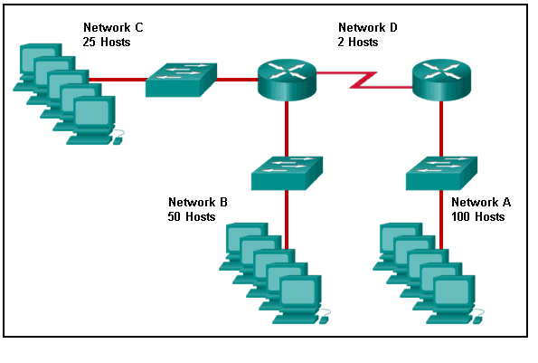

Match the network with the correct IP address and prefix that will satisfy the usable host addressing requirements for each network.

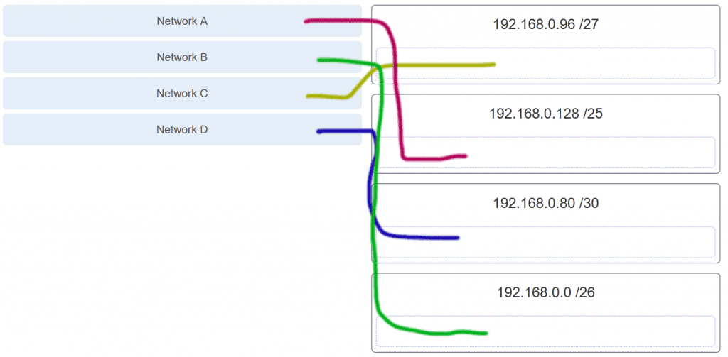

Explanation: Network A needs to use 192.168.0.128 /25, which yields 128 host addresses.  
Network B needs to use 192.168.0.0 /26, which yields 64 host addresses.  
Network C needs to use 192.168.0.96 /27, which yields 32 host addresses.  
Network D needs to use 192.168.0.80/30, which yields 4 host addresses.

18. A high school in New York (school A) is using videoconferencing technology to establish student interactions with another high school (school B) in Russia. The videoconferencing is conducted between two end devices through the Internet. The network administrator of school A configures the end device with the IP address 209.165.201.10. The administrator sends a request for the IP address for the end device in school B and the response is 192.168.25.10. Neither school is using a VPN. The administrator knows immediately that this IP will not work. Why?

This is a loopback address.  
This is a link-local address.  
This is a private IP address.  
There is an IP address conflict.

19. Which three addresses are valid public addresses? (Choose three.)

198.133.219.17  
192.168.1.245  
10.15.250.5  
128.107.12.117  
172.31.1.25  
64.104.78.227

Explanation: The ranges of private IPv4 addresses are as folllows:  
10.0.0.0 – 10.255.255.255  
172.16.0.0 – 172.31.255.255  
192.168.0.0 – 192.168.255.255

20. A message is sent to all hosts on a remote network. Which type of message is it?

limited broadcast  
multicast  
directed broadcast  
unicast

Explanation: A directed broadcast is a message sent to all hosts on a specific network. It is useful for sending a broadcast to all hosts on a nonlocal network. A multicast message is a message sent to a selected group of hosts that are part of a subscribing multicast group. A limited broadcast is used for a communication that is limited to the hosts on the local network. A unicast message is a message sent from one host to another.

21. A company has a network address of 192.168.1.64 with a subnet mask of 255.255.255.192. The company wants to create two subnetworks that would contain 10 hosts and 18 hosts respectively. Which two networks would achieve that? (Choose two.)

192.168.1.16/28  
192.168.1.64/27  
192.168.1.128/27  
192.168.1.96/28  
192.168.1.192/28

22. Which address is a valid IPv6 link-local unicast address?

FEC8:1::FFFF  
FD80::1:1234  
FE80::1:4545:6578:ABC1  
FE0A::100:7788:998F  
FC90:5678:4251:FFFF

Explanation: IPv6 LLAs are in the fe80::/10 range. The /10 indicates that the first 10 bits are 1111 1110 10xx xxxx. The first hextet has a range of 1111 1110 1000 0000 (fe80) to 1111 1110 1011 1111 (febf).

23. Which of these addresses is the shortest abbreviation for the IP address:  
3FFE:1044:0000:0000:00AB:0000:0000:0057?

3FFE:1044::AB::57  
3FFE:1044::00AB::0057  
3FFE:1044:0:0:AB::57  
3FFE:1044:0:0:00AB::0057  
3FFE:1044:0000:0000:00AB::57  
3FFE:1044:0000:0000:00AB::0057

Explanation: The rules for reducing the notation of IPv6 addresses are:  
1. Omit any leading 0s (zeros) in any hextet.  
2. Replace any single, contiguous string of one or more 16-bit hextets consisting of all zeros with a double colon (::) .  
3. The double colon (::) can only be used once within an address.

24. A network administrator has received the IPv6 prefix 2001:DB8::/48 for subnetting. Assuming the administrator does not subnet into the interface ID portion of the address space, how many subnets can the administrator create from the /48 prefix?

16  
256  
4096  
65536

Explanation: With a network prefix of 48, there will be 16 bits available for subnetting because the interface ID starts at bit 64. Sixteen bits will yield 65536 subnets.

25. Given IPv6 address prefix 2001:db8::/48, what will be the last subnet that is created if the subnet prefix is changed to /52?

2001:db8:0:f00::/52  
2001:db8:0:8000::/52  
2001:db8:0:f::/52  
2001:db8:0:f000::/52

Explanation: Prefix 2001:db8::/48 has 48 network bits. If we subnet to a /52, we are moving the network boundary four bits to the right and creating 16 subnets. The first subnet is 2001:db8::/52 the last subnet is 2001:db8:0:f000::/52.

26. Consider the following range of addresses:

2001:0DB8:BC15:00A0:0000::  
2001:0DB8:BC15:00A1:0000::  
2001:0DB8:BC15:00A2:0000::  
…  
2001:0DB8:BC15:00AF:0000::  
The prefix-length for the range of addresses is   /60 .

Explanation: All the addresses have the part 2001:0DB8:BC15:00A in common. Each number or letter in the address represents 4 bits, so the prefix-length is /60.

27. What type of IPv6 address is FE80::1?

loopback  
link-local  
multicast  
global unicast

28. Refer to the exhibit.

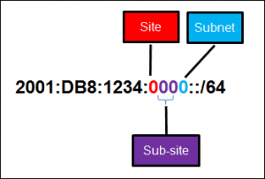

A company is deploying an IPv6 addressing scheme for its network. The company design document indicates that the subnet portion of the IPv6 addresses is used for the new hierarchical network design, with the site subsection to represent multiple geographical sites of the company, the sub-site section to represent multiple campuses at each site, and the subnet section to indicate each network segment separated by routers. With such a scheme, what is the maximum number of subnets achieved per sub-site?

0  
4  
16  
256

Explanation: Because only one hexadecimal character is used to represent the subnet, that one character can represent 16 different values 0 through F.

29. What is used in the EUI-64 process to create an IPv6 interface ID on an IPv6 enabled interface?

the MAC address of the IPv6 enabled interface  
a randomly generated 64-bit hexadecimal address  
an IPv6 address that is provided by a DHCPv6 server  
an IPv4 address that is configured on the interface

Explanation: The EUI-64 process uses the MAC address of an interface to construct an interface ID (IID). Because the MAC address is only 48 bits in length, 16 additional bits (FF:FE) must be added to the MAC address to create the full 64-bit interface ID.

30. What is the prefix for the host address 2001:DB8:BC15:A:12AB::1/64?

2001:DB8:BC15  
2001:DB8:BC15:A  
2001:DB8:BC15:A:1  
2001:DB8:BC15:A:12

31. An IPv6 enabled device sends a data packet with the destination address of FF02::1. What is the target of this packet?​

the one IPv6 device on the link that has been uniquely configured with this address  
all IPv6 enabled devices on the local link​ or network  
only IPv6 DHCP servers​  
only IPv6 configured routers

32. Match the IPv6 address with the IPv6 address type. (Not all options are used.)

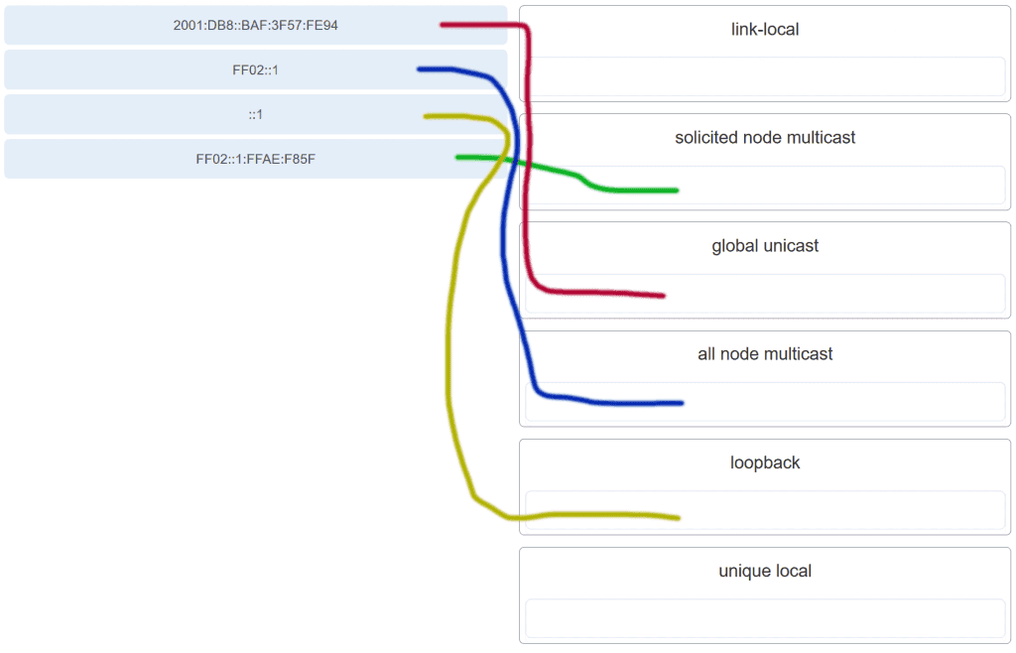

Explanation: FF02::1:FFAE:F85F is a solicited node multicast address.  
2001:DB8::BAF:3F57:FE94 is a global unicast address.  
FF02::1 is the all node multicast address. Packets sent to this address will be received by all IPv6 hosts on the local link.  
::1 is the IPv6 loopback address.  
There are no examples of link local or unique local addresses provided.

33. Which IPv6 prefix is reserved for communication between devices on the same link?

FC00::/7  
2001::/32  
FE80::/10  
FDFF::/7

Explanation: IPv6 link-local unicast addresses are in the FE80::/10 prefix range and are not routable. They are used only for communications between devices on the same link.

34. Which type of IPv6 address refers to any unicast address that is assigned to multiple hosts?

unique local  
global unicast  
link-local  
anycast

35. What are two types of IPv6 unicast addresses? (Choose two.)

multicast  
loopback  
link-local  
anycast  
broadcast

Explanation: Multicast, anycast, and unicast are types of IPv6 addresses. There is no broadcast address in IPv6. Loopback and link-local are specific types of unicast addresses.

36. Which service provides dynamic global IPv6 addressing to end devices without using a server that keeps a record of available IPv6 addresses?

stateful DHCPv6  
SLAAC  
static IPv6 addressing  
stateless DHCPv6

Explanation: Using stateless address autoconfiguration (SLAAC), a PC can solicit a router and receive the prefix length of the network. From this information the PC can then create its own IPv6 global unicast address.

37. Which protocol supports Stateless Address Autoconfiguration (SLAAC) for dynamic assignment of IPv6 addresses to a host?

ARPv6  
DHCPv6  
ICMPv6  
UDP

Explanation: SLAAC uses ICMPv6 messages when dynamically assigning an IPv6 address to a host. DHCPv6 is an alternate method of assigning an IPv6 addresses to a host. ARPv6 does not exist. Neighbor Discovery Protocol (NDP) provides the functionality of ARP for IPv6 networks. UDP is the transport layer protocol used by DHCPv6.

38. Three methods allow IPv6 and IPv4 to co-exist. Match each method with its description. (Not all options are used.)

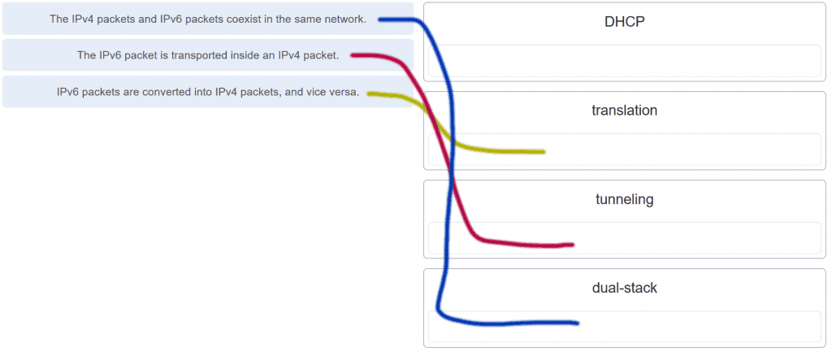

39. A technician uses the ping 127.0.0.1 command. What is the technician testing?

the TCP/IP stack on a network host  
connectivity between two adjacent Cisco devices  
connectivity between a PC and the default gateway  
connectivity between two PCs on the same network  
physical connectivity of a particular PC and the network

40. Refer to the exhibit.

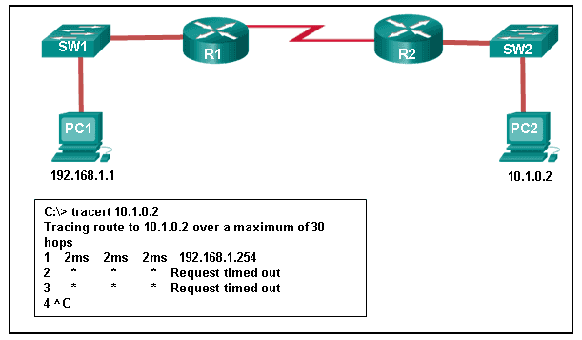

An administrator is trying to troubleshoot connectivity between PC1 and PC2 and uses the tracert command from PC1 to do it. Based on the displayed output, where should the administrator begin troubleshooting?

PC2  
R1  
SW2  
R2  
SW1

41. Which protocol is used by the traceroute command to send and receive echo-requests and echo-replies?

SNMP  
ICMP  
Telnet  
TCP

Explanation: Traceroute uses the ICMP (Internet Control Message Protocol) to send and receive echo-request and echo-reply messages.

42. Which ICMPv6 message is sent when the IPv6 hop limit field of a packet is decremented to zero and the packet cannot be forwarded?

network unreachable  
time exceded  
protocol unreachable  
port unreachable

43. A user executes a traceroute over IPv6. At what point would a router in the path to the destination device drop the packet?

when the value of the Hop Limit field reaches 255  
when the value of the Hop Limit field reaches zero  
when the router receives an ICMP time exceeded message  
when the target host responds with an ICMP echo reply message

44. What is the purpose of ICMP messages?

to inform routers about network topology changes  
to ensure the delivery of an IP packet  
to provide feedback of IP packet transmissions  
to monitor the process of a domain name to IP address resolution

Explanation: The purpose of ICMP messages is to provide feedback about issues that are related to the processing of IP packets.

45. What source IP address does a router use by default when the traceroute command is issued?

the highest configured IP address on the router  
a loopback IP address  
the IP address of the outbound interface  
the lowest configured IP address on the router

Explanation: When sending an echo request message, a router will use the IP address of the exit interface as the source IP address. This default behavior can be changed by using an extended ping and specifying a specific source IP address.

46. Match each description with an appropriate IP address. (Not all options are used.)

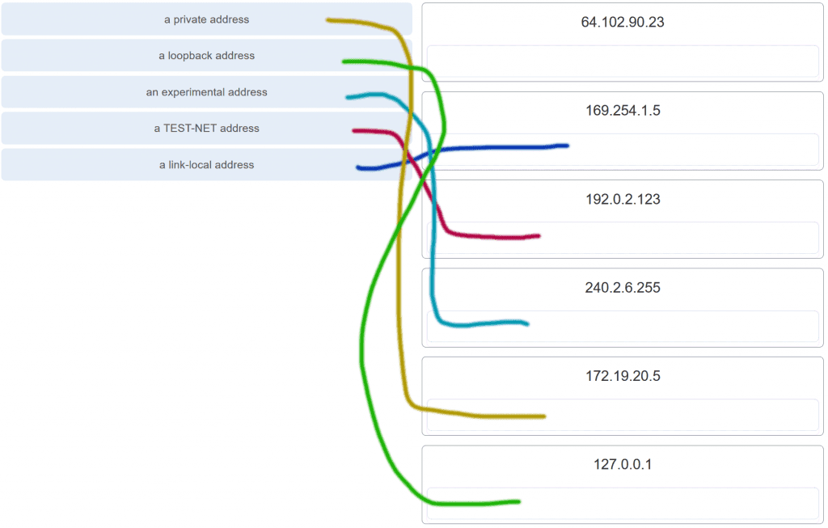

Explanation: Link-Local addresses are assigned automatically by the OS environment and are located in the block 169.254.0.0/16. The private addresses ranges are 10.0.0.0/8, 172.16.0.0/12, and 192.168.0.0/16. TEST-NET addresses belong to the range 192.0.2.0/24. The addresses in the block 240.0.0.0 to 255.255.255.254 are reserved as experimental addresses. Loopback addresses belong to the block 127.0.0.0/8.

47. A user issues a ping 192.135.250.103 command and receives a response that includes a code of 1. What does this code represent?

host unreachable  
protocol unreachable  
port unreachable  
network unreachable

48. Which subnet would include the address 192.168.1.96 as a usable host address?

192.168.1.64/26  
192.168.1.32/27  
192.168.1.32/28  
192.168.1.64/29

Explanation: For the subnet of 192.168.1.64/26, there are 6 bits for host addresses, yielding 64 possible addresses. However, the first and last subnets are the network and broadcast addresses for this subnet. Therefore, the range of host addresses for this subnet is 192.168.1.65 to 192.168.1.126. The other subnets do not contain the address 192.168.1.96 as a valid host address.

49. Open the PT Activity. Perform the tasks in the activity instructions and then answer the question.

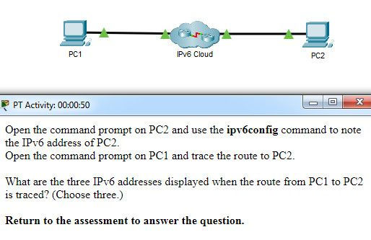

What are the three IPv6 addresses displayed when the route from PC1 to PC2 is traced? (Choose three.)

2001:DB8:1:1::1  
2001:DB8:1:1::A  
2001:DB8:1:2::2  
2001:DB8:1:2::1  
2001:DB8:1:3::1  
2001:DB8:1:3::2  
2001:DB8:1:4::1

Explanation: Using the ipv6config command on PC2 displays the IPv6 address of PC2, which is 2001:DB8:1:4::A. The IPV6 link-local address, FE80::260:70FF:FE34:6930, is not used in route tracing. Using the tracert 2001:DB8:1:4::A command on PC1 displays four addresses: 2001:DB8:1:1::1, 2001:DB8:1:2::1 , 2001:DB8:1:3::2, and 2001:DB8:1:4::A.

50. A host is transmitting a broadcast. Which host or hosts will receive it?

all hosts in the same subnet  
a specially defined group of hosts  
the closest neighbor on the same network  
all hosts on the Internet

51. A host is transmitting a unicast. Which host or hosts will receive it?

one specific host  
a specially defined group of hosts  
all hosts on the Internet  
the closest neighbor on the same network

52. A user issues a ping 2001:db8:FACE:39::10 command and receives a response that includes a code of 3. What does this code represent?

address unreachable  
network unreachable  
host unreachable  
protocol unreachable

53. A host is transmitting a multicast. Which host or hosts will receive it?

a specially defined group of hosts  
one specific host  
all hosts with the same IP address  
the closest neighbor on the same network

54. A host is transmitting a multicast. Which host or hosts will receive it?

a specially defined group of hosts  
one specific host  
directly connected network devices  
the closest neighbor on the same network

55. A host is transmitting a multicast. Which host or hosts will receive it?

a specially defined group of hosts  
one specific host  
all hosts with the same IP address  
all hosts on the Internet

56. A host is transmitting a multicast. Which host or hosts will receive it?

a specially defined group of hosts  
one specific host  
directly connected network devices  
all hosts on the Internet

57. A host is transmitting a multicast. Which host or hosts will receive it?

a specially defined group of hosts  
all hosts in the same subnet  
directly connected network devices  
the closest neighbor on the same network

58. A host is transmitting a broadcast. Which host or hosts will receive it?

all hosts in the same subnet  
one specific host  
the closest neighbor on the same network  
directly connected network devices

59. A host is transmitting a broadcast. Which host or hosts will receive it?

all hosts in the same subnet  
one specific host  
all hosts on the Internet  
directly connected network devices

60. Which is the compressed format of the IPv6 address 2001:0db8:0000:0000:0000:a0b0:0008:0001?

2001:db8::a0b0:8:1  
2001:db8::ab8:1:0:1000  
2001:db80:0:1::80:1  
2001:db80:::1::80:1

61. Which is the compressed format of the IPv6 address fe80:09ea:0000:2200:0000:0000:0fe0:0290?

fe80:9ea:0:2200::fe0:290  
fe80:9:20::b000:290  
fe80:9ea0::2020:0:bf:e0:9290  
fe80:9ea0::2020::bf:e0:9290

62. Which is the compressed format of the IPv6 address 2002:0042:0010:c400:0000:0000:0000:0909?

2002:42:10:c400::909  
200:420:110:c4b::910:0:90  
2002:4200::25:1090:0:99  
2002:42::25:1090:0:99

63. Which is the compressed format of the IPv6 address 2001:0db8:0000:0000:0ab8:0001:0000:1000?

2001:db8::ab8:1:0:1000  
2001:db8::a0b0:8:1  
2001:db8:1::ab8:0:1  
2001:db8:0:1::8:1

64. Which is the compressed format of the IPv6 address 2002:0420:00c4:1008:0025:0190:0000:0990?

2002:420:c4:1008:25:190::990  
2002:42:10:c400::909  
2002:4200::25:1090:0:99  
2002:42::25:1090:0:99

65. Which is the compressed format of the IPv6 address 2001:0db8:0000:0000:0000:a0b0:0008:0001?

2001:db8::a0b0:8:1  
2001:db8:1::ab8:0:1  
2001:db8::ab8:1:0:1000  
2001:db8:0:1::8:1

66. Which is the compressed format of the IPv6 address fe80:0000:0000:0000:0220:0b3f:f0e0:0029?

fe80::220:b3f:f0e0:29  
fe80:9ea:0:2200::fe0:290  
fe80:9ea0::2020:0:bf:e0:9290  
fe80:9ea0::2020::bf:e0:9290

67. Which is the compressed format of the IPv6 address 2001:0db8:0000:0000:0000:a0b0:0008:0001?

2001:db8::a0b0:8:1  
2001:db8::ab8:1:0:1000  
2001:db80:0:1::80:1  
2001:db8:0:1::8:1

68. Which is the compressed format of the IPv6 address 2002:0042:0010:c400:0000:0000:0000:0909?

2002:42:10:c400::909  
2002:4200::25:1090:0:99  
2002:420:c4:1008:25:190::990  
2002:42::25:1090:0:99

69. Which is the compressed format of the IPv6 address fe80:09ea:0000:2200:0000:0000:0fe0:0290?

fe80:9ea:0:2200::fe0:290  
fe80:9ea0::2020:0:bf:e0:9290  
fe80::220:b3f:f0e0:29  
fe80::0220:0b3f:f0e0:0029

70. A user issues a ping 2001:db8:FACE:39::10 command and receives a response that includes a code of 2 . What does this code represent?

beyond scope of the source address  
communication with the destination administratively prohibited  
address unreachable  
no route to destination

71. A user issues a ping 192.135.250.103 command and receives a response that includes a code of 1. What does this code represent?

host unreachable  
beyond scope of the source address  
address unreachable  
communication with the destination administratively prohibited

72. A user issues a ping fe80:65ab:dcc1::100 command and receives a response that includes a code of 3. What does this code represent?

address unreachable  
communication with the destination administratively prohibited  
beyond scope of the source address  
no route to destination

73. A user issues a ping 10.10.14.67 command and receives a response that includes a code of 0. What does this code represent?

network unreachable  
protocol unreachable  
port unreachable  
host unreachable

74. A user issues a ping fe80:65ab:dcc1::100 command and receives a response that includes a code of 4. What does this code represent?

port unreachable  
host unreachable  
protocol unreachable  
network unreachable

75. A user issues a ping 198.133.219.8 command and receives a response that includes a code of 0. What does this code represent?

network unreachable  
protocol unreachable  
port unreachable  
host unreachable

76. A user issues a ping 2001:db8:3040:114::88 command and receives a response that includes a code of 4. What does this code represent?

port unreachable  
host unreachable  
protocol unreachable  
network unreachable

77. A user issues a ping 2001:db8:FACE:39::10 command and receives a response that includes a code of 2. What does this code represent?

beyond scope of the source address  
host unreachable  
protocol unreachable  
network unreachable

Modules 11 – 13: IP Addressing Exam Answers (Additional)

1. What is the prefix length notation for the subnet mask 255.255.255.224?

/25  
/26  
/27  
/28

2. How many valid host addresses are available on an IPv4 subnet that is configured with a /26 mask?

254  
190  
192  
62  
64

3. Which subnet mask would be used if 5 host bits are available?

255.255.255.0  
255.255.255.128  
255.255.255.224​  
255.255.255.240

4. A network administrator subnets the 192.168.10.0/24 network into subnets with /26 masks. How many equal-sized subnets are created?

1  
2  
4  
8  
16  
64

5. What subnet mask is represented by the slash notation /20?

255.255.255.248  
255.255.224.0  
255.255.240.0  
255.255.255.0  
255.255.255.192

6. Which statement is true about variable-length subnet masking?

Each subnet is the same size.  
The size of each subnet may be different, depending on requirements.  
Subnets may only be subnetted one additional time.  
Bits are returned, rather than borrowed, to create additional subnets.

7. Why does a Layer 3 device perform the ANDing process on a destination IP address and subnet mask?

to identify the broadcast address of the destination network  
to identify the host address of the destination host  
to identify faulty frames  
to identify the network address of the destination network

8. How many usable IP addresses are available on the 192.168.1.0/27 network?

256  
254  
62  
30  
16  
32

9. Which subnet mask would be used if exactly 4 host bits are available?

255.255.255.224  
255.255.255.128  
255.255.255.240  
255.255.255.248

10. Which two parts are components of an IPv4 address? (Choose two.)

subnet portion  
network portion  
logical portion  
host portion  
physical portion  
broadcast portion

11. If a network device has a mask of /26, how many IP addresses are available for hosts on this network?

64  
30  
62  
32  
16  
14

12. What does the IP address 172.17.4.250/24 represent?

network address  
multicast address  
host address  
broadcast address

13. If a network device has a mask of /28, how many IP addresses are available for hosts on this network?

256  
254  
62  
32  
16  
14

14. What is the purpose of the subnet mask in conjunction with an IP address?

to uniquely identify a host on a network  
to identify whether the address is public or private  
to determine the subnet to which the host belongs  
to mask the IP address to outsiders

15. A network administrator is variably subnetting a network. The smallest subnet has a mask of 255.255.255.224. How many usable host addresses will this subnet provide?​

2  
6  
14  
30  
62

16. What is indicated by a successful ping to the ::1 IPv6 address?

The host is cabled properly.  
The default gateway address is correctly configured.  
All hosts on the local link are available.  
The link-local address is correctly configured.  
IP is properly installed on the host.

17. What is the most compressed representation of the IPv6 address 2001:0000:0000:abcd:0000:0000:0000:0001?

2001:0:abcd::1  
2001:0:0:abcd::1  
2001::abcd::1  
2001:0000:abcd::1  
2001::abcd:0:1

18. What is the purpose of the command ping ::1?

It tests the internal configuration of an IPv6 host.  
It tests the broadcast capability of all hosts on the subnet.  
It tests the multicast connectivity to all hosts on the subnet.  
It tests the reachability of the default gateway for the network.

19. At a minimum, which address is required on IPv6-enabled interfaces?

link-local  
unique local  
site local  
global unicast

20. What is the interface ID of the IPv6 address 2001:DB8::1000:A9CD:47FF:FE57:FE94/64?

FE94  
FE57:FE94  
47FF:FE57:FE94  
A9CD:47FF:FE57:FE94  
1000:A9CD:47FF:FE57:FE94

21. What are three parts of an IPv6 global unicast address? (Choose three.)

an interface ID that is used to identify the local network for a particular host  
a global routing prefix that is used to identify the network portion of the address that has been provided by an ISP  
a subnet ID that is used to identify networks inside of the local enterprise site  
a global routing prefix that is used to identify the portion of the network address provided by a local administrator  
an interface ID that is used to identify the local host on the network

22. What is the valid most compressed format possible of the IPv6 address 2001:0DB8:0000:AB00:0000:0000:0000:1234?

2001:DB8:0:AB00::1234  
2001:DB8:0:AB::1234  
2001:DB8::AB00::1234  
2001:DB8:0:AB:0:1234

23. What is the prefix associated with the IPv6 address 2001:CA48:D15:EA:CC44::1/64?

2001::/64  
2001:CA48::/64​  
2001:CA48:D15:EA::/64​  
2001:CA48:D15:EA:CC44::/64​

24. What type of address is automatically assigned to an interface when IPv6 is enabled on that interface?

global unicast  
link-local  
loopback  
unique local

25. Which IPv6 network prefix is only intended for local links and can not be routed?

2001::/3  
FC00::/7  
FE80::/10  
FEC0::/10

26. Your organization is issued the IPv6 prefix of 2001:0000:130F::/48 by your service provider. With this prefix, how many bits are available for your organization to create subnetworks if interface ID bits are not borrowed?

8  
16  
80  
128

27. What is the subnet address for the IPv6 address 2001:D12:AA04:B5::1/64?

2001::/64  
2001:D12::/64​  
2001:D12:AA04::/64​  
2001:D12:AA04:B5::/64​

28. Which type of IPv6 address is not routable and used only for communication on a single subnet?

global unicast address  
link-local address  
loopback address  
unique local address  
unspecified address

29. Which address type is not supported in IPv6?

private  
multicast  
unicast  
broadcast

30. What is the minimum configuration for a router interface that is participating in IPv6 routing?

to have only a link-local IPv6 address  
to have both an IPv4 and an IPv6 address  
to have a self-generated loopback address  
to have both a link-local and a global unicast IPv6 address  
to have only an automatically generated multicast IPv6 address

31. A user calls to report that a PC cannot access the internet. The network technician asks the user to issue the command ping 127.0.0.1 in a command prompt window. The user reports that the result is four positive replies. What conclusion can be drawn based on this connectivity test?

The PC can access the network. The problem exists beyond the local network.  
The IP address obtained from the DHCP server is correct.  
The PC can access the Internet. However, the web browser may not work.  
The TCP/IP implementation is functional.

32. Which command can be used to test connectivity between two devices using echo request and echo reply messages?

netstat  
traceroute  
ICMP  
Ping

33. What field content is used by ICMPv6 to determine that a packet has expired?

TTL field  
CRC field  
Hop Limit field  
Time Exceeded field

34. Which protocol provides feedback from the destination host to the source host about errors in packet delivery?

ARP  
BOOTP  
DNS  
ICMP

35. Which utility uses the Internet Control Messaging Protocol (ICMP)?

RIP  
DNS  
Ping  
NTP

36. A network administrator can successfully ping the server at www.cisco.com, but cannot ping the company web server located at an ISP in another city. Which tool or command would help identify the specific router where the packet was lost or delayed?

ipconfig  
netstat  
telnet  
traceroute

37. Which protocol is used by IPv4 and IPv6 to provide error messaging?

ICMP  
NDP  
ARP  
DHCP

38. What message is sent by a host to check the uniqueness of an IPv6 address before using that address?

neighbor solicitation  
ARP request  
echo request  
router solicitation

39. A technician is troubleshooting a network where it is suspected that a defective node in the network path is causing packets to be dropped. The technician only has the IP address of the end point device and does not have any details of the intermediate devices. What command can the technician use to identify the faulty node?

Tracert  
ping  
ipconfig /flushdns  
ipconfig /displaydns

40. A user who is unable to connect to the file server contacts the help desk. The helpdesk technician asks the user to ping the IP address of the default gateway that is configured on the workstation. What is the purpose for this ping command?

to obtain a dynamic IP address from the server  
to request that gateway forward the connection request to the file server  
to test that the host has the capability to reach hosts on other networks  
to resolve the domain name of the file server to its IP address

41. What is a function of the tracert command that differs from the ping command when they are used on a workstation?

The tracert command reaches the destination faster.  
The tracert command shows the information of routers in the path.  
The tracert command sends one ICMP message to each hop in the path.  
The tracert command is used to test the connectivity between two devices.

42. Which ICMP message is used by the traceroute utility during the process of finding the path between two end hosts?

redirect  
ping  
time exceeded  
destination unreachable

43. Which two things can be determined by using the ping command? (Choose two.)

the number of routers between the source and destination device  
the IP address of the router nearest the destination device  
the average time it takes a packet to reach the destination and for the response to return to the source  
the destination device is reachable through the network  
the average time it takes each router in the path between source and destination to respond

44. Which statement describes a characteristic of the traceroute utility?

It sends four Echo Request messages.  
It utilizes the ICMP Source Quench messages.  
It is primarily used to test connectivity between two hosts.  
It identifies the routers in the path from a source host to a destination host.

. Which action is performed by a client when establishing communication with a server via the use of UDP at the transport layer?

The client sets the window size for the session.  
The client sends an ISN to the server to start the 3-way handshake.  
The client randomly selects a source port number.  
The client sends a synchronization segment to begin the session.

2. Which transport layer feature is used to guarantee session establishment?

UDP ACK flag  
TCP 3-way handshake  
UDP sequence number  
TCP port number

3. What is the complete range of TCP and UDP well-known ports?

0 to 255  
0 to 1023  
256 – 1023  
1024 – 49151

4. What is a socket?

the combination of the source and destination IP address and source and destination Ethernet address  
the combination of a source IP address and port number or a destination IP address and port number  
the combination of the source and destination sequence and acknowledgment numbers  
the combination of the source and destination sequence numbers and port numbers

5. A PC is downloading a large file from a server. The TCP window is 1000 bytes. The server is sending the file using 100-byte segments. How many segments will the server send before it requires an acknowledgment from the PC?

1 segment  
**10 segments**  
100 segments  
1000 segments

6. Which factor determines TCP window size?

the amount of data to be transmitted  
the number of services included in the TCP segment  
**the amount of data the destination can process at one time**  
the amount of data the source is capable of sending at one time

Explanation:Window is the number of bytes that the sender will send prior to expecting an acknowledgement from the destination device. The initial window is agreed upon during the session startup via the three-way handshake between source and destination. It is determined by how much data the destination device of a TCP session is able to accept and process at one time.

**7. What does a client do when it has UDP datagrams to send?**

**It just sends the datagrams.**  
It queries the server to see if it is ready to receive data.  
It sends a simplified three-way handshake to the server.  
It sends to the server a segment with the SYN flag set to synchronize the conversation.

Explanation: When a client has UDP datagrams to send, it just sends the datagrams.

8. Which three fields are used in a UDP segment header? (Choose three.)

Window Size  
**Length**  
**Source Port**  
Acknowledgment Number  
**Checksum**  
Sequence Number

Explanation: A UDP header consists of only the Source Port, Destination Port, Length, and Checksum fields. Sequence Number, Acknowledgment Number, and Window Size are TCP header fields.

9. What are two roles of the transport layer in data communication on a network? (Choose two.)

**identifying the proper application for each communication stream**  
**tracking the individual communication between applications on the source and destination hosts**  
providing frame delimiting to identify bits making up a frame  
performing a cyclic redundancy check on the frame for errors  
providing the interface between applications and the underlying network over which messages are transmitted

Explanation: The transport layer has several responsibilities. The primary responsibilities include the following:  
Tracking the individual communication streams between applications on the source and destination hosts  
Segmenting data at the source and reassembling the data at the destination  
Identifying the proper application for each communication stream through the use of port numbers

10. What information is used by TCP to reassemble and reorder received segments?

port numbers  
**sequence numbers**  
acknowledgment numbers  
fragment numbers

11. What important information is added to the TCP/IP transport layer header to ensure communication and connectivity with a remote network device?

timing and synchronization  
**destination and source port numbers**  
destination and source physical addresses  
destination and source logical network addresses

12. Which two characteristics are associated with UDP sessions? (Choose two.)

**Destination devices receive traffic with minimal delay.**  
Transmitted data segments are tracked.  
Destination devices reassemble messages and pass them to an application.  
**Received data is unacknowledged.**  
Unacknowledged data packets are retransmitted.

Explanation:  
TCP:  
Provides tracking of transmitted data segments  
Destination devices will acknowledge received data.  
Source devices will retransmit unacknowledged data.  
UDP:  
Destination devices will not acknowledge received data  
Headers use very little overhead and cause minimal delay.​

13. A client application needs to terminate a TCP communication session with a server. Place the termination process steps in the order that they will occur. (Not all options are used.)

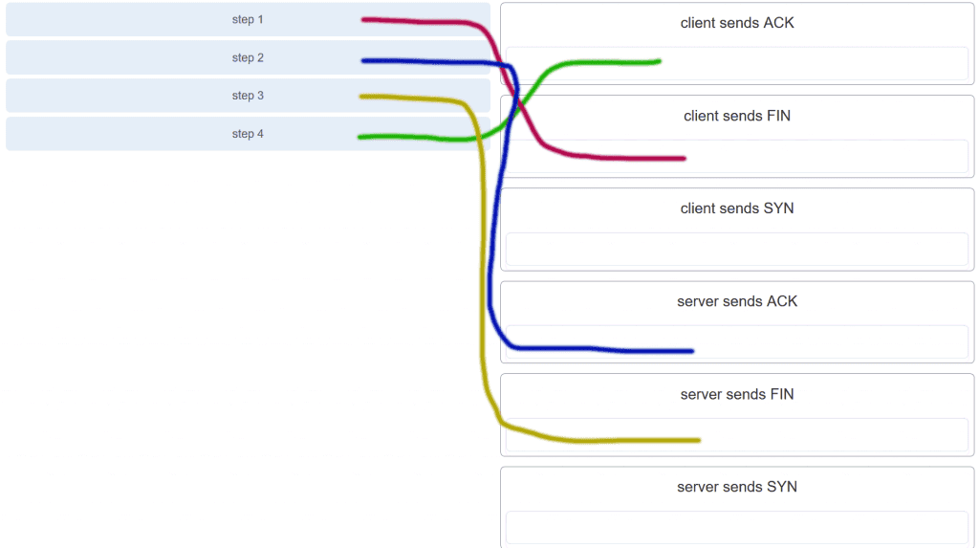

CCNA 1 v7.0 Modules 14 – 15 Exam Answers p13

14. Which flag in the TCP header is used in response to a received FIN in order to terminate connectivity between two network devices?

FIN  
**ACK**  
SYN  
RST

15. Which protocol or service uses UDP for a client-to-server communication and TCP for server-to-server communication?

HTTP  
FTP  
**DNS**  
SMTP

Explanation: Some applications may use both TCP and UDP. DNS uses UDP when clients send requests to a DNS server, and TCP when two DNS serves directly communicate.

16. What is a characteristic of UDP?

UDP datagrams take the same path and arrive in the correct order at the destination.​  
Applications that use UDP are always considered unreliable.​  
**UDP reassembles the received datagrams in the order they were received.**UDP only passes data to the network when the destination is ready to receive the data.

Explanation: UDP has no way to reorder the datagrams into their transmission order, so UDP simply reassembles the data in the order it was received and forwards it to the application.​

17. What kind of port must be requested from IANA in order to be used with a specific application?

**registered port**  
private port  
dynamic port  
source port

Explanation: Registered ports (numbers 1024 to 49151) are assigned by IANA to a requesting entity to use with specific processes or applications. These processes are primarily individual applications that a user has chosen to install, rather than common applications that would receive a well-known port number. For example, Cisco has registered port 1985 for its Hot Standby Routing Protocol (HSRP) process.​

18. Which three application layer protocols use TCP? (Choose three.)

**SMTP**  
**FTP**  
SNMP  
**HTTP**  
TFTP  
DHCP

Explanation: Some protocols require the reliable data transport that is provided by TCP. In addition, these protocols do not have real time communication requirements and can tolerate some data loss while minimizing protocol overhead. Examples of these protocols are SMTP, FTP, and HTTP.

19. Which three statements characterize UDP? (Choose three.)

**UDP provides basic connectionless transport layer functions.**  
UDP provides connection-oriented, fast transport of data at Layer 3.  
**UDP relies on application layer protocols for error detection.**  
**UDP is a low overhead protocol that does not provide sequencing or flow control mechanisms.**  
UDP relies on IP for error detection and recovery.  
UDP provides sophisticated flow control mechanisms.

20. Which two fields are included in the TCP header but not in the UDP header? (Choose two.)

**Window**  
checksum  
source port  
destination port  
**sequence number**

Explanation: The sequence number and window fields are included in the TCP header but not in the UDP header.

21. Which field in the TCP header indicates the status of the three-way handshake process?

window  
reserved  
checksum  
**control bits**

Explanation: The value in the control bits field of theTCP header indicates the progress and status of the connection.

22. Why does HTTP use TCP as the transport layer protocol?

to ensure the fastest possible download speed  
because HTTP is a best-effort protocol  
because transmission errors can be tolerated easily  
**because HTTP requires reliable delivery**

23. Which two types of applications are best suited for UDP? (Choose two.)

applications that need data flow control  
applications that require reliable delivery  
**applications that handle reliability themselves**  
applications that need the reordering of segments  
**applications that can tolerate some data loss, but require little or no delay**

24. How are port numbers used in the TCP/IP encapsulation process?

Source port numbers and destination port numbers are not necessary when UDP is the transport layer protocol being used for the communication.  
Source port and destination port numbers are randomly generated.  
If **multiple conversations occur that are using the same service, the source port number is used to track the separate conversations**.  
Destination port numbers are assigned automatically and cannot be changed.

Explanation: Both UDP and TCP use port numbers to provide a unique identifier for each conversation. Source port numbers are randomly generated and are used to track different conversations. Destination port numbers identify specific services by using either a default port number for the service or a port number that is assigned manually by a system administrator.

25. In what two situations would UDP be better than TCP as the preferred transport protocol? (Choose two.)

when applications need to guarantee that a packet arrives intact, in sequence, and unduplicated  
**when a faster delivery mechanism is needed**  
when delivery overhead is not an issue  
**when applications do not need to guarantee delivery of the data**  
when destination port numbers are dynamic

Explanation: UDP is a very simple transport layer protocol that does not guarantee delivery. Devices on both ends of the conversation are not required to keep track of the conversation. UDP is used as the transport protocol for applications that need a speedy, best-effort delivery.

26. What are three responsibilities of the transport layer? (Choose three.)

**meeting the reliability requirements of applications, if any**  
**multiplexing multiple communication streams from many users or applications on the same network**  
**identifying the applications and services on the client and server that should handle transmitted data**  
directing packets towards the destination network  
formatting data into a compatible form for receipt by the destination devices  
conducting error detection of the contents in frames

27. Which three statements describe a DHCP Discover message? (Choose three.)

The source MAC address is 48 ones (FF-FF-FF-FF-FF-FF).  
**The destination IP address is 255.255.255.255.**The message comes from a server offering an IP address.  
**The message comes from a client seeking an IP address.**  
**All hosts receive the message, but only a DHCP server replies.**  
Only the DHCP server receives the message.

Explanation: When a host configured to use DHCP powers up on a network it sends a DHCPDISCOVER message. FF-FF-FF-FF-FF-FF is the L2 broadcast address. A DHCP server replies with a unicast DHCPOFFER message back to the host.

28. Which two protocols may devices use in the application process that sends email? (Choose two.)

HTTP  
**SMTP**  
POP  
IMAP  
**DNS**  
POP3

29. What is true about the Server Message Block protocol?

Different SMB message types have a different format.  
**Clients establish a long term connection to servers.**SMB messages cannot authenticate a session.  
SMB uses the FTP protocol for communication.

Explanation: The Server Message Block protocol is a protocol for file, printer, and directory sharing. Clients establish a long term connection to servers and when the connection is active, the resources can be accessed. Every SMB message has the same format. The use of SMB differs from FTP mainly in the length of the sessions. SMB messages can authenticate sessions.

30. What is the function of the HTTP GET message?

**to request an HTML page from a web server**  
to send error information from a web server to a web client  
to upload content to a web server from a web client  
to retrieve client email from an email server using TCP port 110

31. Which OSI layer provides the interface between the applications used to communicate and the underlying network over which messages are transmitted?

**Application**  
presentation  
session  
transport

32. Which networking model is being used when an author uploads one chapter document to a file server of a book publisher?

peer-to-peer  
master-slave  
**client/server**  
point-to-point

Explanation: In the client/server network model, a network device assumes the role of server in order to provide a particular service such as file transfer and storage. In the client/server network model, a dedicated server does not have to be used, but if one is present, the network model being used is the client/server model. In contrast, a peer-to-peer network does not have a dedicated server.

33. What do the client/server and peer-to-peer network models have in common?

Both models have dedicated servers.  
**Both models support devices in server and client roles.**Both models require the use of TCP/IP-based protocols.  
Both models are used only in the wired network environment.

Explanation: In both the client/server and peer-to-peer network models, clients and servers exist. In peer-to-peer networks, no dedicated server exists, but a device can assume the server role to provide information to a device serving in the client role.

34. In what networking model would eDonkey, eMule, BitTorrent, Bitcoin, and LionShare be used?

**peer-to-peer**  
client-based  
master-slave  
point-to-point

Explanation: In a peer-to-peer networking model, data is exchanged between two network devices without the use of a dedicated server. Peer-to-peer applications such as Shareaz, eDonkey, and Bitcoin allow one network device to assume the role of server, while one or more other network devices assume the role of client using the peer-to-peer application.

35. What is a common protocol that is used with peer-to-peer applications such as WireShare, Bearshare, and Shareaza?

Ethernet  
**Gnutella**  
POP  
SMTP

36. What is a key characteristic of the peer-to-peer networking model?

wireless networking  
social networking without the Internet  
network printing using a print server  
**resource sharing without a dedicated server**

Explanation: The peer-to-peer (P2P) networking model allows data, printer, and resource sharing without a dedicated server.​​

37. The application layer of the TCP/IP model performs the functions of what three layers of the OSI model? (Choose three.)

physical  
**sesión**  
network  
**presentation**  
data link  
transport  
**application**

Explanation: The network access layer of the TCP/IP model performs the same functions as the physical and data link layers of the OSI model. The internetwork layer equates to the network layer of the OSI model. The transport layers are the same in both models. The application layer of the TCP/IP model represents the session, presentation, and application layers of the OSI model.​

38. What is an example of network communication that uses the client-server model?

A user uses eMule to download a file that is shared by a friend after the file location is determined.  
A workstation initiates an ARP to find the MAC address of a receiving host.  
A user prints a document by using a printer that is attached to a workstation of a coworker.  
**A workstation initiates a DNS request when the user types www.cisco.com in the address bar of a web browser.**

Explanation: When a user types a domain name of a website into the address bar of a web browser, a workstation needs to send a DNS request to the DNS server for the name resolution process. This request is a client/server model application. The eMule application is P2P. Sharing a printer on a workstation is a peer-to-peer network. Using ARP is just a broadcast message sent by a host.

39. Which layer in the TCP/IP model is used for formatting, compressing, and encrypting data?

internetwork  
session  
presentation  
**application**  
network access

Explanation: The application layer of the TCP/IP model performs the functions of three layers of the OSI model – application, presentation, and session. The application layer of the TCP/IP model is the layer that provides the interface between the applications, is responsible for formatting, compressing, and encrypting data, and is used to create and maintain dialogs between source and destination applications.

40. What is an advantage of SMB over FTP?​

Only with SMB can data transfers occur in both directions.  
Only SMB establishes two simultaneous connections with the client, making the data transfer faster.​  
SMB is more reliable than FTP because SMB uses TCP and FTP uses UDP.​  
**SMB clients can establish a long-term connection to the server.​**

41. A manufacturing company subscribes to certain hosted services from its ISP. The services that are required include hosted world wide web, file transfer, and e-mail. Which protocols represent these three key applications? (Choose three.)

**FTP**  
**HTTP**  
DNS  
SNMP  
DHCP  
**SMTP**

42. Which application layer protocol uses message types such as GET, PUT, and POST?

DNS  
DHCP  
SMTP  
**HTTP**  
POP3

Explanation: The GET command is a client request for data from a web server. A PUT command uploads resources and content, such as images, to a web server. A POST command uploads data files to a web server.

43. What type of information is contained in a DNS MX record?

the FQDN of the alias used to identify a service  
the IP address for an FQDN entry  
**the domain name mapped to mail exchange servers**  
the IP address of an authoritative name server

Explanation: MX, or mail exchange messages, are used to map a domain name to several mail exchange servers that all belong to the same domain.

44. Which three protocols operate at the application layer of the TCP/IP model? (Choose three.)

ARP  
TCP  
UDP  
**FTP**  
**POP3**  
**DHCP**

Explanation: FTP, DHCP, and POP3 are application layer protocols. TCP and UDP are transport layer protocols. ARP is a network layer protocol.

45. Which protocol is used by a client to communicate securely with a web server?

SMTP  
SMB  
IMAP  
**HTTPS**

Explanation: HTTPS is a secure form of HTTP used to access web content hosted by a web server.

46. Which applications or services allow hosts to act as client and server at the same time?

client/server applications  
email applications  
**P2P applications**  
authentication services

47. What are two characteristics of peer-to-peer networks? (Choose two.)

scalability  
one way data flow  
decentralized resources  
centralized user accounts  
**resource sharing without a dedicated server**

Explanation: Peer-to-peer networks have decentralized resources because every computer can serve as both a server and a client. One computer might assume the role of server for one transaction while acting as a client for another transaction. Peer-to-peer networks can share resources among network devices without the use of a dedicated server.

48. Which scenario describes a function provided by the transport layer?

A student is using a classroom VoIP phone to call home. The unique identifier burned into the phone is a transport layer address used to contact another network device on the same network.  
A student is playing a short web-based movie with sound. The movie and sound are encoded within the transport layer header.  
**A student has two web browser windows open in order to access two web sites. The transport layer ensures the correct web page is delivered to the correct browser window**.  
A corporate worker is accessing a web server located on a corporate network. The transport layer formats the screen so the web page appears properly no matter what device is being used to view the web site.

Explanation: The source and destination port numbers are used to identify the correct application and window within that application.

49. Which three layers of the OSI model provide similar network services to those provided by the application layer of the TCP/IP model? (Choose three.)

physical layer  
**session layer**  
transport layer  
**application layer**  
**presentation layer**  
data link layer

Explanation: The three upper layers of the OSI model, the session, presentation, and application layers, provide application services similar to those provided by the TCP/IP model application layer. Lower layers of the OSI model are more concerned with data flow.

50. A PC that is communicating with a web server has a TCP window size of 6,000 bytes when sending data and a packet size of 1,500 bytes. Which byte of information will the web server acknowledge after it has received two packets of data from the PC?

3001  
6001  
4500  
6000

51. A PC that is communicating with a web server has a TCP window size of 6,000 bytes when sending data and a packet size of 1,500 bytes. Which byte of information will the web server acknowledge after it has received three packets of data from the PC?

4501  
6001  
6000  
4500

52. A PC that is communicating with a web server has a TCP window size of 6,000 bytes when sending data and a packet size of 1,500 bytes. Which byte of information will the web server acknowledge after it has received four packets of data from the PC?

6001  
3001  
1501  
1500

53. A PC that is communicating with a web server has a TCP window size of 6,000 bytes when sending data and a packet size of 1,500 bytes. Which byte of information will the web server acknowledge after it has received four packets of data from the PC?

6001  
3001  
3000  
1500

54. A PC that is communicating with a web server has a TCP window size of 6,000 bytes when sending data and a packet size of 1,500 bytes. Which byte of information will the web server acknowledge after it has received two packets of data from the PC?

3001  
4501  
3000  
1500

55. A PC that is communicating with a web server has a TCP window size of 6,000 bytes when sending data and a packet size of 1,500 bytes. Which byte of information will the web server acknowledge after it has received two packets of data from the PC?

3001  
4501  
4500  
1500

56. A PC that is communicating with a web server has a TCP window size of 6,000 bytes when sending data and a packet size of 1,500 bytes. Which byte of information will the web server acknowledge after it has received two packets of data from the PC?

3001  
6001  
4500  
3000

57. A PC that is communicating with a web server has a TCP window size of 6,000 bytes when sending data and a packet size of 1,500 bytes. Which byte of information will the web server acknowledge after it has received two packets of data from the PC?

3001  
6001  
6000  
3000

58. A PC that is communicating with a web server has a TCP window size of 6,000 bytes when sending data and a packet size of 1,500 bytes. Which byte of information will the web server acknowledge after it has received three packets of data from the PC?

4501  
6001  
6000  
3000

59. A PC that is communicating with a web server has a TCP window size of 6,000 bytes when sending data and a packet size of 1,500 bytes. Which byte of information will the web server acknowledge after it has received three packets of data from the PC?

4501  
6001  
1500  
4500

60. A client creates a packet to send to a server. The client is requesting TFTP service. What number will be used as the destination port number in the sending packet?

69  
67  
53  
80

61. A client creates a packet to send to a server. The client is requesting FTP service. What number will be used as the destination port number in the sending packet?

21  
69  
67  
80

62. A client creates a packet to send to a server. The client is requesting SSH service. What number will be used as the destination port number in the sending packet?

22  
69  
67  
80

63. A client creates a packet to send to a server. The client is requesting HTTP service. What number will be used as the destination port number in the sending packet?

80  
67  
53  
69

64. A client creates a packet to send to a server. The client is requesting POP3 service. What number will be used as the destination port number in the sending packet?

110  
67  
53  
69

65. A client creates a packet to send to a server. The client is requesting telnet service. What number will be used as the destination port number in the sending packet?

23  
443  
161  
110

66. A client creates a packet to send to a server. The client is requesting POP3 service. What number will be used as the destination port number in the sending packet?

110  
443  
161  
80

67. A client creates a packet to send to a server. The client is requesting SNMP service. What number will be used as the destination port number in the sending packet?

161  
443  
110  
80

68. A client creates a packet to send to a server. The client is requesting SMTP service. What number will be used as the destination port number in the sending packet?

25  
443  
161  
110

69. A client creates a packet to send to a server. The client is requesting HTTPS service. What number will be used as the destination port number in the sending packet?

443  
161  
110  
80

Modules 14 – 15: Network Application Communications Exam Answers (Additional)

1. Which action is performed by a client when establishing communication with a server via the use of UDP at the transport layer?

The client sets the window size for the session.  
The client sends an ISN to the server to start the 3-way handshake.  
**The client randomly selects a source port number.**  
The client sends a synchronization segment to begin the session.

2. Which transport layer feature is used to guarantee session establishment?

UDP ACK flag  
**TCP 3-way handshake**  
UDP sequence number  
TCP port number

3. What is the complete range of TCP and UDP well-known ports?

0 to 255  
**0 to 1023**  
256 – 1023  
1024 – 49151

4. What is a socket?

the combination of the source and destination IP address and source and destination Ethernet address  
**the combination of a source IP address and port number or a destination IP address and port number**  
the combination of the source and destination sequence and acknowledgment numbers  
the combination of the source and destination sequence numbers and port numbers

5. How does a networked server manage requests from multiple clients for different services?

The server sends all requests through a default gateway.  
Each request is assigned source and destination port numbers.  
The server uses IP addresses to identify different services.  
Each request is tracked through the physical address of the client.

6. Which two services or protocols use the preferred UDP protocol for fast transmission and low overhead? (Choose two)

FTP  
DNS  
HTTP  
POP3  
VoIP

7. What is the purpose of using a source port number in a TCP communication?

to notify the remote device that the conversation is over  
to assemble the segments that arrived out of order  
to keep track of multiple conversations between devices  
to inquire for a nonreceived segment

8. Which number or set of numbers represents a socket?

01-23-45-67-89-AB  
21  
192.168.1.1:80  
10.1.1.15

9. Which two flags in the TCP header are used in a TCP three-way handshake to establish connectivity between two network devices? (Choose two.)

ACK  
FIN  
PSH  
RST  
SYN  
URG

10. What happens if part of an FTP message is not delivered to the destination?

The message is lost because FTP does not use a reliable delivery method.  
The FTP source host sends a query to the destination host.  
The part of the FTP message that was lost is re-sent.  
The entire FTP message is re-sent.

11. What type of applications are best suited for using UDP?

applications that are sensitive to delay  
applications that need reliable delivery  
applications that require retransmission of lost segments  
applications that are sensitive to packet loss

12. Network congestion has resulted in the source learning of the loss of TCP segments that were sent to the destination. What is one way that the TCP protocol addresses this?

The source decreases the amount of data that it transmits before it receives an acknowledgement from the destination.  
The source decreases the window size to decrease the rate of transmission from the destination.  
The destination decreases the window size.  
The destination sends fewer acknowledgement messages in order to conserve bandwidth.

13. Which two operations are provided by TCP but not by UDP? (Choose two.)

identifying the applications  
acknowledging received data  
tracking individual conversations  
retransmitting any unacknowledged data  
reconstructing data in the order received

14. What is the TCP mechanism used in congestion avoidance ?

three-way handshake  
socket pair  
two-way handshake  
sliding window

15. What is a responsibility of transport layer protocols?

providing network access  
tracking individual conversations  
determining the best path to forward a packet  
translating private IP addresses to public IP addresses

16. Which protocol can be used to transfer messages from an email server to an email client?

SMTP  
POP3  
SNMP  
HTTP

17. When retrieving email messages, which protocol allows for easy, centralized storage and backup of emails that would be desirable for a small- to medium-sized business?

IMAP  
POP  
SMTP  
HTTPS

18. Which application layer protocol is used to provide file-sharing and print services to Microsoft applications?

HTTP  
SMTP  
DHCP  
SMB

19. An author is uploading one chapter document from a personal computer to a file server of a book publisher. What role is the personal computer assuming in this network model?

Client  
master  
server  
slave  
transient

20. Which statement is true about FTP?

The client can choose if FTP is going to establish one or two connections with the server.  
The client can download data from or upload data to the server.  
FTP is a peer-to-peer application.  
FTP does not provide reliability during data transmission.

21. A wireless host needs to request an IP address. What protocol would be used to process the request?

FTP  
HTTP  
DHCP  
ICMP  
SNMP

22. Which TCP/IP model layer is closest to the end user?

Application  
internet  
network access  
transport

23. Which three protocols or standards are used at the application layer of the TCP/IP model? (Choose three.)

TCP  
HTTP  
MPEG  
GIF  
IP  
UDP

24. Which protocol uses encryption?

DHCP  
DNS  
FTP  
HTTPS

25. Why is DHCP preferred for use on large networks?

Large networks send more requests for domain to IP address resolution than do smaller networks.  
DHCP uses a reliable transport layer protocol.  
It prevents sharing of files that are copyrighted.  
It is a more efficient way to manage IP addresses than static address assignment.  
Hosts on large networks require more IP addressing configuration settings than hosts on small networks.

26. Which two tasks can be performed by a local DNS server? (Choose two.)

providing IP addresses to local hosts  
allowing data transfer between two network devices  
mapping name-to-IP addresses for internal hosts  
forwarding name resolution requests between servers  
retrieving email messages

27. On a home network, which device is most likely to provide dynamic IP addressing to clients on the home network?

a dedicated file server  
a home router  
an ISP DHCP server  
a DNS server

28. What part of the URL, http://www.cisco.com/index.html, represents the top-level DNS domain?

.com  
www  
http  
index

29. What are two characteristics of the application layer of the TCP/IP model? (Choose two.)

responsibility for logical addressing  
responsibility for physical addressing  
the creation and maintenance of dialogue between source and destination applications  
closest to the end user  
the establishing of window size

30. What message type is used by an HTTP client to request data from a web server?

GET  
POST  
PUT  
ACK

1. Which component is designed to protect against unauthorized communications to and from a computer?

security center  
port scanner  
antimalware  
antivirus  
**firewall**

2. Which command will block login attempts on RouterA for a period of 30 seconds if there are 2 failed login attempts within 10 seconds?

RouterA(config)# login block-for 10 attempts 2 within 30  
**RouterA(config)# login block-for 30 attempts 2 within 10**RouterA(config)# login block-for 2 attempts 30 within 10  
RouterA(config)# login block-for 30 attempts 10 within 2

3. What is the purpose of the network security accounting function?

to require users to prove who they are  
to determine which resources a user can access  
**to keep track of the actions of a user**  
to provide challenge and response questions

4. What type of attack may involve the use of tools such as nslookup and fping?

access attack  
**reconnaissance attack**  
denial of service attack  
worm attack

5. Match each weakness with an example. (Not all options are used.)

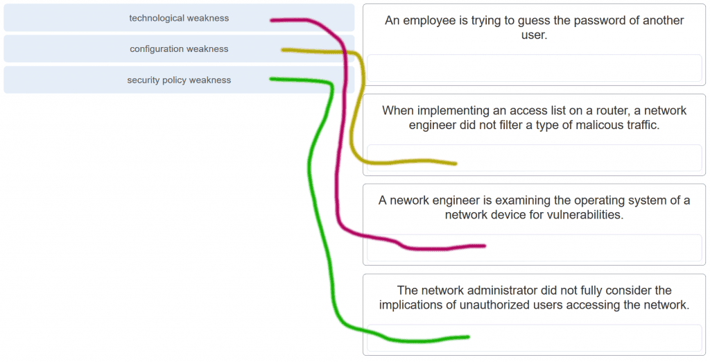

CCNA 1 v7.0 Modules 16 – 17 Exam Answers p5

6. Match the type of information security threat to the scenario. (Not all options are used.)

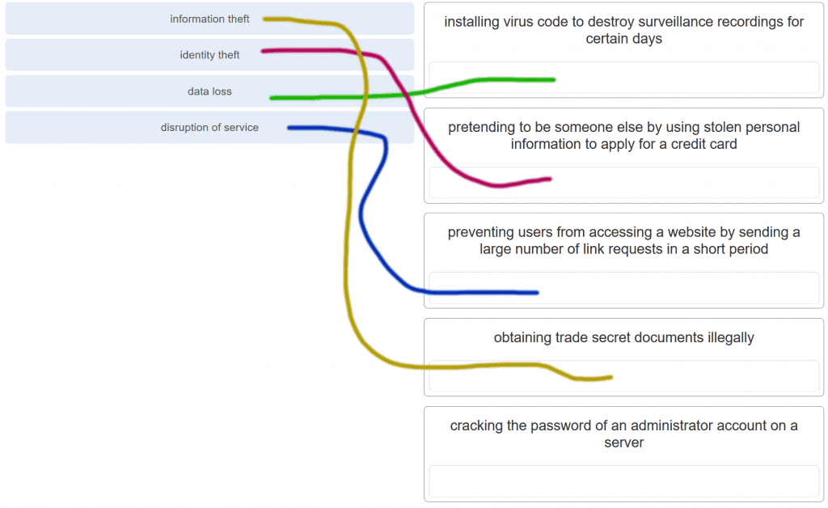

CCNA 1 v7.0 Modules 16 – 17 Exam Answers p6

7. Which example of malicious code would be classified as a Trojan horse?

m**alware that was written to look like a video game**  
malware that requires manual user intervention to spread between systems  
malware that attaches itself to a legitimate program and spreads to other programs when launched  
malware that can automatically spread from one system to another by exploiting a vulnerability in the target

8. What is the difference between a virus and a worm?

Viruses self-replicate but worms do not.  
**Worms self-replicate but viruses do not.**  
Worms require a host file but viruses do not.  
Viruses hide in legitimate programs but worms do not.

Explanation:Worms are able to self-replicate and exploit vulnerabilities on computer networks without user participation.

9. Which attack involves a compromise of data that occurs between two end points?

denial-of-service  
**man-in-the-middle attack**  
extraction of security parameters  
username enumeration

Explanation: Threat actors frequently attempt to access devices over the internet through communication protocols. Some of the most popular remote exploits are as follows:  
*Man-In-the-middle attack (MITM)* – The threat actor gets between devices in the system and intercepts all of the data being transmitted. This information could simply be collected or modified for a specific purpose and delivered to its original destination.  
*Eavesdropping attack*– When devices are being installed, the threat actor can intercept data such as security keys that are used by constrained devices to establish communications once they are up and running.  
*SQL injection (SQLi)* – Threat actors uses a flaw in the Structured Query Language (SQL) application that allows them to have access to modify the data or gain administrative privileges.  
*Routing attack* – A threat actor could either place a rogue routing device on the network or modify routing packets to manipulate routers to send all packets to the chosen destination of the threat actor. The threat actor could then drop specific packets, known as selective forwarding, or drop all packets, known as a sinkhole attack.

10. Which type of attack involves an adversary attempting to gather information about a network to identify vulnerabilities?

**Reconnaissance**  
DoS  
dictionary  
man-in-the-middle

11. Match the description to the type of firewall filtering. (Not all options are used.)

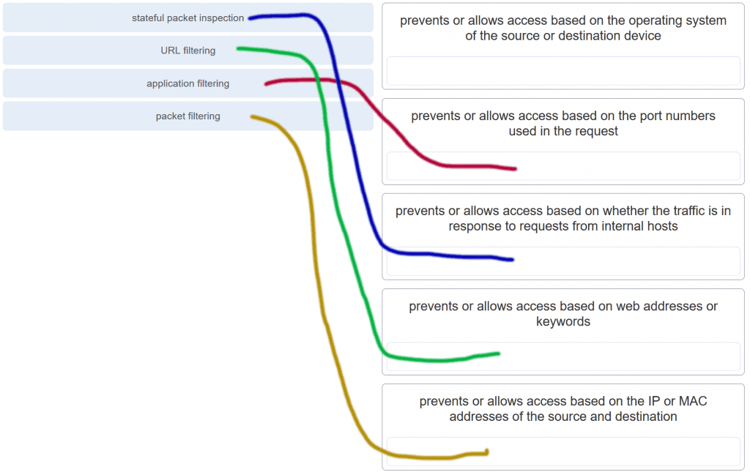

CCNA 1 v7.0 Modules 16 – 17 Exam Answers p11

12. What is the purpose of the network security authentication function?

**to require users to prove who they are**  
to determine which resources a user can access  
to keep track of the actions of a user  
to provide challenge and response questions

Explanation: Authentication, authorization, and accounting are network services collectively known as AAA. Authentication requires users to prove who they are. Authorization determines which resources the user can access. Accounting keeps track of the actions of the user.

13. Which firewall feature is used to ensure that packets coming into a network are legitimate responses to requests initiated from internal hosts?

**stateful packet inspection**  
URL filtering  
application filtering  
packet filtering

14. When applied to a router, which command would help mitigate brute-force password attacks against the router?

exec-timeout 30  
service password-encryption  
banner motd $Max failed logins = 5$  
**login block-for 60 attempts 5 within 60**

Explanation: The login block-for command sets a limit on the maximum number of failed login attempts allowed within a defined period of time. If this limit is exceeded, no further logins are allowed for the specified period of time. This helps to mitigate brute-force password cracking since it will significantly increase the amount of time required to crack a password. The exec-timeout command specifies how long the session can be idle before the user is disconnected. The service password-encryption command encrypts the passwords in the running configuration. The banner motd command displays a message to users who are logging in to the device.

15. Identify the steps needed to configure a switch for SSH. The answer order does not matter. (Not all options are used.)

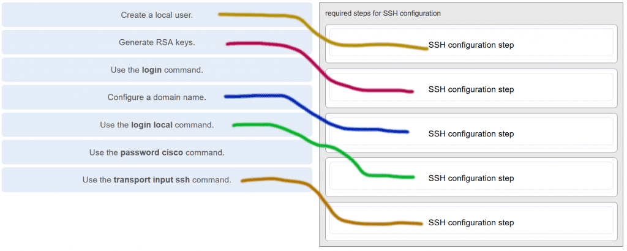

CCNA 1 v7.0 Modules 16 – 17 Exam Answers p15

Explanation: The login and password cisco commands are used with Telnet switch configuration, not SSH configuration.

16. What feature of SSH makes it more secure than Telnet for a device management connection?

confidentiality with IPsec  
stronger password requirement  
random one-time port connection  
**login information and data encryption**

Explanation: Secure Shell (SSH) is a protocol that provides a secure management connection to a remote device. SSH provides security by providing encryption for both authentication (username and password) and the transmitted data. Telnet is a protocol that uses unsecure plaintext transmission. SSH is assigned to TCP port 22 by default. Although this port can be changed in the SSH server configuration, the port is not dynamically changed. SSH does not use IPsec.

17. What is the advantage of using SSH over Telnet?

SSH is easier to use.  
SSH operates faster than Telnet.  
**SSH provides secure communications to access hosts.**SSH supports authentication for a connection request.

Explanation: SSH provides a secure method for remote access to hosts by encrypting network traffic between the SSH client and remote hosts. Although both Telnet and SSH request authentication before a connection is established, Telnet does not support encryption of login credentials.

18. What is the role of an IPS?

**detecting and blocking of attacks in real time**connecting global threat information to Cisco network security devices  
authenticating and validating traffic  
filtering of nefarious websites

Explanation: An intrusion prevention system (IPS) provides real-time detection and blocking of attacks.

19. A user is redesigning a network for a small company and wants to ensure security at a reasonable price. The user deploys a new application-aware firewall with intrusion detection capabilities on the ISP connection. The user installs a second firewall to separate the company network from the public network. Additionally, the user installs an IPS on the internal network of the company. What approach is the user implementing?

attack based  
risk based  
structured  
**layered**

Explanation: Using different defenses at various points of the network creates a layered approach.

20. What is an accurate description of redundancy?

configuring a router with a complete MAC address database to ensure that all frames can be forwarded to the correct destination  
configuring a switch with proper security to ensure that all traffic forwarded through an interface is filtered  
designing a network to use multiple virtual devices to ensure that all traffic uses the best path through the internetwork  
**designing a network to use multiple paths between switches to ensure there is no single point of failure**

Explanation: Redundancy attempts to remove any single point of failure in a network by using multiple physically cabled paths between switches in the network.

21. A network administrator is upgrading a small business network to give high priority to real-time applications traffic. What two types of network services is the network administrator trying to accommodate? (Choose two.)

**voice  
video**  
instant messaging  
FTP  
SNMP

22. What is the purpose of a small company using a protocol analyzer utility to capture network traffic on the network segments where the company is considering a network upgrade?

to identify the source and destination of local network traffic  
to capture the Internet connection bandwidth requirement  
**to document and analyze network traffic requirements on each network segment**  
to establish a baseline for security analysis after the network is upgraded

Explanation: An important prerequisite for considering network growth is to understand the type and amount of traffic that is crossing the network as well as the current traffic flow. By using a protocol analyzer in each network segment, the network administrator can document and analyze the network traffic pattern for each segment, which becomes the base in determining the needs and means of the network growth.

23. Refer to the exhibit.

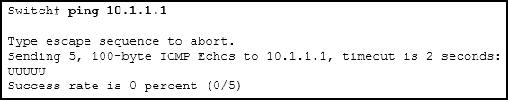

CCNA 1 v7.0 Modules 16 – 17 Exam Answers p23

An administrator is testing connectivity to a remote device with the IP address 10.1.1.1. What does the output of this command indicate?

Connectivity to the remote device was successful.  
**A router along the path did not have a route to the destination.**  
A ping packet is being blocked by a security device along the path.  
The connection timed out while waiting for a reply from the remote device.

Explanation: In the output of the ping command, an exclamation mark (!) indicates a response was successfully received, a period (.) indicates that the connection timed out while waiting for a reply, and the letter “U” indicates that a router along the path did not have a route to the destination and sent an ICMP destination unreachable message back to the source.

24. Which method is used to send a ping message specifying the source address for the ping?

Issue the ping command from within interface configuration mode.  
**Issue the ping command without specifying a destination IP address.**  
Issue the ping command without extended commands.  
Issue the ping command after shutting down un-needed interfaces.

Explanation: By issuing the ping command without a destination IP address in privileged EXEC mode, the Cisco IOS enters extended ping mode. This allows the user to implement extended commands which include source IP address.​

25. A network engineer is analyzing reports from a recently performed network baseline. Which situation would depict a possible latency issue?

a change in the bandwidth according to the show interfaces output  
a next-hop timeout from a traceroute  
**an increase in host-to-host ping response times**a change in the amount of RAM according to the show version output

Explanation: While analyzing historical reports an administrator can compare host-to-host timers from the ping command and depict possible latency issues.​

26. Which statement is true about Cisco IOS ping indicators?​

‘!’ indicates that the ping was unsuccessful and that the device may have issues finding a DNS server.  
**‘U’ may indicate that a router along the path did not contain a route to the destination address and that the ping was unsuccessful.**‘.’ indicates that the ping was successful but the response time was longer than normal.  
A combination of ‘.’ and ‘!’ indicates that a router along the path did not have a route to the destination address and responded with an ICMP unreachable message.​

Explanation: The most common indicators of a ping issued from the Cisco IOS are “!”, “.”, and “U”. The “!” indicates that the ping completed successfully, verifying connectivity at Layer 3. The “.” may indicate that a connectivity problem, routing problem, or device security issue exists along the path and that an ICMP destination unreachable message was not provided. The “U” indicates that a router along the path may not have had a route to the destination address, and that it responded with an ICMP unreachable message.

27. A user reports a lack of network connectivity. The technician takes control of the user machine and attempts to ping other computers on the network and these pings fail. The technician pings the default gateway and that also fails. What can be determined for sure by the results of these tests?

The NIC in the PC is bad.  
The TCP/IP protocol is not enabled.  
The router that is attached to the same network as the workstation is down.  
**Nothing can be determined for sure at this point.**

Explanation: In networks today, a failed ping could mean that the other devices on the network are blocking pings. Further investigation such as checking network connectivity from other devices on the same network is warranted.

28. A network technician issues the C:\> tracert -6 www.cisco.com command on a Windows PC. What is the purpose of the -6 command option?

**It forces the trace to use IPv6.**  
It limits the trace to only 6 hops.  
It sets a 6 milliseconds timeout for each replay.  
It sends 6 probes within each TTL time period.

29. Why would a network administrator use the tracert utility?

to determine the active TCP connections on a PC  
to check information about a DNS name in the DNS server  
**to identify where a packet was lost or delayed on a network**  
to display the IP address, default gateway, and DNS server address for a PC

Explanation: The tracert utility is used to identify the path a packet takes from source to destination. Tracert is commonly used when packets are dropped or not reaching a specific destination.

30. A ping fails when performed from router R1 to directly connected router R2. The network administrator then proceeds to issue the show cdp neighbors command. Why would the network administrator issue this command if the ping failed between the two routers?

The network administrator suspects a virus because the ping command did not work.  
**The network administrator wants to verify Layer 2 connectivity.**  
The network administrator wants to verify the IP address configured on router R2.  
The network administrator wants to determine if connectivity can be established from a non-directly connected network.

Explanation: The show cdp neighbors command can be used to prove that Layer 1 and Layer 2 connectivity exists between two Cisco devices. For example, if two devices have duplicate IP addresses, a ping between the devices will fail, but the output of show cdp neighbors will be successful. The show cdp neighbors detail could be used to verify the IP address of the directly connected device in case the same IP address is assigned to the two routers.

31. A network engineer is troubleshooting connectivity issues among interconnected Cisco routers and switches. Which command should the engineer use to find the IP address information, host name, and IOS version of neighboring network devices?

show version  
show ip route  
show interfaces  
**show cdp neighbors detail**

Explanation: The show cdp neighbors detail command reveals much information about neighboring Cisco devices, including the IP address, the capabilities, host name, and IOS version. The show interfaces and show version commands display information about the local device.

32. What information about a Cisco router can be verified using the show version command?

the routing protocol version that is enabled  
**the value of the configuration register**the operational status of serial interfaces  
the administrative distance used to reach networks

Explanation: The value of the configuration register can be verified with the show version command.

33. Which command should be used on a Cisco router or switch to allow log messages to be displayed on remotely connected sessions using Telnet or SSH?

debug all  
logging synchronous  
show running-config​  
**terminal monitor**

34. Which command can an administrator issue on a Cisco router to send debug messages to the vty lines?

**terminal monitor**logging console  
logging buffered  
logging synchronous

Explanation: Debug messages, like other IOS log messages, are sent to the console line by default. Sending these messages to the terminal lines requires the terminal monitor command.

35. By following a structured troubleshooting approach, a network administrator identified a network issue after a conversation with the user. What is the next step that the administrator should take?

Verify full system functionality.  
Test the theory to determine cause.  
**Establish a theory of probable causes**.  
Establish a plan of action to resolve the issue.

Explanation: A structured network troubleshooting approach should include these steps in sequence:  
1. Identify the problem.  
2. Establish a theory of probable causes.  
3. Test the theory to determine cause.  
4. Establish a plan of action to resolve the issue.  
5. Verify full system functionality and implement preventive measures.  
6. Document findings, actions, and outcomes.

36. Users are complaining that they are unable to browse certain websites on the Internet. An administrator can successfully ping a web server via its IP address, but cannot browse to the domain name of the website. Which troubleshooting tool would be most useful in determining where the problem is?

netstat  
tracert  
**nslookup**  
ipconfig

Explanation: The nslookup command can be used to look up information about a particular DNS name in the DNS server. The information includes the IP address of the DNS server being used as well as the IP address associated with the specified DNS name. This command can help verify the DNS that is used and if the domain name to IP address resolution works.

37. An employee complains that a Windows PC cannot connect to the Internet. A network technician issues the ipconfig command on the PC and is shown an IP address of 169.254.10.3. Which two conclusions can be drawn? (Choose two.)

**The PC cannot contact a DHCP server.**  
The DNS server address is misconfigured.  
The default gateway address is not configured.  
**The PC is configured to obtain an IP address automatically.**  
The enterprise network is misconfigured for dynamic routing.

38. Refer to the exhibit.

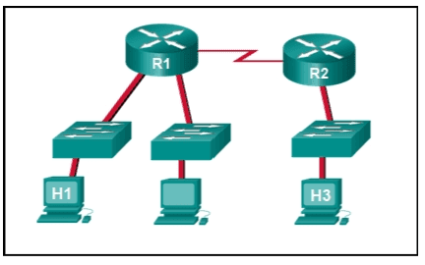

CCNA 1 v7.0 Modules 16 – 17 Exam Answers p38

Host H3 is having trouble communicating with host H1. The network administrator suspects a problem exists with the H3 workstation and wants to prove that there is no problem with the R2 configuration. What tool could the network administrator use on router R2 to prove that communication exists to host H1 from the interface on R2, which is the interface that H3 uses when communicating with remote networks?

traceroute  
show cdp neighbors  
Telnet  
**an extended ping**

39. Refer to the exhibit.



CCNA 1 v7.0 Modules 16 – 17 Exam Answers p39

Baseline documentation for a small company had ping round trip time statistics of 36/97/132 between hosts H1 and H3. Today the network administrator checked connectivity by pinging between hosts H1 and H3 that resulted in a round trip time of 1458/2390/6066. What does this indicate to the network administrator?

Connectivity between H1 and H3 is fine.  
H3 is not connected properly to the network.  
Something is causing interference between H1 and R1.  
Performance between the networks is within expected parameters.  
**Something is causing a time delay between the networks.**

40. Which network service automatically assigns IP addresses to devices on the network?

**DHCP**  
Telnet  
DNS  
traceroute

Explanation: Dynamic Host Configuration Protocol (DHCP) can be used to allow end devices to automatically configure IP information, such as their IP address, subnet mask, DNS server, and default gateway. The DNS service is used to provide domain name resolution, mapping hostnames to IP addresses. Telnet is a method for remotely accessing a CLI session of a switch or router. Traceroute is a command used to determine the path a packet takes as it traverses the network.

41. Which command can an administrator execute to determine what interface a router will use to reach remote networks?

show arp  
show interfaces  
**show ip route**  
show protocols

Explanation: The show ip route command is used to display the IP routing table of the router. The IP routing table will show a list of known local and remote networks and the interfaces that the router will use to reach those networks.

42. On which two interfaces or ports can security be improved by configuring executive timeouts? (Choose two.)

Fast Ethernet interfaces  
**console ports**  
serial interfaces  
**vty ports**  
loopback interfaces

Explanation: Executive timeouts allow the Cisco device to automatically disconnect users after they have been idle for the specified time. Console, vty, and aux ports can be configured with executive timeouts.

43. When configuring SSH on a router to implement secure network management, a network engineer has issued the login local and transport input ssh line vty commands. What three additional configuration actions have to be performed to complete the SSH configuration? (Choose three.)

Set the user privilege levels.  
**Generate the asymmetric RSA keys**.  
**Configure the correct IP domain name.**  
Configure role-based CLI access.  
**Create a valid local username and password database.**  
Manually enable SSH after the RSA keys are generated.

Explanation: SSH is automatically enabled after the RSA keys are generated. Setting user privilege levels and configuring role-based CLI access are good security practices but are not a requirement of implementing SSH.

44. What is considered the most effective way to mitigate a worm attack?

Change system passwords every 30 days.  
Ensure that all systems have the most current virus definitions.  
Ensure that AAA is configured in the network.  
**Download security updates from the operating system vendor and patch all vulnerable systems**.

Explanation: Because worms take advantage of vulnerabilities in the system itself, the most effective way to mitigate worm attacks is to download security updates from the operating system vendor and patch all vulnerable systems.

45. Which statement describes the ping and tracert commands?

**Tracert shows each hop, while ping shows a destination reply only**.  
Tracert uses IP addresses; ping does not.  
Both ping and tracert can show results in a graphical display.  
Ping shows whether the transmission is successful; tracert does not.

Explanation: The ping utility tests end-to-end connectivity between the two hosts. However, if the message does not reach the destination, there is no way to determine where the problem is located. On the other hand, the traceroute utility (tracert in Windows) traces the route a message takes from its source to the destination. Traceroute displays each hop along the way and the time it takes for the message to get to that network and back.

46. A technician is to document the current configurations of all network devices in a college, including those in off-site buildings. Which protocol would be best to use to securely access the network devices?

FTP  
HTTP  
**SSH**  
Telnet

Explanation: Telnet sends passwords and other information in clear text, while SSH encrypts its data. FTP and HTTP do not provide remote device access for configuration purposes.

47. Open the PT Activity. Perform the tasks in the activity instructions and then answer the question.

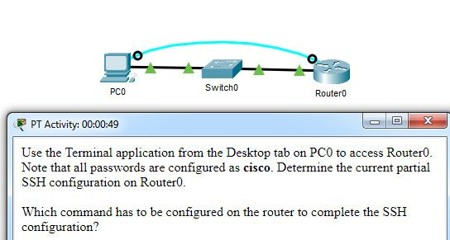

CCNA 1 v7.0 Modules 16 – 17 Exam Answers p47

Which command has to be configured on the router to complete the SSH configuration?

service password-encryption  
**transport input ssh**  
enable secret class  
ip domain-name cisco.com

Explanation: The missing command to complete the SSH configuration is transport input ssh in line vty 0 4 mode.The commands service password-encryption and enable secret class do configure secure features on the router, but are not required to configure SSH. The command ip domain-name cisco.com is not required because the command ip domain-name span.com has been used.

48. An administrator decides to use “WhatAreyouwaiting4” as the password on a newly installed router. Which statement applies to the password choice?

It is strong because it uses a passphrase.  
It is weak because it is often the default password on new devices.  
It is weak since it uses easily found personal information.  
It is weak since it is a word that is easily found in the dictionary.

49. An administrator decides to use “pR3s!d7n&0” as the password on a newly installed router. Which statement applies to the password choice?

It is strong because it uses a minimum of 10 numbers, letters and special characters.  
It is weak because it is often the default password on new devices.  
It is weak since it uses easily found personal information.  
It is weak since it is a word that is easily found in the dictionary.

50. An administrator decides to use “5$74#033!” as the password on a newly installed router. Which statement applies to the password choice?

It is strong because it contains 10 numbers and special characters.  
It is weak because it is often the default password on new devices.  
It is weak since it uses easily found personal information.  
It is strong because it uses a minimum of 10 numbers, letters and special characters.

51. An administrator decides to use “pR3s!d7n&0” as the password on a newly installed router. Which statement applies to the password choice?

It is strong because it uses a minimum of 10 numbers, letters and special characters.  
It is weak since it is a word that is easily found in the dictionary.  
It is strong because it uses a passphrase.  
It is strong because it contains 10 numbers and special characters.

52. An administrator decides to use “12345678!” as the password on a newly installed router. Which statement applies to the password choice?

It is weak because it uses a series of numbers or letters.  
It is strong because it uses a passphrase.  
It is weak since it is a word that is easily found in the dictionary.  
It is strong because it uses a minimum of 10 numbers, letters and special characters.

53. An administrator decides to use “admin” as the password on a newly installed router. Which statement applies to the password choice?

It is weak because it is often the default password on new devices.  
It is strong because it uses a passphrase.  
It is strong because it uses a minimum of 10 numbers, letters and special characters.  
It is strong because it contains 10 numbers and special characters.

54. An administrator decides to use “Feb121978” as the password on a newly installed router. Which statement applies to the password choice?

It is weak because it uses easily found personal information.  
It is strong because it uses a passphrase.  
It is weak since it is a word that is easily found in the dictionary.  
It is strong because it uses a minimum of 10 numbers, letters and special characters.

55. An administrator decides to use “password” as the password on a newly installed router. Which statement applies to the password choice?

It is weak because it is a commonly used password.  
It is weak since it is a word that is easily found in the dictionary.  
It is strong because it uses a passphrase.  
It is strong because it uses a minimum of 10 numbers, letters and special characters.

56. An administrator decides to use “RobErT” as the password on a newly installed router. Which statement applies to the password choice?

It is weak since it uses easily found personal information.  
It is strong because it uses a passphrase.  
It is strong because it uses a minimum of 10 numbers, letters and special characters.  
It is strong because it contains 10 numbers and special characters.

57. An administrator decides to use “Elizabeth” as the password on a newly installed router. Which statement applies to the password choice?

It is weak because it uses easily found personal information.  
It is strong because it uses a passphrase.  
It is weak since it is a word that is easily found in the dictionary.  
It is strong because it uses a minimum of 10 numbers, letters and special characters.

Rules for strong passwords:  
 minimum of 8 characters, preferably 10.  
 use complex combinations of numbers, special characters, and upper and lower case letters.  
 avoid repetition, common dictionary words, letter or number sequences.  
 avoid names of children, relatives, pets, birthdays, or any easily identifiable personal information.  
 can be created by misspelling words or replacing vowels with numbers or special characters.

58. A network technician is troubleshooting an issue and needs to verify the IP addresses of all interfaces on a router. What is the best command to use to accomplish the task?

**show ip interface brief**  
nslookup  
ipconfig getifaddr en0  
show ip route

59. Students who are connected to the same switch are having slower than normal response times. The administrator suspects a duplex setting issue. What is the best command to use to accomplish the task?

**show interfaces**  
ipconfig getifaddr en0  
copy running-config startup-config  
show ip nat translations

60. A user wants to know the IP address of the PC. What is the best command to use to accomplish the task?

**Ipconfig**  
copy running-config startup-config  
show interfaces  
show ip nat translations

61. A student wants to save a router configuration to NVRAM. What is the best command to use to accomplish the task?

**copy running-config startup-config**  
show interfaces  
show ip nat translations  
show ip route

62. A support technician needs to know the IP address of the wireless interface on a MAC. What is the best command to use to accomplish the task?

**ipconfig getifaddr en0**  
copy running-config startup-config  
show interfaces  
show ip nat translations

63. A network technician is troubleshooting an issue and needs to verify all of the IPv6 interface addresses on a router. What is the best command to use to accomplish the task?

**show ipv6 interface**  
show interfaces  
show ip nat translations  
show ip route

64. A teacher is having difficulties connecting his PC to the classroom network. He needs to verify that a default gateway is configured correctly. What is the best command to use to accomplish the task?

**Ipconfig**  
copy running-config startup-config  
show interfaces  
show ip nat translations

65. Only employees connected to IPv6 interfaces are having difficulty connecting to remote networks. The analyst wants to verify that IPv6 routing has been enabled. What is the best command to use to accomplish the task?

**show running-config**  
show interfaces  
copy running-config startup-config  
show ip nat translations

66. An administrator is troubleshooting connectivity issues and needs to determine the IP address of a website. What is the best command to use to accomplish the task?

**Nslookup**  
show ipv6 route  
show ipv6 interface  
copy startup-config running-config

67. Only employees connected to IPv6 interfaces are having difficulty connecting to remote networks. The analyst wants to verify that IPv6 routing has been enabled. What is the best command to use to accomplish the task?

**show running-config**  
show ipv6 route  
show ipv6 interface  
copy startup-config running-config

Modules 16 – 17: Building and Securing a Small Network Exam Answers (Additional)

1. Which component is designed to protect against unauthorized communications to and from a computer?

security center  
port scanner  
antimalware  
antivirus  
firewall

2. Which command will block login attempts on RouterA for a period of 30 seconds if there are 2 failed login attempts within 10 seconds?

RouterA(config)# login block-for 10 attempts 2 within 30  
RouterA(config)# login block-for 30 attempts 2 within 10  
RouterA(config)# login block-for 2 attempts 30 within 10  
RouterA(config)# login block-for 30 attempts 10 within 2

3. What is the purpose of the network security accounting function?

to require users to prove who they are  
to determine which resources a user can access  
to keep track of the actions of a user  
to provide challenge and response questions

4. What type of attack may involve the use of tools such as nslookup and fping?

access attack  
reconnaissance attack  
denial of service attack  
worm attack

5. Which benefit does SSH offer over Telnet for remotely managing a router?

Encryption  
TCP usage  
authorization  
connections via multiple VTY lines

6. What is one of the most effective security tools available for protecting users from external threats?

Firewalls  
router that run AAA services  
patch servers  
password encryption techniques

7. Which type of network threat is intended to prevent authorized users from accessing resources?

DoS attacks  
access attacks  
reconnaissance attacks  
trust exploitation

8. Which three services are provided by the AAA framework? (Choose three.)

accounting  
automation  
authorization  
authentication  
autobalancing  
autoconfiguration

9. Which malicious code attack is self-contained and tries to exploit a specific vulnerability in a system being attacked?

virus  
worm  
Trojan horse  
social engineering

10. Some routers and switches in a wiring closet malfunctioned after an air conditioning unit failed. What type of threat does this situation describe?

configuration  
environmental  
electrical  
maintenance

11. What does the term vulnerability mean?

a weakness that makes a target susceptible to an attack  
a computer that contains sensitive information  
a method of attack to exploit a target  
a known target or victim machine  
a potential threat that a hacker creates

12. What three configuration steps must be performed to implement SSH access to a router? (Choose three.)

a password on the console line  
an IP domain name  
a user account  
an enable mode password  
a unique hostname  
an encrypted password

13. What is the objective of a network reconnaissance attack?

discovery and mapping of systems  
unauthorized manipulation of data  
disabling network systems or services  
denying access to resources by legitimate users

14. For security reasons a network administrator needs to ensure that local computers cannot ping each other. Which settings can accomplish this task?

smartcard settings  
firewall settings  
MAC address settings  
file system settings

15. A network administrator establishes a connection to a switch via SSH. What characteristic uniquely describes the SSH connection?

out-of-band access to a switch through the use of a virtual terminal with password authentication  
remote access to the switch through the use of a telephone dialup connection  
on-site access to a switch through the use of a directly connected PC and a console cable  
remote access to a switch where data is encrypted during the session  
direct access to the switch through the use of a terminal emulation program

16. Which network design consideration would be more important to a large corporation than to a small business?

Internet router  
firewall  
low port density switch  
redundancy

17. A newly hired network technician is given the task of ordering new hardware for a small business with a large growth forecast. Which primary factor should the technician be concerned with when choosing the new devices?

devices with a fixed number and type of interfaces  
devices that have support for network monitoring  
redundant devices  
devices with support for modularity

18. What type of traffic would most likely have the highest priority through the network?

FTP  
instant messaging  
voice  
SNMP

19. A network technician is investigating network connectivity from a PC to a remote host with the address 10.1.1.5. Which command, when issued on a Windows PC, will display the path to the remote host?

trace 10.1.1.5  
traceroute 10.1.1.5  
tracert 10.1.1.5  
ping 10.1.1.5

20. A user is unable to reach the website when typing ht​tp://ww​w.cisco.com in a web browser, but can reach the same site by typing ht​tp://72.163.4.161. What is the issue?

default gateway  
DHCP  
DNS  
TCP/IP protocol stack

21. Where are Cisco IOS debug output messages sent by default?

memory buffers  
vty lines  
Syslog server  
console line

22. Which element of scaling a network involves identifying the physical and logical topologies?

traffic analysis  
network documentation  
device inventory  
cost analysis

23. What mechanism can be implemented in a small network to help minimize network latency for real-time streaming applications?

QoS  
PoE  
AAA  
ICMP

24. Which process failed if a computer cannot access the internet and received an IP address of 169.254.142.5?

IP  
DNS  
DHCP  
HTTP

25. A small company has only one router as the exit point to its ISP. Which solution could be adopted to maintain connectivity if the router itself, or its connection to the ISP, fails?

Activate another router interface that is connected to the ISP, so the traffic can flow through it.  
Have a second router that is connected to another ISP.  
Purchase a second least-cost link from another ISP to connect to this router.  
Add more interfaces to the router that is connected to the internal network.

26. When should an administrator establish a network baseline?

when the traffic is at peak in the network  
when there is a sudden drop in traffic  
at the lowest point of traffic in the network  
at regular intervals over a period of time

27. Which two traffic types require delay sensitive delivery? (Choose two.)

email  
web  
FTP  
Voice  
Video

28. A network technician suspects that a particular network connection between two Cisco switches is having a duplex mismatch. Which command would the technician use to see the Layer 1 and Layer 2 details of a switch port?

show interfaces  
show running-config  
show ip interface brief​  
show mac-address-table

29. Which statement is true about CDP on a Cisco device?​

The show cdp neighbor detail command will reveal the IP address of a neighbor only if there is Layer 3 connectivity​.  
To disable CDP globally, the no cdp enable command in interface configuration mode must be used.  
CDP can be disabled globally or on a specific interface​.  
Because it runs at the data link layer​, the CDP protocol can only be implemented in switches.

30. What factor should be considered in the design of a small network when devices are being chosen?

cost of devices  
redundancy  
traffic analysis  
ISP

. A client packet is received by a server. The packet has a destination port number of 22. What service is the client requesting?

SSH  
TFTP  
DHCP  
DNS

2. Refer to the exhibit.

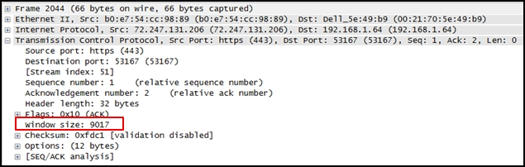

CCNA 1 v7 ITN Practice Final Exam Answers p2

What does the value of the window size specify?

the amount of data that can be sent at one time  
the amount of data that can be sent before an acknowledgment is required  
the total number of bits received during this TCP session  
a random number that is used in establishing a connection with the 3-way handshake

Explanation: The window size determines the number of bytes that can be sent before expecting an acknowledgment. The acknowledgment number is the number of the next expected byte.

3. To which TCP port group does the port 414 belong?

well-known  
private or dynamic  
public  
registered

Explanation: Well Known Ports: 0 through 1023.  
Registered Ports: 1024 through 49151.  
Dynamic/Private : 49152 through 65535.

4. Refer to the exhibit.

CCNA 1 v7 ITN Practice Final Exam Answers p4

CCNA 1 v7 ITN Practice Final Exam Answers p4

An administrator is trying to configure the switch but receives the error message that is displayed in the exhibit. What is the problem?

The entire command, configure terminal, must be used.  
The administrator is already in global configuration mode.  
The administrator must first enter privileged EXEC mode before issuing the command.  
The administrator must connect via the console port to access global configuration mode.

Explanation: In order to enter global configuration mode, the command configure terminal, or a shortened version such as config t, must be entered from privileged EXEC mode. In this scenario the administrator is in user EXEC mode, as indicated by the > symbol after the hostname. The administrator would need to use the enable command to move into privileged EXEC mode before entering the configure terminal command.

5. What is a user trying to determine when issuing a ping 10.1.1.1 command on a PC?

if the TCP/IP stack is functioning on the PC without putting traffic on the wire  
if there is connectivity with the destination device  
the path that traffic will take to reach the destination  
what type of device is at the destination

Explanation: The ping destination command can be used to test connectivity.

6. What is a characteristic of a switch virtual interface (SVI)?​

An SVI is created in software and requires a configured IP address and a subnet mask in order to provide remote access to the switch.  
Although it is a virtual interface, it needs to have physical hardware on the device associated with it.  
SVIs do not require the no shutdown command to become enabled.  
SVIs come preconfigured on Cisco switches.

Explanation: Cisco IOS Layer 2 switches have physical ports for devices to connect. These ports do not support Layer 3 IP addresses. Therefore, switches have one or more switch virtual interfaces (SVIs). These are virtual interfaces because there is no physical hardware on the device associated with it. An SVI is created in software.  
The virtual interface lets you remotely manage a switch over a network using IPv4 and IPv6. Each switch comes with one SVI appearing in the default configuration “out-of-the-box.” The default SVI is interface VLAN1.

7. Match the descriptions to the terms. (Not all options are used.)

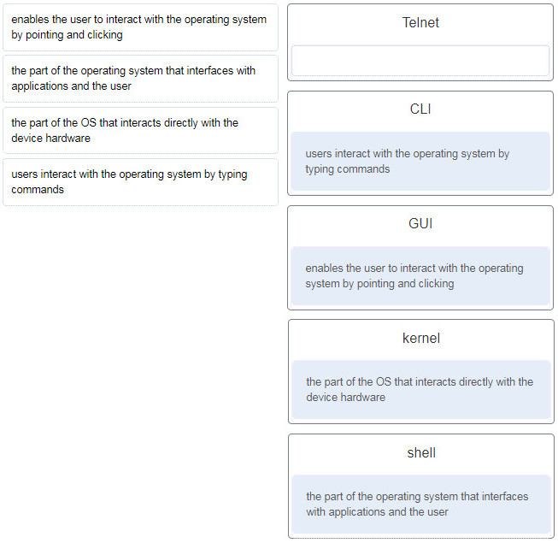

CCNA 1 v7 ITN Practice Final Exam Answers p7

8. What happens when a switch receives a frame and the calculated CRC value is different than the value that is in the FCS field?

The switch notifies the source of the bad frame.  
The switch places the new CRC value in the FCS field and forwards the frame.  
The switch drops the frame.  
The switch floods the frame to all ports except the port through which the frame arrived to notify the hosts of the error.

9. Two network engineers are discussing the methods used to forward frames through a switch. What is an important  
concept related to the cut-through method of switching?

The fragment-free switching offers the lowest level of latency.  
Fast-forward switching can be viewed as a compromise between store-and-forward switching and fragment-free switching.  
Fragment-free switching is the typical cut-through method of switching.  
Packets can be relayed with errors when fast-forward switching is used.

10. Which two issues can cause both runts and giants in Ethernet networks? (Choose two.)

using the incorrect cable type  
half-duplex operations  
a malfunctioning NIC  
electrical interference on serial interfaces  
CRC errors

11. Which two functions are performed at the LLC sublayer of the OSI Data Link Layer to facilitate Ethernet communication? (Choose two.)

places information in the Ethernet frame that identifies which network layer protocol is being encapsulated by the frame  
adds Ethernet control information to network protocol data  
implements CSMA/CD over legacy shared half-duplex media  
applies source and destination MAC addresses to Ethernet frame  
integrates Layer 2 flows between 10 Gigabit Ethernet over fiber and 1 Gigabit Ethernet over copper

12. Which two commands could be used to check if DNS name resolution is working properly on a Windows PC? (Choose two.)

nslookup cisco.com  
ping cisco.com  
ipconfig /flushdns  
net cisco.com  
nbtstat cisco.com

13. A small advertising company has a web server that provides critical business service. The company connects to the Internet through a leased line service to an ISP. Which approach best provides cost effective redundancy for the Internet connection?

Add a second NIC to the web server.  
Add a connection to the Internet via a DSL line to another ISP.  
Add another web server to prepare failover support.  
Add multiple connections between the switches and the edge router.

14. Only employees connected to IPv6 interfaces are having difficulty connecting to remote networks. The analyst wants to verify that IPv6 routing has been enabled. What is the best command to use to accomplish the task?

copy running-config startup-config  
show interfaces  
show ip nat translations  
show running-config

15. Refer to the exhibit. A network administrator is connecting a new host to the Registrar LAN. The host needs to communicate with remote networks. What IP address would be configured as the default gateway on the new host?

Floor(config)# interface gi0/1

Floor(config-if)# description Connects to the Registrar LAN

Floor(config-if)# ip address 192.168.235.234 255.255.255.0

Floor(config-if)# no shutdown

Floor(config-if)# interface gi0/0

Floor(config-if)# description Connects to the Manager LAN

Floor(config-if)# ip address 192.168.234.114 255.255.255.0

Floor(config-if)# no shutdown

Floor(config-if)# interface s0/0/0

Floor(config-if)# description Connects to the ISP

Floor(config-if)# ip address 10.234.235.254 255.255.255.0

Floor(config-if)# no shutdown

Floor(config-if)# interface s0/0/1

Floor(config-if)# description Connects to the Head Office WAN

Floor(config-if)# ip address 203.0.113.3 255.255.255.0

Floor(config-if)# no shutdown

Floor(config-if)# end

192.168.235.234  
203.0.113.3  
192.168.235.1  
10.234.235.254  
192.168.234.114

16. Match the command with the device mode at which the command is entered. (Not all options are used.)

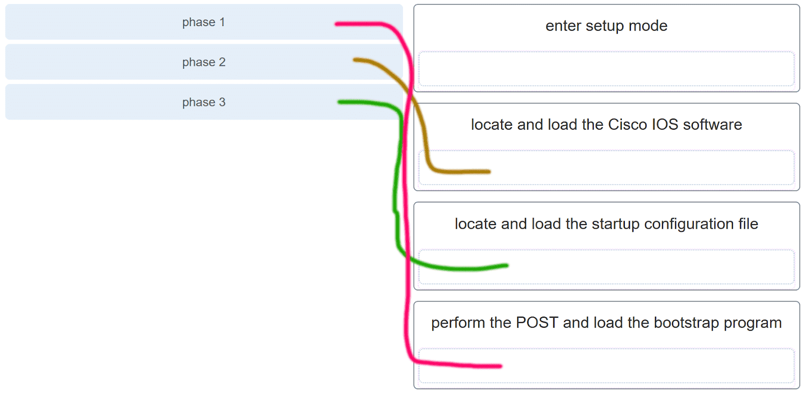

CCNA 1 v7 ITN Practice Final Exam Answers p16

Explanation: The enable command is entered in R1> mode. The login command is entered in R1(config-line)# mode. The copy running-config startup-config command is entered in R1# mode. The ip address 192.168.4.4 255.255.255.0 command is entered in R1(config-if)# mode. The service password-encryption command is entered in global configuration mode.

17. A router boots and enters setup mode. What is the reason for this?

The IOS image is corrupt.  
Cisco IOS is missing from flash memory.  
The configuration file is missing from NVRAM.  
The POST process has detected hardware failure.

Explanation: The startup configuration file is stored in NVRAM and contains the commands needed to initially configure a router. It also creates the running configuration file that is stored in in RAM.

18. What service is provided by POP3?

Retrieves email from the server by downloading the email to the local mail application of the client.  
An application that allows real-time chatting among remote users.  
Allows remote access to network devices and servers.  
Uses encryption to provide secure remote access to network devices and servers.

19. Two students are working on a network design project. One student is doing the drawing, while the other student is writing the proposal. The drawing is finished and the student wants to share the folder that contains the drawing so that the other student can access the file and copy it to a USB drive. Which networking model is being used?

peer-to-peer  
client-based  
master-slave  
point-to-point

Explanation: In a peer-to-peer (P2P) networking model, data is exchanged between two network devices without the use of a dedicated server.

20. Which command is used to manually query a DNS server to resolve a specific host name?

tracert  
ipconfig /displaydns  
nslookup  
net

21. Which PDU is processed when a host computer is de-encapsulating a message at the transport layer of the TCP/IP model?

bits  
frame  
packet  
segment

Explanation: At the transport layer, a host computer will de-encapsulate a segment to reassemble data to an acceptable format by the application layer protocol of the TCP/IP model.

22. Which two OSI model layers have the same functionality as two layers of the TCP/IP model? (Choose two.)

data link  
network  
physical  
session  
transport

Explanation: The OSI transport layer is functionally equivalent to the TCP/IP transport layer, and the OSI network layer is equivalent to the TCP/IP internet layer. The OSI data link and physical layers together are equivalent to the TCP/IP network access layer. The OSI session layer (with the presentation layer) is included within the TCP/IP application layer.

23. Which three layers of the OSI model are comparable in function to the application layer of the TCP/IP model? (Choose three.)

presentation  
physical  
network  
data link  
transport  
application  
sesión

24. Network information:

local router LAN interface: 172.19.29.254 / fe80:65ab:dcc1::10

local router WAN interface: 198.133.219.33 / 2001:db8:FACE:39::10

remote server: 192.135.250.103

What task might a user be trying to accomplish by using the ping 2001:db8:FACE:39::10 command?

verifying that there is connectivity within the local network  
creating a network performance benchmark to a server on the company intranet  
determining the path to reach the remote server  
verifying that there is connectivity to the internet

25. Which two ICMP messages are used by both IPv4 and IPv6 protocols? (Choose two.)​

neighbor solicitation  
router advertisement  
router solicitation  
protocol unreachable  
route redirection

26. A network technician types the command ping 127.0.0.1 at the command prompt on a computer. What is the technician trying to accomplish?

pinging a host computer that has the IP address 127.0.0.1 on the network  
tracing the path to a host computer on the network and the network has the IP address 127.0.0.1  
checking the IP address on the network card  
testing the integrity of the TCP/IP stack on the local machine

27. Although CSMA/CD is still a feature of Ethernet, why is it no longer necessary?

the virtually unlimited availability of IPv6 addresses  
the use of CSMA/CA  
the use of full-duplex capable Layer 2 switches  
the development of half-duplex switch operation  
the use of Gigabit Ethernet speeds

Explanation: The use of Layer 2 switches operating in full-duplex mode eliminates collisions, thereby eliminating the need for CSMA/CD.

28. What does a router do when it receives a Layer 2 frame over the network medium?

re-encapsulates the packet into a new frame  
forwards the new frame appropriate to the medium of that segment of the physical network  
determines the best path  
de-encapsulates the frame

29. Which two acronyms represent the data link sublayers that Ethernet relies upon to operate? (Choose two.)

SFD  
LLC  
CSMA  
MAC  
FCS

30. A network team is comparing topologies for connecting on a shared media. Which physical topology is an example of a hybrid topology for a LAN?

bus  
extended star  
ring  
partial mesh

Explanation: An extended star topology is an example of a hybrid topology as additional switches are interconnected with other star topologies. A partial mesh topology is a common hybrid WAN topology. The bus and ring are not hybrid topology types.

31. Given network 172.18.109.0, which subnet mask would be used if 6 host bits were available?

255.255.192.0  
255.255.224.0  
255.255.255.192  
255.255.255.248  
255.255.255.252

32. Three devices are on three different subnets. Match the network address and the broadcast address with each subnet where these devices are located. (Not all options are used.)

Device 1: IP address 192.168.10.77/28 on subnet 1

Device 2: IP address192.168.10.17/30 on subnet 2

Device 3: IP address 192.168.10.35/29 on subnet 3

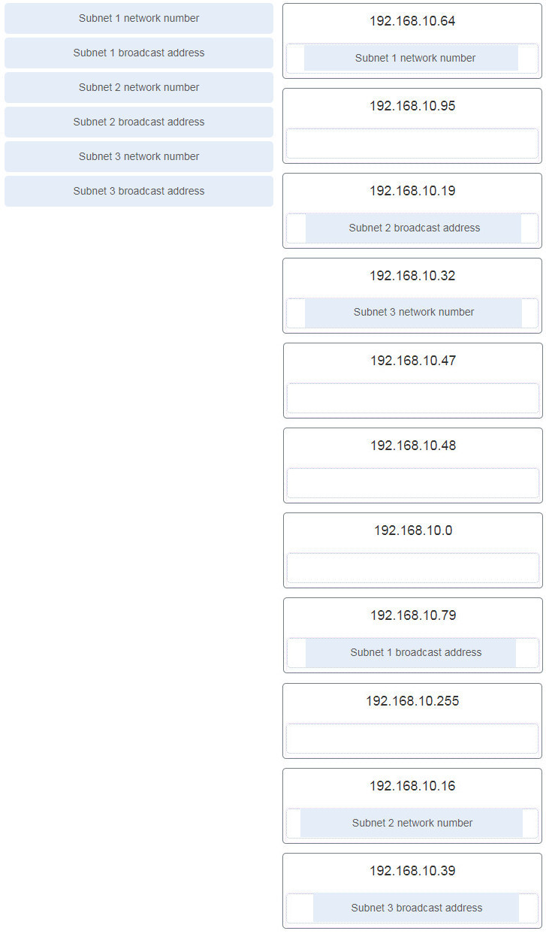

CCNA 1 v7 ITN Practice Final Exam Answers p32

To calculate any of these addresses, write the device IP address in binary. Draw a line showing where the subnet mask 1s end. For example, with Device 1, the final octet (77) is 01001101. The line would be drawn between the 0100 and the 1101 because the subnet mask is /28. Change all the bits to the right of the line to 0s to determine the network number (01000000 or 64). Change all the bits to the right of the line to 1s to determine the broadcast address (01001111 or 79).

33. What type of address is 198.133.219.162?

link-local  
public  
loopback  
multicast

34. What does the IP address 192.168.1.15/29 represent?

subnetwork address  
unicast address  
multicast address  
broadcast address

35. Why is NAT not needed in IPv6?​

Because IPv6 has integrated security, there is no need to hide the IPv6 addresses of internal networks.​  
The problems that are induced by NAT applications are solved because the IPv6 header improves packet handling by intermediate routers.​  
The end-to-end connectivity problems that are caused by NAT are solved because the number of routes increases with the number of nodes that are connected to the Internet.  
Any host or user can get a public IPv6 network address because the number of available IPv6 addresses is extremely large.​

36. What routing table entry has a next hop address associated with a destination network?

directly-connected routes  
local routes  
remote routes  
C and L source routes

Explanation: Routing table entries for remote routes will have a next hop IP address. The next hop IP address is the address of the router interface of the next device to be used to reach the destination network. Directly-connected and local routes have no next hop, because they do not require going through another router to be reached.

37. Which term describes a field in the IPv4 packet header that contains a unicast, multicast, or broadcast address?

destination IPv4 address  
protocol  
TTL  
header checksum

38. If the default gateway is configured incorrectly on the host, what is the impact on communications?

There is no impact on communications.  
The host is unable to communicate on the local network.  
The host can communicate with other hosts on the local network, but is unable to communicate with hosts on remote networks.  
The host can communicate with other hosts on remote networks, but is unable to communicate with hosts on the local network.

39. Which is the compressed format of the IPv6 address fe80:0000:0000:0000:0220:0b3f:f0e0:0029?

fe80:9ea:0:2200::fe0:290  
fe80:9ea0::2020::bf:e0:9290  
fe80::220:b3f:f0e0:29  
fe80:9ea0::2020:0:bf:e0:9290

40. Refer to the exhibit.

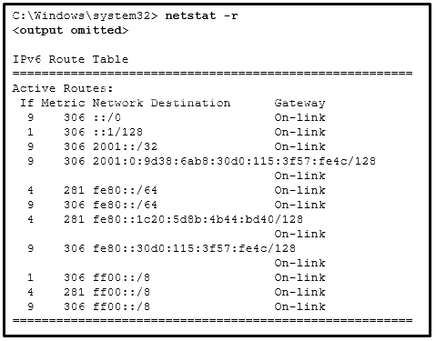

CCNA 1 v7 ITN Practice Final Exam Answers p40

A user issues the command netstat –r on a workstation. Which IPv6 address is one of the link-local addresses of the workstation?

::1/128  
fe80::30d0:115:3f57:fe4c/128  
fe80::/64  
2001:0:9d38:6ab8:30d0:115:3f57:fe4c/128

Explanation: In the IPv6 address scheme, the network of fe80::/10 is reserved for link-local addresses. The address fe80::/64 is a network address that indicates, in this workstation, fe80::/64 is actually used for link-local addresses. Thus the address fe80::30d0:115:3f57:fe4c/128 is a valid IPv6 link-local address.

41. What type of IPv6 address is represented by ::1/128?

EUI-64 generated link-local  
global unicast  
unspecified  
loopback

42. Which statement describes network security?

It supports growth over time in accordance with approved network design procedures.  
It synchronizes traffic flows using timestamps.  
It ensures sensitive corporate data is available for authorized users.  
It prioritizes data flows in order to give priority to delay-sensitive traffic.

43. Which two devices would be described as intermediary devices? (Choose two.)

wireless LAN controller  
server  
assembly line robots  
IPS  
gaming console  
retail scanner

44. What characteristic describes spyware?

software that is installed on a user device and collects information about the user  
the use of stolen credentials to access private data  
an attack that slows or crashes a device or network service  
a network device that filters access and traffic coming into a network

45. Refer to the exhibit.

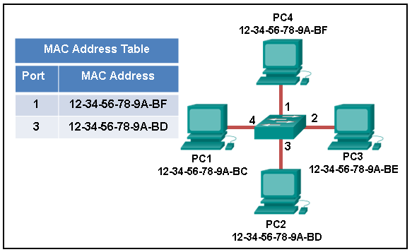

CCNA 1 v7 ITN Practice Final Exam Answers p45

The exhibit shows a small switched network and the contents of the MAC address table of the switch. PC1 has sent a frame addressed to PC3. What will the switch do with the frame?

The switch will discard the frame.  
The switch will forward the frame to all ports.  
The switch will forward the frame only to port 2.  
The switch will forward the frame only to ports 1 and 3.  
The switch will forward the frame to all ports except port 4.

46. Which destination address is used in an ARP request frame?

0.0.0.0  
255.255.255.255  
the physical address of the destination host  
FFFF.FFFF.FFFF  
AAAA.AAAA.AAAA

47. Refer to the exhibit.

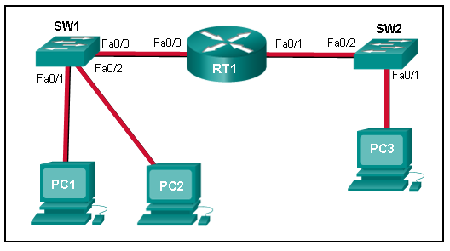

CCNA 1 v7 ITN Practice Final Exam Answers p47

PC1 issues an ARP request because it needs to send a packet to PC3. In this scenario, what will happen next?

SW1 will send an ARP reply with its Fa0/1 MAC address.  
RT1 will send an ARP reply with its own Fa0/0 MAC address.  
RT1 will forward the ARP request to PC3.  
RT1 will send an ARP reply with the PC3 MAC address.  
RT1 will send an ARP reply with its own Fa0/1 MAC address.

48. A network administrator is issuing the login block-for 180 attempts 2 within 30 command on a router. Which threat is the network administrator trying to prevent?

a user who is trying to guess a password to access the router  
a worm that is attempting to access another part of the network  
an unidentified individual who is trying to access the network equipment room  
a device that is trying to inspect the traffic on a link

Explanation: The login block-for 180 attempts 2 within 30 command will cause the device to block authentication after 2 unsuccessful attempts within 30 seconds for a duration of 180 seconds. A device inspecting the traffic on a link has nothing to do with the router. The router configuration cannot prevent unauthorized access to the equipment room. A worm would not attempt to access the router to propagate to another part of the network.

49. Which statement describes the characteristics of packet-filtering and stateful firewalls as they relate to the OSI model?

A packet-filtering firewall uses session layer information to track the state of a connection, whereas a stateful firewall uses application layer information to track the state of a connection.  
Both stateful and packet-filtering firewalls can filter at the application layer.  
A packet-filtering firewall typically can filter up to the transport layer, whereas a stateful firewall can filter up to the session layer.  
A stateful firewall can filter application layer information, whereas a packet-filtering firewall cannot filter beyond the network layer.

50. What are two ways to protect a computer from malware? (Choose two.)

Empty the browser cache.  
Use antivirus software.  
Delete unused software.  
Keep software up to date.  
Defragment the hard disk.

Explanation: At a minimum, a computer should use antivirus software and have all software up to date to defend against malware.

51. The employees and residents of Ciscoville cannot access the Internet or any remote web-based services. IT workers quickly determine that the city firewall is being flooded with so much traffic that a breakdown of connectivity to the Internet is occurring. Which type of attack is being launched at Ciscoville?

access  
Trojan horse  
reconnaissance  
DoS

52. Which two statements describe the characteristics of fiber-optic cabling? (Choose two.)

Fiber-optic cabling does not conduct electricity.  
Multimode fiber-optic cabling carries signals from multiple sending devices.  
Fiber-optic cabling is primarily used as backbone cabling.  
Fiber-optic cabling uses LEDs for single-mode cab​les and laser technology for multimode cables.  
Fiber-optic cabling has high signal loss.

53. What OSI physical layer term describes the measure of the transfer of bits across a medium over a given period of time?

latency  
goodput  
throughput  
bandwidth

54. Refer to the exhibit.

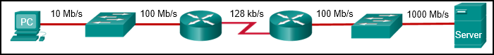

CCNA 1 v7 ITN Practice Final Exam Answers p54

What is the maximum possible throughput between the PC and the server?

10 Mb/s  
1000 Mb/s  
128 kb/s  
100 Mb/s

55. Match the description with the media. (Not all options are used.)

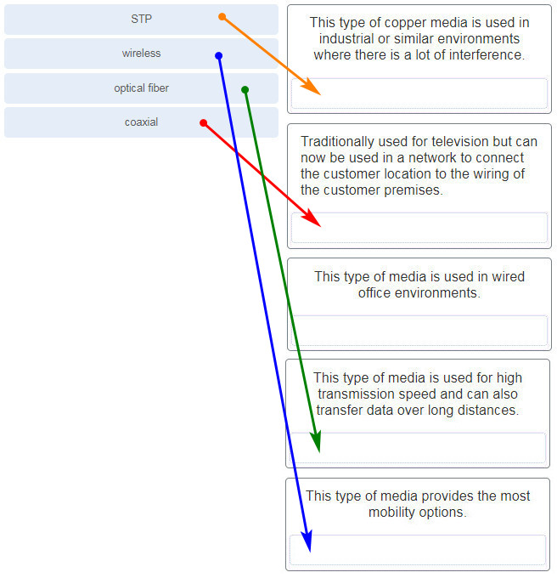

What two ICMPv6 message types must be permitted through IPv6 access control lists to allow resolution of Layer 3 addresses to Layer 2 MAC addresses? (Choose two.)

neighbor solicitations  
echo requests  
neighbor advertisements  
echo replies  
router solicitations  
router advertisements

2. Which range of link-local addresses can be assigned to an IPv6-enabled interface?

FEC0::/10  
FDEE::/7  
FE80::/10  
FF00::/8

Explanation:  
Link-local addresses are in the range of FE80::/10 to FEBF::/10. The original IPv6 specification defined site-local addresses and used the prefix range FEC0::/10, but these addresses were deprecated by the IETF in favor of unique local addresses. FDEE::/7 is a unique local address because it is in the range of FC00::/7 to FDFF::/7. IPv6 multicast addresses have the prefix FF00::/8.

3. What would be the interface ID of an IPv6 enabled interface with a MAC address of 1C-6F-65-C2-BD-F8 when the interface ID is generated by using the EUI-64 process?

0C6F:65FF:FEC2:BDF8  
1E6F:65FF:FEC2:BDF8  
C16F:65FF:FEC2:BDF8  
106F:65FF:FEC2:BDF8

4. An organization is assigned an IPv6 address block of 2001:db8:0:ca00::/56. How many subnets can be created without using bits in the interface ID space?

256  
512  
1024  
4096

5. Refer to the exhibit.

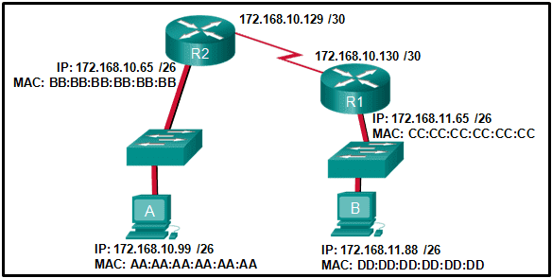

If host A sends an IP packet to host B, what will the destination address be in the frame when it leaves host A?

DD:DD:DD:DD:DD:DD  
172.168.10.99  
CC:CC:CC:CC:CC:CC  
172.168.10.65  
BB:BB:BB:BB:BB:BB  
AA:AA:AA:AA:AA:AA

Explanation:  
When a host sends information to a distant network, the Layer 2 frame header will contain a source and destination MAC address. The source address will be the originating host device. The destination address will be the router interface that connects to the same network. In the case of host A sending information to host B, the source address is AA:AA:AA:AA:AA:AA and the destination address is the MAC address assigned to the R2 Ethernet interface, BB:BB:BB:BB:BB:BB.

6. When a switch configuration includes a user-defined error threshold on a per-port basis, to which switching method will the switch revert when the error threshold is reached?

cut-through  
store-and-forward  
fast-forward  
fragment-free

7. Which two statements are correct about MAC and IP addresses during data transmission if NAT is not involved? (Choose two.)

Destination IP addresses in a packet header remain constant along the entire path to a target host.  
Destination MAC addresses will never change in a frame that goes across seven routers.  
Every time a frame is encapsulated with a new destination MAC address, a new destination IP address is needed.  
Destination and source MAC addresses have local significance and change every time a frame goes from one LAN to another.  
A packet that has crossed four routers has changed the destination IP address four times.

8. What is one main characteristic of the data link layer?

It generates the electrical or optical signals that represent the 1 and 0 on the media.  
It converts a stream of data bits into a predefined code.  
It shields the upper layer protocol from being aware of the physical medium to be used in the communication.  
It accepts Layer 3 packets and decides the path by which to forward the packet to a remote network.

9. What are three characteristics of the CSMA/CD process? (Choose three.)

The device with the electronic token is the only one that can transmit after a collision.  
A device listens and waits until the media is not busy before transmitting.  
After detecting a collision, hosts can attempt to resume transmission after a random time delay has expired.  
All of the devices on a segment see data that passes on the network medium.  
A jam signal indicates that the collision has cleared and the media is not busy.  
Devices can be configured with a higher transmission priority.

10. What are two primary responsibilities of the Ethernet MAC sublayer? (Choose two.)

error detection  
frame delimiting  
accessing the media  
data encapsulation  
logical addressing

11. Which two commands can be used on a Windows host to display the routing table? (Choose two.)

netstat -s  
route print  
show ip route  
netstat –r  
tracert

Explanation:  
On a Windows host, the route print or netstat -r commands can be used to display the host routing table. Both commands generate the same output. On a router, the show ip route command is used to display the routing table. The netstat –s command is used to display per-protocol statistics. The tracert command is used to display the path that a packet travels to its destination.

12. What are two functions that are provided by the network layer? (Choose two.)

directing data packets to destination hosts on other networks  
placing data on the network medium  
carrying data between processes that are running on source and destination hosts  
providing dedicated end-to-end connections  
providing end devices with a unique network identifier

13. Which two statements describe features of an IPv4 routing table on a router? (Choose two.)​

Directly connected interfaces will have two route source codes in the routing table: C and S.  
If there are two or more possible routes to the same destination, the route associated with the higher metric value is included in the routing table.  
The netstat -r command can be used to display the routing table of a router.​  
The routing table lists the MAC addresses of each active interface.  
It stores information about routes derived from the active router interfaces.  
If a default static route is configured in the router, an entry will be included in the routing table with source code S.

14. How does the service password-encryption command enhance password security on Cisco routers and switches?

It requires encrypted passwords to be used when connecting remotely to a router or switch with Telnet.  
It encrypts passwords that are stored in router or switch configuration files.  
It requires that a user type encrypted passwords to gain console access to a router or switch.  
It encrypts passwords as they are sent across the network.

Explanation: The service password-encryption command encrypts plaintext passwords in the configuration file so that they cannot be viewed by unauthorized users.

15. Why would a Layer 2 switch need an IP address?

to enable the switch to send broadcast frames to attached PCs  
to enable the switch to function as a default gateway  
to enable the switch to be managed remotely  
to enable the switch to receive frames from attached PCs

Explanation:  A switch, as a Layer 2 device, does not need an IP address to transmit frames to attached devices. However, when a switch is accessed remotely through the network, it must have a Layer 3 address. The IP address must be applied to a virtual interface rather than to a physical interface. Routers, not switches, function as default gateways.

16. What characteristic describes identity theft?

the use of stolen credentials to access private data  
software on a router that filters traffic based on IP addresses or applications  
software that identifies fast-spreading threats  
a tunneling protocol that provides remote users with secure access into the network of an organization

17. Match each description to its corresponding term. (Not all options are used.)

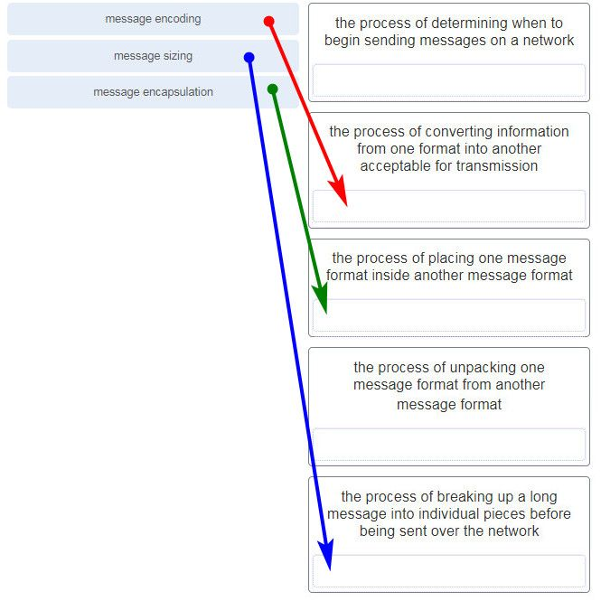

18. A user sends an HTTP request to a web server on a remote network. During encapsulation for this request, what information is added to the address field of a frame to indicate the destination?

the network domain of the destination host  
the IP address of the default gateway  
the MAC address of the destination host  
the MAC address of the default gateway

19. Data is being sent from a source PC to a destination server. Which three statements correctly describe the function of TCP or UDP in this situation? (Choose three.)

The source port field identifies the running application or service that will handle data returning to the PC.  
The TCP process running on the PC randomly selects the destination port when establishing a session with the server.  
UDP segments are encapsulated within IP packets for transport across the network.  
The UDP destination port number identifies the application or service on the server which will handle the data.  
TCP is the preferred protocol when a function requires lower network overhead.  
The TCP source port number identifies the sending host on the network.

Explanation: Layer 4 port numbers identify the application or service which will handle the data. The source port number is added by the sending device and will be the destination port number when the requested information is returned. Layer 4 segments are encapsulated within IP packets. UDP, not TCP, is used when low overhead is needed. A source IP address, not a TCP source port number, identifies the sending host on the network. Destination port numbers are specific ports that a server application or service monitors for requests.

20. Match each description with the corresponding TCP mechanism. (Not all options are used.)

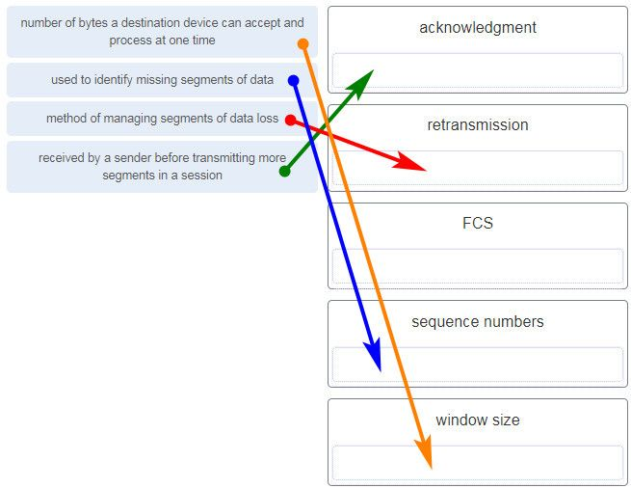

21. Refer to the exhibit.

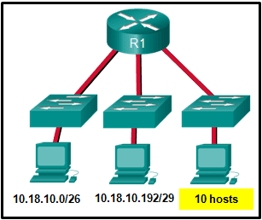

Which two network addresses can be assigned to the network containing 10 hosts? Your answers should waste the fewest addresses, not reuse addresses that are already assigned, and stay within the 10.18.10.0/24 range of addresses. (Choose two.)

10.18.10.200/28  
10.18.10.208/28  
10.18.10.240/27  
10.18.10.200/27  
10.18.10.224/27  
10.18.10.224/28

Explanation: Addresses 10.18.10.0 through 10.18.10.63 are taken for the leftmost network. Addresses 192 through 199 are used by the center network. Because 4 host bits are needed to accommodate 10 hosts, a /28 mask is needed. 10.18.10.200/28 is not a valid network number. Two subnets that can be used are 10.18.10.208/28 and 10.18.10.224/28.

22. Refer to the exhibit.

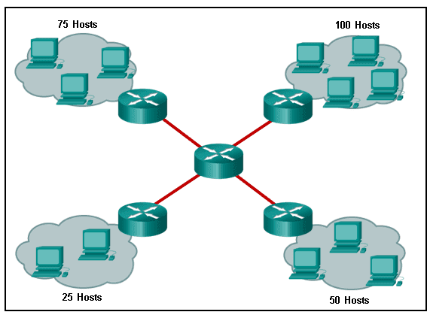

A company uses the address block of 128.107.0.0/16 for its network. What subnet mask would provide the maximum number of equal size subnets while providing enough host addresses for each subnet in the exhibit?

255.255.255.192  
255.255.255.0  
255.255.255.128  
255.255.255.240  
255.255.255.224

Explanation: The largest subnet in the topology has 100 hosts in it so the subnet mask must have at least 7 host bits in it (27-2=126). 255.255.255.0 has 8 hosts bits, but this does not meet the requirement of providing the maximum number of subnets.

23. A network administrator wants to have the same subnet mask for three subnetworks at a small site. The site has the following networks and numbers of devices:

Subnetwork A: IP phones – 10 addresses

Subnetwork B: PCs – 8 addresses

Subnetwork C: Printers – 2 addresses

What single subnet mask would be appropriate to use for the three subnetworks?

255.255.255.0  
255.255.255.240  
255.255.255.248  
255.255.255.252

Explanation:  
If the same mask is to be used, then the network with the most hosts must be examined for number of hosts. Because this is 10 hosts, 4 host bits are needed. The /28 or 255.255.255.240 subnet mask would be appropriate to use for these networks. ​

24. Match each item to the type of topology diagram on which it is typically identified. (Not all options are used.)

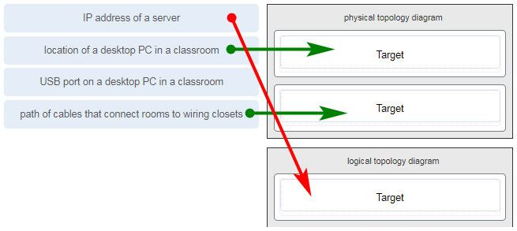

25. What two pieces of information are displayed in the output of the show ip interface brief command? (Choose two.)

IP addresses  
interface descriptions  
MAC addresses  
next-hop addresses  
Layer 1 statuses  
speed and duplex settings

Explanation: The command show ip interface brief shows the IP address of each interface, as well as the operational status of the interfaces at both Layer 1 and Layer 2. In order to see interface descriptions and speed and duplex settings, use the command show running-config interface. Next-hop addresses are displayed in the routing table with the command show ip route, and the MAC address of an interface can be seen with the command show interfaces.

26. A user is complaining that an external web page is taking longer than normal to load.The web page does eventually load on the user machine. Which tool should the technician use with administrator privileges in order to locate where the issue is in the network?

ping  
nslookup  
tracert  
ipconfig /displaydns

27. A network technician is researching the use of fiber optic cabling in a new technology center. Which two issues should be considered before implementing fiber optic media? (Choose two.)

Fiber optic cabling requires different termination and splicing expertise from what copper cabling requires.  
Fiber optic cabling requires specific grounding to be immune to EMI.  
Fiber optic cabling is susceptible to loss of signal due to RFI.  
Fiber optic cable is able to withstand rough handling.  
Fiber optic provides higher data capacity but is more expensive than copper cabling.

28. What technique is used with UTP cable to help protect against signal interference from crosstalk?

wrapping a foil shield around the wire pairs  
twisting the wires together into pairs  
terminating the cable with special grounded connectors  
encasing the cables within a flexible plastic sheath

Explanation: To help prevent the effects of crosstalk, UTP cable wires are twisted together into pairs. Twisting the wires together causes the magnetic fields of each wire to cancel each other out.

29. A network administrator is designing the layout of a new wireless network. Which three areas of concern should be accounted for when building a wireless network? (Choose three.)

extensive cabling  
mobility options  
packet collision  
interference  
security  
coverage área

Explanation: The three areas of concern for wireless networks focus on the size of the coverage area, any nearby interference, and providing network security. Extensive cabling is not a concern for wireless networks, as a wireless network will require minimal cabling for providing wireless access to hosts. Mobility options are not a component of the areas of concern for wireless networks.

30. Match each description with an appropriate IP address. (Not all options are used.)

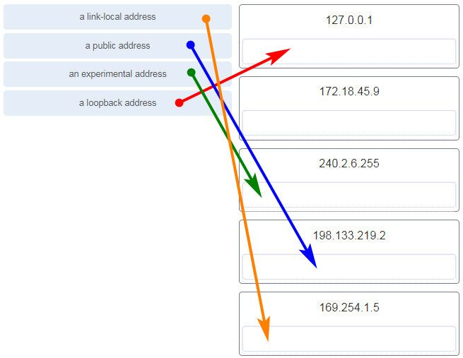

31. Users report that the network access is slow. After questioning the employees, the network administrator learned that one employee downloaded a third-party scanning program for the printer. What type of malware might be introduced that causes slow performance of the network?

virus  
worm  
phishing  
spam

Explanation: A cybersecurity specialist needs to be familiar with the characteristics of the different types of malware and attacks that threaten an organization.

32. Which scenario describes a function provided by the transport layer?

A student is using a classroom VoIP phone to call home. The unique identifier burned into the phone is a transport layer address used to contact another network device on the same network.  
A student is playing a short web-based movie with sound. The movie and sound are encoded within the transport layer header.  
A student has two web browser windows open in order to access two web sites. The transport layer ensures the correct web page is delivered to the correct browser window.  
A corporate worker is accessing a web server located on a corporate network. The transport layer formats the screen so the web page appears properly no matter what device is being used to view the web site.

Explanation:  
The source and destination port numbers are used to identify the correct application and window within that application.

33. Refer to the exhibit.

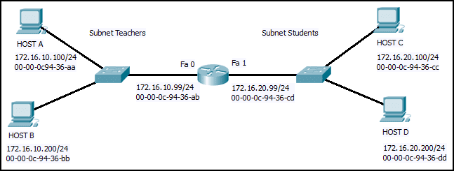

Host B on subnet Teachers transmits a packet to host D on subnet Students. Which Layer 2 and Layer 3 addresses are contained in the PDUs that are transmitted from host B to the router?

Layer 2 destination address = 00-00-0c-94-36-ab  
Layer 2 source address = 00-00-0c-94-36-bb  
Layer 3 destination address = 172.16.20.200  
Layer 3 source address = 172.16.10.200

Layer 2 destination address = 00-00-0c-94-36-dd  
Layer 2 source address = 00-00-0c-94-36-bb  
Layer 3 destination address = 172.16.20.200  
Layer 3 source address = 172.16.10.200

Layer 2 destination address = 00-00-0c-94-36-cd  
Layer 2 source address = 00-00-0c-94-36-bb  
Layer 3 destination address = 172.16.20.99  
Layer 3 source address = 172.16.10.200

Layer 2 destination address = 00-00-0c-94-36-ab  
Layer 2 source address = 00-00-0c-94-36-bb  
Layer 3 destination address = 172.16.20.200  
Layer 3 source address = 172.16.100.200

34. What does the term “attenuation” mean in data communication?

strengthening of a signal by a networking device  
leakage of signals from one cable pair to another  
time for a signal to reach its destination  
loss of signal strength as distance increases

35. Refer to the exhibit.

CCNA%2B1%2Bv7%2BFinal%2BExam%2BAnswers%2Bp35

An administrator is trying to configure the switch but receives the error message that is displayed in the exhibit. What is the problem?

The entire command, configure terminal, must be used.  
The administrator is already in global configuration mode.  
The administrator must first enter privileged EXEC mode before issuing the command.  
The administrator must connect via the console port to access global configuration mode.

36. Which two protocols operate at the top layer of the TCP/IP protocol suite? (Choose two.)

TCP  
IP  
UDP  
POP  
DNS  
Ethernet

37. A company has a file server that shares a folder named Public. The network security policy specifies that the Public folder is assigned Read-Only rights to anyone who can log into the server while the Edit rights are assigned only to the network admin group. Which component is addressed in the AAA network service framework?

automation  
accounting  
authentication  
authorization

Explanation:  
After a user is successfully authenticated (logged into the server), the authorization is the process of determining what network resources the user can access and what operations (such as read or edit) the user can perform.

38. What three requirements are defined by the protocols used in network communcations to allow message transmission across a network? (Choose three.)

message size  
message encoding  
connector specifications  
media selection  
delivery options  
end-device installation

39. What are two characteristics of IP? (Choose two.)

does not require a dedicated end-to-end connection  
operates independently of the network media  
retransmits packets if errors occur  
re-assembles out of order packets into the correct order at the receiver end  
guarantees delivery of packets

Explanation:  
The Internet Protocol (IP) is a connectionless, best effort protocol. This means that IP requires no end-to-end connection nor does it guarantee delivery of packets. IP is also media independent, which means it operates independently of the network media carrying the packets.

40. An employee of a large corporation remotely logs into the company using the appropriate username and password. The employee is attending an important video conference with a customer concerning a large sale. It is important for the video quality to be excellent during the meeting. The employee is unaware that after a successful login, the connection to the company ISP failed. The secondary connection, however, activated within seconds. The disruption was not noticed by the employee or other employees. What three network characteristics are described in this scenario? (Choose three.)

security  
quality of service  
scalability  
powerline networking  
integrity  
fault tolerance

41. What are two common causes of signal degradation when using UTP cabling? (Choose two.)

improper termination  
low-quality shielding in cable  
installing cables in conduit  
low-quality cable or connectors  
loss of light over long distances

42. Which subnet would include the address 192.168.1.96 as a usable host address?

192.168.1.64/26  
192.168.1.32/27  
192.168.1.32/28  
192.168.1.64/29

Explanation: For the subnet of 192.168.1.64/26, there are 6 bits for host addresses, yielding 64 possible addresses. However, the first and last subnets are the network and broadcast addresses for this subnet. Therefore, the range of host addresses for this subnet is 192.168.1.65 to 192.168.1.126. The other subnets do not contain the address 192.168.1.96 as a valid host address.

43. Refer to the exhibit.

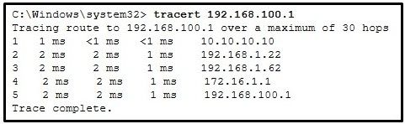

On the basis of the output, which two statements about network connectivity are correct? (Choose two.)

This host does not have a default gateway configured.  
There are 4 hops between this device and the device at 192.168.100.1.  
There is connectivity between this device and the device at 192.168.100.1.  
The connectivity between these two hosts allows for videoconferencing calls.  
The average transmission time between the two hosts is 2 milliseconds.

Explanation:  
The output displays a successful Layer 3 connection between a host computer and a host at 19.168.100.1. It can be determined that 4 hops exist between them and the average transmission time is 1 milliseconds. Layer 3 connectivity does not necessarily mean that an application can run between the hosts.

44. Which two statements describe how to assess traffic flow patterns and network traffic types using a protocol analyzer? (Choose two.)

Capture traffic on the weekends when most employees are off work.  
Capture traffic during peak utilization times to get a good representation of the different traffic types.  
Only capture traffic in the areas of the network that receive most of the traffic such as the data center.  
Perform the capture on different network segments.  
Only capture WAN traffic because traffic to the web is responsible for the largest amount of traffic on a network.

Explanation: Traffic flow patterns should be gathered during peak utilization times to get a good representation of the different traffic types. The capture should also be performed on different network segments because some traffic will be local to a particular segment.

45. What is the consequence of configuring a router with the ipv6 unicast-routing global configuration command?​

All router interfaces will be automatically activated.  
The IPv6 enabled router interfaces begin sending ICMPv6 Router Advertisement messages.  
Each router interface will generate an IPv6 link-local address.​  
It statically creates a global unicast address on this router.​

46. Which three layers of the OSI model map to the application layer of the TCP/IP model? (Choose three.)

Application  
network  
data link  
sesión  
presentation  
transport

Explanation: The TCP/IP model consists of four layers: application, transport, internet, and network access. The OSI model consists of seven layers: application, presentation, session, transport, network, data link, and physical. The top three layers of the OSI model: application, presentation, and session map to the application layer of the TCP/IP model.

47. Refer to the exhibit.

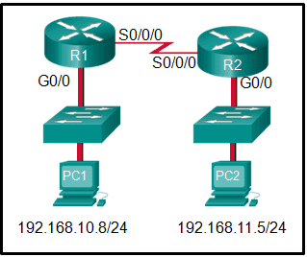

If PC1 is sending a packet to PC2 and routing has been configured between the two routers, what will R1 do with the Ethernet frame header attached by PC1?

nothing, because the router has a route to the destination network  
open the header and use it to determine whether the data is to be sent out S0/0/0  
open the header and replace the destination MAC address with a new one  
remove the Ethernet header and configure a new Layer 2 header before sending it out S0/0/0

Explanation: When PC1 forms the various headers attached to the data one of those headers is the Layer 2 header. Because PC1 connects to an Ethernet network, an Ethernet header is used. The source MAC address will be the MAC address of PC1 and the destination MAC address will be that of G0/0 on R1. When R1 gets that information, the router removes the Layer 2 header and creates a new one for the type of network the data will be placed onto (the serial link).

48. What will happen if the default gateway address is incorrectly configured on a host?

The host cannot communicate with other hosts in the local network.  
The host cannot communicate with hosts in other networks.  
A ping from the host to 127.0.0.1 would not be successful.  
The host will have to use ARP to determine the correct address of the default gateway.  
The switch will not forward packets initiated by the host.

49. What are two features of ARP? (Choose two.)

When a host is encapsulating a packet into a frame, it refers to the MAC address table to determine the mapping of IP addresses to MAC addresses.  
An ARP request is sent to all devices on the Ethernet LAN and contains the IP address of the destination host and its multicast MAC address.  
If a host is ready to send a packet to a local destination device and it has the IP address but not the MAC address of the destination, it generates an ARP broadcast.  
If no device responds to the ARP request, then the originating node will broadcast the data packet to all devices on the network segment.  
If a device receiving an ARP request has the destination IPv4 address, it responds with an ARP reply.

50. A network administrator is adding a new LAN to a branch office. The new LAN must support 90 connected devices. What is the smallest network mask that the network administrator can use for the new network?

255.255.255.128  
255.255.255.240  
255.255.255.248  
255.255.255.224

51. What are two ICMPv6 messages that are not present in ICMP for IPv4? (Choose two.)

Neighbor Solicitation  
Destination Unreachable  
Host Confirmation  
Time Exceeded  
Router Advertisement  
Route Redirection

52. A client packet is received by a server. The packet has a destination port number of 80. What service is the client requesting?

DHCP  
SMTP  
DNS  
HTTP

53. What is an advantage for small organizations of adopting IMAP instead of POP?

POP only allows the client to store messages in a centralized way, while IMAP allows distributed storage.  
Messages are kept in the mail servers until they are manually deleted from the email client.  
When the user connects to a POP server, copies of the messages are kept in the mail server for a short time, but IMAP keeps them for a long time.  
IMAP sends and retrieves email, but POP only retrieves email.

Explanation: IMAP and POP are protocols that are used to retrieve email messages. The advantage of using IMAP instead of POP is that when the user connects to an IMAP-capable server, copies of the messages are downloaded to the client application. IMAP then stores the email messages on the server until the user manually deletes those messages.

54. A technician can ping the IP address of the web server of a remote company but cannot successfully ping the URL address of the same web server. Which software utility can the technician use to diagnose the problem?

tracert  
ipconfig  
netstat  
nslookup

Explanation:  
Traceroute (tracert) is a utility that generates a list of hops that were successfully reached along the path from source to destination.This list can provide important verification and troubleshooting information. The ipconfig utility is used to display the IP configuration settings on a Windows PC. The Netstat utility is used to identify which active TCP connections are open and running on a networked host. Nslookup is a utility that allows the user to manually query the name servers to resolve a given host name. This utility can also be used to troubleshoot name resolution issues and to verify the current status of the name servers.

55. Which two functions are performed at the LLC sublayer of the OSI Data Link Layer to facilitate Ethernet communication? (Choose two.)

implements CSMA/CD over legacy shared half-duplex media  
enables IPv4 and IPv6 to utilize the same physical medium  
integrates Layer 2 flows between 10 Gigabit Ethernet over fiber and 1 Gigabit Ethernet over copper  
implements a process to delimit fields within an Ethernet 2 frame  
places information in the Ethernet frame that identifies which network layer protocol is being encapsulated by the frame

Explanation: The data link layer is actually divided into two sublayers:  
+ Logical Link Control (LLC): This upper sublayer defines the software processes that provide services to the network layer protocols. It places information in the frame that identifies which network layer protocol is being used for the frame. This information allows multiple Layer 3 protocols, such as IPv4 and IPv6, to utilize the same network interface and media.  
+ Media Access Control (MAC): This lower sublayer defines the media access processes performed by the hardware. It provides data link layer addressing and delimiting of data according to the physical signaling requirements of the medium and the type of data link layer protocol in use.

56. The global configuration command ip default-gateway 172.16.100.1 is applied to a switch. What is the effect of this command?

The switch can communicate with other hosts on the 172.16.100.0 network.  
The switch can be remotely managed from a host on another network.  
The switch is limited to sending and receiving frames to and from the gateway 172.16.100.1.  
The switch will have a management interface with the address 172.16.100.1.

Explanation: A default gateway address is typically configured on all devices to allow them to communicate beyond just their local network.In a switch this is achieved using the command ip default-gateway .

57. What happens when the transport input ssh command is entered on the switch vty lines?

The SSH client on the switch is enabled.  
The switch requires a username/password combination for remote access.  
Communication between the switch and remote users is encrypted.  
The switch requires remote connections via a proprietary client software.

Explanation: The transport input ssh command when entered on the switch vty (virtual terminal lines) will encrypt all inbound controlled telnet connections.

58. Match the type of threat with the cause. (Not all options are used.)

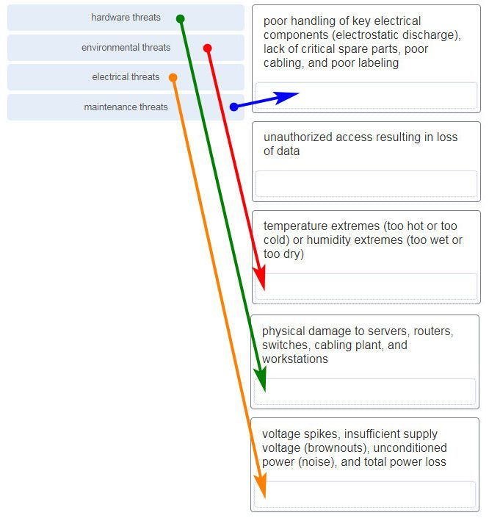

59. A disgruntled employee is using some free wireless networking tools to determine information about the enterprise wireless networks. This person is planning on using this information to hack the wireless network. What type of attack is this?

DoS  
access  
reconnaissance  
Trojan horse

60. What service is provided by HTTP?

Uses encryption to secure the exchange of text, graphic images, sound, and video on the web.  
Allows for data transfers between a client and a file server.  
An application that allows real-time chatting among remote users.  
A basic set of rules for exchanging text, graphic images, sound, video, and other multimedia files on the web.

61. A client packet is received by a server. The packet has a destination port number of 67. What service is the client requesting?

FTP  
DHCP  
Telnet  
SSH

62. What are two problems that can be caused by a large number of ARP request and reply messages? (Choose two.)

Switches become overloaded because they concentrate all the traffic from the attached subnets.  
The ARP request is sent as a broadcast, and will flood the entire subnet.  
The network may become overloaded because ARP reply messages have a very large payload due to the 48-bit MAC address and 32-bit IP address that they contain.  
A large number of ARP request and reply messages may slow down the switching process, leading the switch to make many changes in its MAC table.  
All ARP request messages must be processed by all nodes on the local network.

63. A group of Windows PCs in a new subnet has been added to an Ethernet network. When testing the connectivity, a technician finds that these PCs can access local network resources but not the Internet resources. To troubleshoot the problem, the technician wants to initially confirm the IP address and DNS configurations on the PCs, and also verify connectivity to the local router. Which three Windows CLI commands and utilities will provide the necessary information? (Choose three.)

netsh interface ipv6 show neighbor  
arp -a  
tracert  
ping  
ipconfig  
nslookup  
telnet

64. During the process of forwarding traffic, what will the router do immediately after matching the destination IP address to a network on a directly connected routing table entry?

analyze the destination IP address  
switch the packet to the directly connected interface  
look up the next-hop address for the packet  
discard the traffic after consulting the route table

65. What characteristic describes antispyware?

applications that protect end devices from becoming infected with malicious software  
a network device that filters access and traffic coming into a network  
software on a router that filters traffic based on IP addresses or applications  
a tunneling protocol that provides remote users with secure access into the network of an organization

66. A network administrator needs to keep the user ID, password, and session contents private when establishing remote CLI connectivity with a switch to manage it. Which access method should be chosen?

Telnet  
AUX  
SSH  
Console

67. What are the two most effective ways to defend against malware? (Choose two.)

Implement a VPN.  
Implement network firewalls.  
Implement RAID.  
Implement strong passwords.  
Update the operating system and other application software.  
Install and update antivirus software.

Explanation: A cybersecurity specialist must be aware of the technologies and measures that are used as countermeasures to protect the organization from threats and vulnerabilities.

68. Which type of security threat would be responsible if a spreadsheet add-on disables the local software firewall?

brute-force attack  
Trojan horse  
DoS  
buffer overflow

Explanation: A Trojan horse is software that does something harmful, but is hidden in legitimate software code. A denial of service (DoS) attack results in interruption of network services to users, network devices, or applications. A brute-force attack commonly involves trying to access a network device. A buffer overflow occurs when a program attempts to store more data in a memory location than it can hold.

69. Match the header field with the appropriate layer of the OSI model. (Not all options are used.)

70. Which frame field is created by a source node and used by a destination node to ensure that a transmitted data signal has not been altered by interference, distortion, or signal loss?

User Datagram Protocol field  
transport layer error check field  
flow control field  
frame check sequence field  
error correction process field

71. A network administrator is adding a new LAN to a branch office. The new LAN must support 4 connected devices. What is the smallest network mask that the network administrator can use for the new network?

255.255.255.248  
255.255.255.0  
255.255.255.128  
255.255.255.192

72. What service is provided by POP3?

Retrieves email from the server by downloading the email to the local mail application of the client.  
An application that allows real-time chatting among remote users.  
Allows remote access to network devices and servers.  
Uses encryption to provide secure remote access to network devices and servers.

73. What two security solutions are most likely to be used only in a corporate environment? (Choose two.)

antispyware  
virtual private networks  
intrusion prevention systems  
strong passwords  
antivirus software

74. What characteristic describes antivirus software?

applications that protect end devices from becoming infected with malicious software  
a network device that filters access and traffic coming into a network  
a tunneling protocol that provides remote users with secure access into the network of an organization  
software on a router that filters traffic based on IP addresses or applications

75. What mechanism is used by a router to prevent a received IPv4 packet from traveling endlessly on a network?

It checks the value of the TTL field and if it is 0, it discards the packet and sends a Destination Unreachable message to the source host.  
It checks the value of the TTL field and if it is 100, it discards the packet and sends a Destination Unreachable message to the source host.  
It decrements the value of the TTL field by 1 and if the result is 0, it discards the packet and sends a Time Exceeded message to the source host.  
It increments the value of the TTL field by 1 and if the result is 100, it discards the packet and sends a Parameter Problem message to the source host.

76. A client packet is received by a server. The packet has a destination port number of 69. What service is the client requesting?

DNS  
DHCP  
SMTP  
TFTP

77. An administrator defined a local user account with a secret password on router R1 for use with SSH. Which three additional steps are required to configure R1 to accept only encrypted SSH connections? (Choose three.)

Configure DNS on the router.  
Generate two-way pre-shared keys.  
Configure the IP domain name on the router.  
Generate the SSH keys.  
Enable inbound vty SSH sessions.  
Enable inbound vty Telnet sessions.

78. Which two functions are performed at the MAC sublayer of the OSI Data Link Layer to facilitate Ethernet communication? (Choose two.)

places information in the Ethernet frame that identifies which network layer protocol is being encapsulated by the frame  
adds Ethernet control information to network protocol data  
responsible for internal structure of Ethernet frame  
enables IPv4 and IPv6 to utilize the same physical medium  
implements trailer with frame check sequence for error detection

79. An IPv6 enabled device sends a data packet with the destination address of FF02::2. What is the target of this packet?​

all IPv6 enabled devices on the local link​  
all IPv6 DHCP servers​  
all IPv6 enabled devices across the network​  
all IPv6 configured routers on the local link​

80. What are the three parts of an IPv6 global unicast address? (Choose three.)

subnet ID  
subnet mask  
broadcast address  
global routing prefix  
interface ID

81. A client is using SLAAC to obtain an IPv6 address for its interface. After an address has been generated and applied to the interface, what must the client do before it can begin to use this IPv6 address?

It must send a DHCPv6 INFORMATION-REQUEST message to request the address of the DNS server.  
It must send a DHCPv6 REQUEST message to the DHCPv6 server to request permission to use this address.  
It must send an ICMPv6 Router Solicitation message to determine what default gateway it should use.  
It must send an ICMPv6 Neighbor Solicitation message to ensure that the address is not already in use on the network.

82. A new network administrator has been asked to enter a banner message on a Cisco device. What is the fastest way a network administrator could test whether the banner is properly configured?

Enter CTRL-Z at the privileged mode prompt.  
Exit global configuration mode.  
Power cycle the device.  
Reboot the device.  
Exit privileged EXEC mode and press Enter.

83. What method is used to manage contention-based access on a wireless network?

token passing  
CSMA/CA  
priority ordering  
CSMA/CD

84. What is a function of the data link layer?

provides the formatting of data  
provides end-to-end delivery of data between hosts  
provides delivery of data between two applications  
provides for the exchange of frames over a common local media

85. What is the purpose of the TCP sliding window?

to ensure that segments arrive in order at the destination  
to end communication when data transmission is complete  
to inform a source to retransmit data from a specific point forward  
to request that a source decrease the rate at which it transmits data

86. What characteristic describes spyware?

a network device that filters access and traffic coming into a network  
software that is installed on a user device and collects information about the user  
an attack that slows or crashes a device or network service  
the use of stolen credentials to access private data

87. Which switching method drops frames that fail the FCS check?

store-and-forward switching  
borderless switching  
ingress port buffering  
cut-through switching

88. Two pings were issued from a host on a local network. The first ping was issued to the IP address of the default gateway of the host and it failed. The second ping was issued to the IP address of a host outside the local network and it was successful. What is a possible cause for the failed ping?

The default gateway is not operational.  
The default gateway device is configured with the wrong IP address.  
Security rules are applied to the default gateway device, preventing it from processing ping requests.  
The TCP/IP stack on the default gateway is not working properly.

89. What service is provided by FTP?

A basic set of rules for exchanging text, graphic images, sound, video, and other multimedia files on the web.  
An application that allows real-time chatting among remote users.  
Allows for data transfers between a client and a file server.  
Uses encryption to secure the exchange of text, graphic images, sound, and video on the web.

90. A user is attempting to access http://www.cisco.com/ without success. Which two configuration values must be set on the host to allow this access? (Choose two.)

DNS server  
source port number  
HTTP server  
source MAC address  
default Gateway

91. Which two statements accurately describe an advantage or a disadvantage when deploying NAT for IPv4 in a network? (Choose two.)

NAT adds authentication capability to IPv4.  
NAT introduces problems for some applications that require end-to-end connectivity.  
NAT will impact negatively on switch performance.  
NAT provides a solution to slow down the IPv4 address depletion.  
NAT improves packet handling.  
NAT causes routing tables to include more information.

92. What subnet mask is needed if an IPv4 network has 40 devices that need IP addresses and address space is not to be wasted?

255.255.255.0  
255.255.255.240  
255.255.255.128  
255.255.255.192  
255.255.255.224

93. Refer to the exhibit.

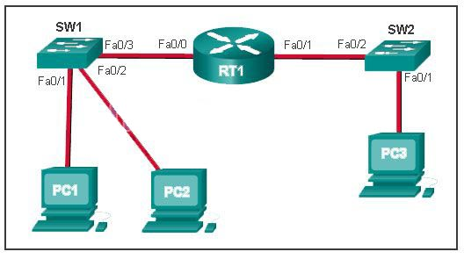

PC1 issues an ARP request because it needs to send a packet to PC2. In this scenario, what will happen next?

PC2 will send an ARP reply with its MAC address.  
RT1 will send an ARP reply with its Fa0/0 MAC address.  
RT1 will send an ARP reply with the PC2 MAC address.  
SW1 will send an ARP reply with the PC2 MAC address.  
SW1 will send an ARP reply with its Fa0/1 MAC address.

Explanation:  
When a network device wants to communicate with another device on the same network, it sends a broadcast ARP request. In this case, the request will contain the IP address of PC2. The destination device (PC2) sends an ARP reply with its MAC address.

94. What service is provided by BOOTP?

Uses encryption to secure the exchange of text, graphic images, sound, and video on the web.  
Allows for data transfers between a client and a file server.  
Legacy application that enables a diskless workstation to discover its own IP address and find a BOOTP server on the network.  
A basic set of rules for exchanging text, graphic images, sound, video, and other multimedia files on the web.

95. What characteristic describes adware?

a network device that filters access and traffic coming into a network  
software that is installed on a user device and collects information about the user  
the use of stolen credentials to access private data  
an attack that slows or crashes a device or network service

96. What is a benefit of using cloud computing in networking?

Technology is integrated into every-day appliances allowing them to interconnect with other devices, making them more ‘smart’ or automated.  
Network capabilities are extended without requiring investment in new infrastructure, personnel, or software.  
End users have the freedom to use personal tools to access information and communicate across a business network.  
Home networking uses existing electrical wiring to connect devices to the network wherever there is an electrical outlet, saving the cost of installing data cables.

97. Match a statement to the related network model. (Not all options are used.)

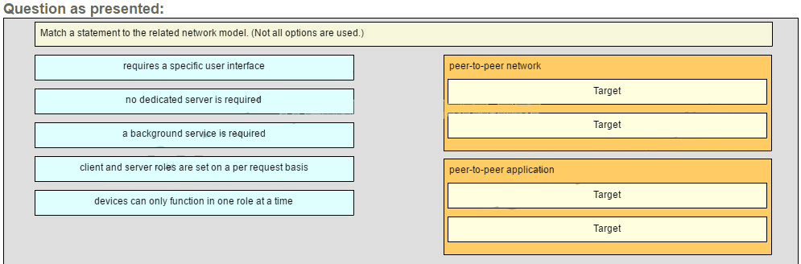

Place the options in the following order:

peer-to-peer network

[+] no dedicated server is required  
[+] client and server roles are set on a per request basis

peer-to-peer aplication

[#] requires a specific user interface  
[#] a background service is required

Explanation:  
Peer-to-peer networks do not require the use of a dedicated server, and devices can assume both client and server roles simultaneously on a per request basis. Because they do not require formalized accounts or permissions, they are best used in limited situations. Peer-to-peer applications require a user interface and background service to be running, and can be used in more diverse situations.

98. Which information does the show startup-config command display?

the IOS image copied into RAM  
the bootstrap program in the ROM  
the contents of the current running configuration file in the RAM  
the contents of the saved configuration file in the NVRAM

Explanation:  
The show startup-config command displays the saved configuration located in NVRAM. The show running-config command displays the contents of the currently running configuration file located in RAM.​

99. Refer to the exhibit.

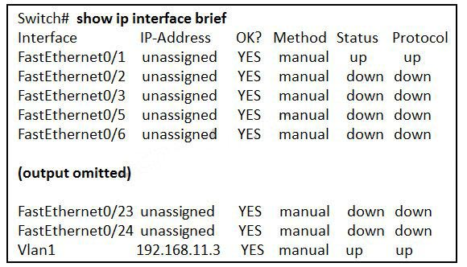

What three facts can be determined from the viewable output of the show ip interface brief command? (Choose three.)

Two physical interfaces have been configured.  
The switch can be remotely managed.  
One device is attached to a physical interface.  
Passwords have been configured on the switch.  
Two devices are attached to the switch.  
The default SVI has been configured.

Explanation:  
Vlan1 is the default SVI. Because an SVI has been configured, the switch can be configured and managed remotely. FastEthernet0/0 is showing up and up, so a device is connected.

100. Match each type of frame field to its function. (Not all options are used.)

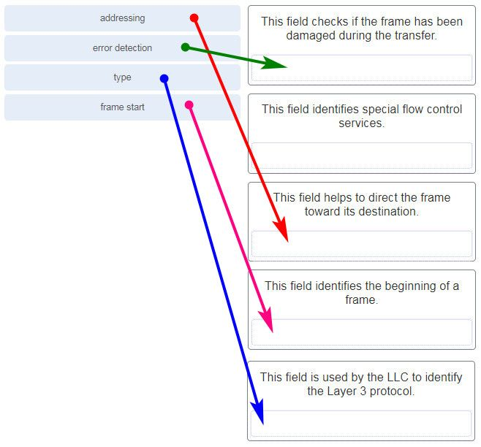

101. What is the subnet ID associated with the IPv6 address 2001:DA48:FC5:A4:3D1B::1/64?

2001:DA48::/64​  
2001:DA48:FC5::A4:/64​  
2001:DA48:FC5:A4::/64​  
2001::/64

102. Match the firewall function to the type of threat protection it provides to the network. (Not all options are used.)

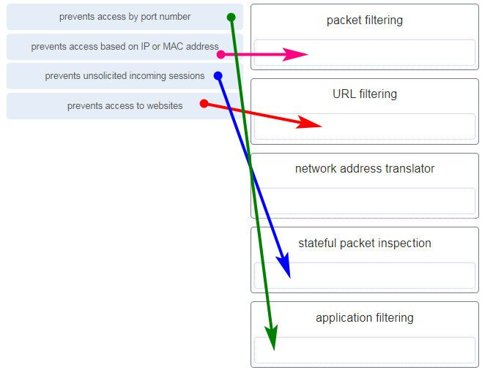

packet filtering – prevents access based on IP or MAC address  
URL filtering – prevents access to websites  
network address translator – (none)  
stateful packet inspection – prevents unsolicited incoming sessions  
application filtering – prevents access by port number

Explanation:Firewall products come packaged in various forms. These products use different techniques for determining what will be permitted or denied access to a network. They include the following:  
+ Packet filtering – Prevents or allows access based on IP or MAC addresses  
+ Application filtering – Prevents or allows access by specific application types based on port numbers  
+ URL filtering – Prevents or allows access to websites based on specific URLs or keywords  
+ Stateful packet inspection (SPI) – Incoming packets must be legitimate responses to requests from internal hosts. Unsolicited packets are blocked unless permitted specifically. SPI can also include the capability to recognize and filter out specific types of attacks, such as denial of service (DoS)

103. Users are reporting longer delays in authentication and in accessing network resources during certain time periods of the week. What kind of information should network engineers check to find out if this situation is part of a normal network behavior?

syslog records and messages  
the network performance baseline  
debug output and packet captures  
network configuration files

104. What characteristic describes a VPN?

software on a router that filters traffic based on IP addresses or applications  
software that identifies fast-spreading threats  
a tunneling protocol that provides remote users with secure access into the network of an organization  
a network device that filters access and traffic coming into a network

105. Which two statements are correct in a comparison of IPv4 and IPv6 packet headers? (Choose two.)

The Source Address field name from IPv4 is kept in IPv6.  
The Version field from IPv4 is not kept in IPv6.  
The Destination Address field is new in IPv6.  
The Header Checksum field name from IPv4 is kept in IPv6.  
The Time-to-Live field from IPv4 has been replaced by the Hop Limit field in IPv6.

106. A network administrator wants to have the same network mask for all networks at a particular small site. The site has the following networks and number of devices:

IP phones – 22 addresses

PCs – 20 addresses needed

Printers – 2 addresses needed

Scanners – 2 addresses needed

The network administrator has deemed that 192.168.10.0/24 is to be the network used at this site. Which single subnet mask would make the most efficient use of the available addresses to use for the four subnetworks?

255.255.255.192  
255.255.255.252  
255.255.255.240  
255.255.255.248  
255.255.255.0  
255.255.255.224

107. What is an advantage to using a protocol that is defined by an open standard?

A company can monopolize the market.  
The protocol can only be run on equipment from a specific vendor.  
An open standard protocol is not controlled or regulated by standards organizations.  
It encourages competition and promotes choices.

Explanation:  
A monopoly by one company is not a good idea from a user point of view. If a protocol can only be run on one brand, it makes it difficult to have mixed equipment in a network. A proprietary protocol is not free to use. An open standard protocol will in general be implemented by a wide range of vendors.

108. A network administrator is adding a new LAN to a branch office. The new LAN must support 200 connected devices. What is the smallest network mask that the network administrator can use for the new network?

255.255.255.240  
255.255.255.0  
255.255.255.248  
255.255.255.224

109. What are three commonly followed standards for constructing and installing cabling? (Choose three.)

cost per meter (foot)  
cable lengths  
connector color  
pinouts  
connector types  
tensile strength of plastic insulator

110. Refer to the exhibit.



What is wrong with the displayed termination?

The woven copper braid should not have been removed.  
The wrong type of connector is being used.  
The untwisted length of each wire is too long.  
The wires are too thick for the connector that is used.

Explanation: When a cable to an RJ-45 connector is terminated, it is important to ensure that the untwisted wires are not too long and that the flexible plastic sheath surrounding the wires is crimped down and not the bare wires. None of the colored wires should be visible from the bottom of the jack.

111. Match the characteristic to the category. (Not all options are used.)

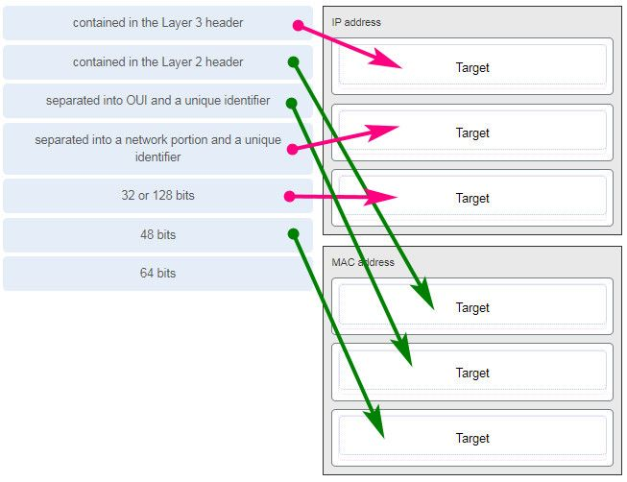

112. A client packet is received by a server. The packet has a destination port number of 143. What service is the client requesting?

IMAP  
FTP  
SSH  
Telnet

113. What are two characteristics shared by TCP and UDP? (Choose two.)

default window size  
connectionless communication  
port numbering  
3-way handshake  
ability to to carry digitized voice  
use of checksum

Explanation:  
Both TCP and UDP use source and destination port numbers to distinguish different data streams and to forward the right data segments to the right applications. Error checking the header and data is done by both protocols by using a checksum calculation to determine the integrity of the data that is received. TCP is connection-oriented and uses a 3-way handshake to establish an initial connection. TCP also uses window to regulate the amount of traffic sent before receiving an acknowledgment. UDP is connectionless and is the best protocol for carry digitized VoIP signals.

114. Which value, that is contained in an IPv4 header field, is decremented by each router that receives a packet?

Header Length  
Differentiated Services  
Time-to-Live  
Fragment Offset

115. A client packet is received by a server. The packet has a destination port number of 21. What service is the client requesting?

FTP  
LDAP  
SLP  
SNMP

116. What attribute of a NIC would place it at the data link layer of the OSI model?

attached Ethernet cable  
IP address  
MAC address  
RJ-45 port  
TCP/IP protocol stack

117. A network administrator is adding a new LAN to a branch office. The new LAN must support 10 connected devices. What is the smallest network mask that the network administrator can use for the new network?

255.255.255.192  
255.255.255.248  
255.255.255.224  
255.255.255.240

118. A user is executing a tracert to a remote device. At what point would a router, which is in the path to the destination device, stop forwarding the packet?

when the router receives an ICMP Time Exceeded message  
when the RTT value reaches zero  
when the host responds with an ICMP Echo Reply message  
when the value in the TTL field reaches zero  
when the values of both the Echo Request and Echo Reply messages reach zero

Explanation:  
When a router receives a traceroute packet, the value in the TTL field is decremented by 1. When the value in the field reaches zero, the receiving router will not forward the packet, and will send an ICMP Time Exceeded message back to the source.

119. Refer to the exhibit.

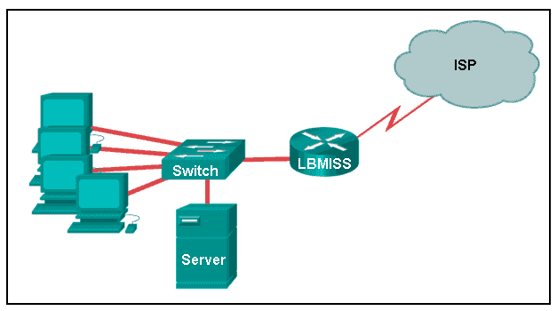

The network administrator has assigned the LAN of LBMISS an address range of 192.168.10.0. This address range has been subnetted using a /29 prefix. In order to accommodate a new building, the technician has decided to use the fifth subnet for configuring the new network (subnet zero is the first subnet). By company policies, the router interface is always assigned the first usable host address and the workgroup server is given the last usable host address. Which configuration should be entered into the properties of the workgroup server to allow connectivity to the Internet?

IP address: 192.168.10.65 subnet mask: 255.255.255.240, default gateway: 192.168.10.76  
IP address: 192.168.10.38 subnet mask: 255.255.255.240, default gateway: 192.168.10.33  
IP address: 192.168.10.38 subnet mask: 255.255.255.248, default gateway: 192.168.10.33  
IP address: 192.168.10.41 subnet mask: 255.255.255.248, default gateway: 192.168.10.46  
IP address: 192.168.10.254 subnet mask: 255.255.255.0, default gateway: 192.168.10.1

Explanation:  
Using a /29 prefix to subnet 192.168.10.0 results in subnets that increment by 8:

192.168.10.0 (1)  
192.168.10.8 (2)  
192.168.10.16 (3)  
192.168.10.24 (4)  
192.168.10.32 (5)

120. Refer to the exhibit.

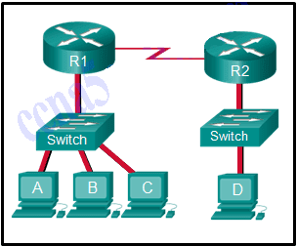

The switches are in their default configuration. Host A needs to communicate with host D, but host A does not have the MAC address for its default gateway. Which network hosts will receive the ARP request sent by host A?

only host D  
only router R1  
only hosts A, B, and C  
only hosts A, B, C, and D  
only hosts B and C  
only hosts B, C, and router R1

Explanation:  
Since host A does not have the MAC address of the default gateway in its ARP table, host A sends an ARP broadcast. The ARP broadcast would be sent to every device on the local network. Hosts B, C, and router R1 would receive the broadcast. Router R1 would not forward the message.

121. Which two traffic types use the Real-Time Transport Protocol (RTP)? (Choose two.)

video  
web  
file transfer  
voice  
peer to peer

122. Which wireless technology has low-power and data rate requirements making it popular in home automation applications?

ZigBee  
LoRaWAN  
5G  
Wi-Fi

123. Which layer of the TCP/IP model provides a route to forward messages through an internetwork?

application  
network access  
internet  
transport

Explanation:  
The OSI model network layer corresponds directly to the internet layer of the TCP/IP model and is used to describe protocols that address and route messages through an internetwork.

124. Which type of server relies on record types such as A, NS, AAAA, and MX in order to provide services?

DNS  
email  
file  
web

Explanation:  
A DNS server stores records that are used to resolve IP addresses to host names. Some DNS record types include the following:  
A – an end device IPv4 address  
NS – an authoritative name server  
AAAA – an end device IPv6 address  
MX – a mail exchange record

125. What are proprietary protocols?

protocols developed by private organizations to operate on any vendor hardware  
protocols that can be freely used by any organization or vendor  
protocols developed by organizations who have control over their definition and operation  
a collection of protocols known as the TCP/IP protocol suite

Explanation:  
Proprietary protocols have their definition and operation controlled by one company or vendor. Some of them can be used by different organizations with permission from the owner. The TCP/IP protocol suite is an open standard, not a proprietary protocol.

126. What service is provided by DNS?

Resolves domain names, such as cisco.com, into IP addresses.  
A basic set of rules for exchanging text, graphic images, sound, video, and other multimedia files on the web.  
Allows for data transfers between a client and a file server.  
Uses encryption to secure the exchange of text, graphic images, sound, and video on the web.

127. A client packet is received by a server. The packet has a destination port number of 110. What service is the client requesting?

DNS  
DHCP  
SMTP  
POP3

128. What command can be used on a Windows PC to see the IP configuration of that computer?

show ip interface brief  
ping  
show interfaces  
ipconfig

129. A wired laser printer is attached to a home computer. That printer has been shared so that other computers on the home network can also use the printer. What networking model is in use?

client-based  
master-slave  
point-to-point  
peer-to-peer (P2P)

Explanation: Peer-to-peer (P2P) networks have two or more network devices that can share resources such as printers or files without having a dedicated server.

130. What characteristic describes a virus?

a network device that filters access and traffic coming into a network  
the use of stolen credentials to access private data  
an attack that slows or crashes a device or network service  
malicious software or code running on an end device

131. Three bank employees are using the corporate network. The first employee uses a web browser to view a company web page in order to read some announcements. The second employee accesses the corporate database to perform some financial transactions. The third employee participates in an important live audio conference with other corporate managers in branch offices. If QoS is implemented on this network, what will be the priorities from highest to lowest of the different data types?

financial transactions, web page, audio conference  
audio conference, financial transactions, web page  
financial transactions, audio conference, web page  
audio conference, web page, financial transactions

132. Match the description to the IPv6 addressing component. (Not all options are used.)

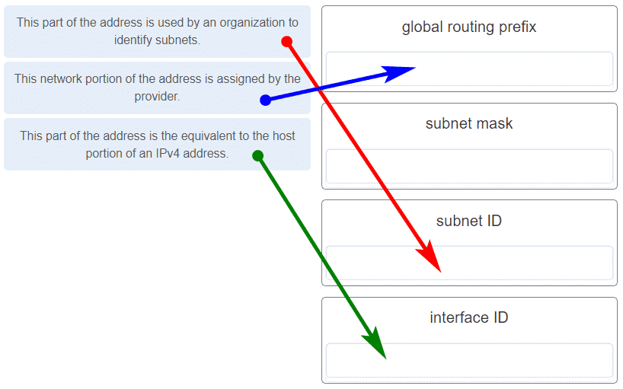

133. Refer to the exhibit.

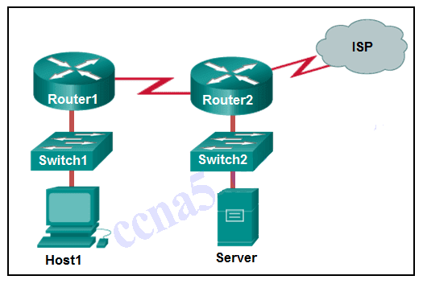

If Host1 were to transfer a file to the server, what layers of the TCP/IP model would be used?

only application and Internet layers  
only Internet and network access layers  
only application, Internet, and network access layers  
application, transport, Internet, and network access layers  
only application, transport, network, data link, and physical layers  
application, session, transport, network, data link, and physical layers

Explanation: The TCP/IP model contains the application, transport, internet, and network access layers. A file transfer uses the FTP application layer protocol. The data would move from the application layer through all of the layers of the model and across the network to the file server.

134. Match the characteristic to the forwarding method. (Not all options are used.)

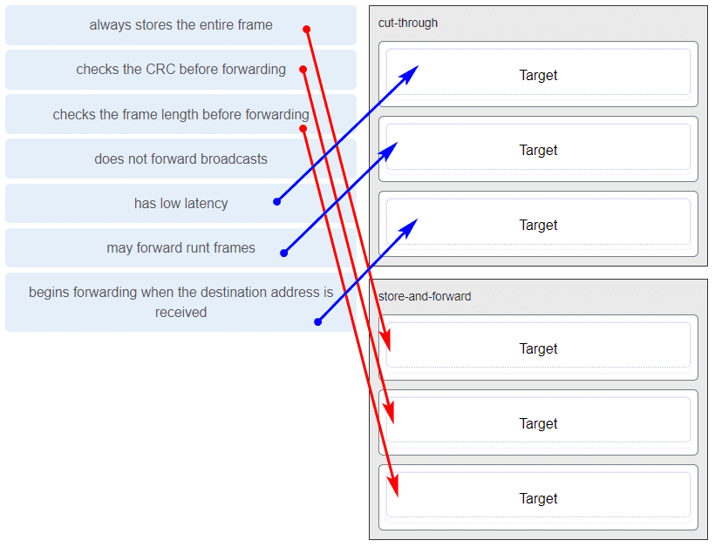

Explanation: A store-and-forward switch always stores the entire frame before forwarding, and checks its CRC and frame length. A cut-through switch can forward frames before receiving the destination address field, thus presenting less latency than a store-and-forward switch. Because the frame can begin to be forwarded before it is completely received, the switch may transmit a corrupt or runt frame. All forwarding methods require a Layer 2 switch to forward broadcast frames.

135. Refer to the exhibit.

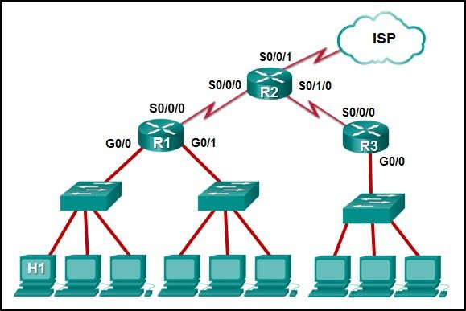

The IP address of which device interface should be used as the default gateway setting of host H1?

R1: S0/0/0  
R2: S0/0/1  
R1: G0/0  
R2: S0/0/0

136. What service is provided by Internet Messenger?

An application that allows real-time chatting among remote users.  
Allows remote access to network devices and servers.  
Resolves domain names, such as cisco.com, into IP addresses.  
Uses encryption to provide secure remote access to network devices and servers.

137. Refer to the exhibit.



Match the network with the correct IP address and prefix that will satisfy the usable host addressing requirements for each network.

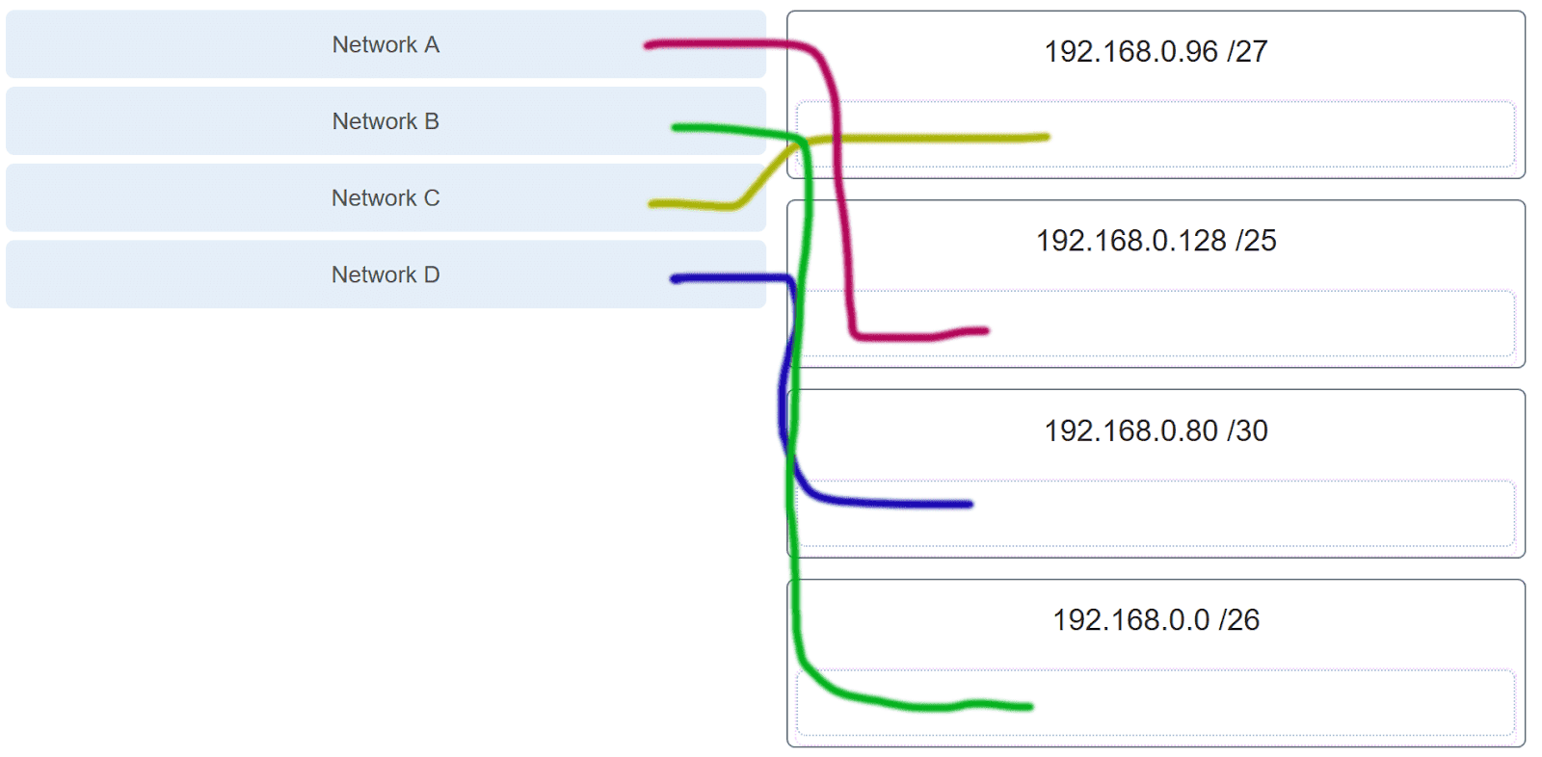

Explanation: Network A needs to use 192.168.0.128 /25, which yields 128 host addresses.  
Network B needs to use 192.168.0.0 /26, which yields 64 host addresses.  
Network C needs to use 192.168.0.96 /27, which yields 32 host addresses.  
Network D needs to use 192.168.0.80/30, which yields 4 host addresses.

138. Refer to the exhibit. Which protocol was responsible for building the table that is shown?

interface: 192.168.1.67 — 0xa

internet address physical address type

192.168.1.254 64-0f-29-0d-36-91 dynamic

.

.

.

interface: 10.82.253.91 —- 0x10

DHCP  
ARP  
DNS  
ICMP

139. A network administrator notices that some newly installed Ethernet cabling is carrying corrupt and distorted data signals. The new cabling was installed in the ceiling close to fluorescent lights and electrical equipment. Which two factors may interfere with the copper cabling and result in signal distortion and data corruption? (Choose two.)

crosstalk  
extended length of cabling  
RFI​  
EMI  
signal attenuation

140. A host is trying to send a packet to a device on a remote LAN segment, but there are currently no mappings in its ARP cache. How will the device obtain a destination MAC address?

It will send the frame and use its own MAC address as the destination.  
It will send an ARP request for the MAC address of the destination device.  
It will send the frame with a broadcast MAC address.  
It will send a request to the DNS server for the destination MAC address.  
It will send an ARP request for the MAC address of the default gateway.

141. Which two functions are performed at the MAC sublayer of the OSI Data Link Layer to facilitate Ethernet communication?

integrates Layer 2 flows between 10 Gigabit Ethernet over fiber and 1 Gigabit Ethernet over copper  
enables IPv4 and IPv6 to utilize the same physical medium  
handles communication between upper layer networking software and Ethernet NIC hardware  
adds Ethernet control information to network protocol data  
implements CSMA/CD over legacy shared half-duplex media

142. A client packet is received by a server. The packet has a destination port number of 53. What service is the client requesting?

DNS  
NetBIOS (NetBT)  
POP3  
IMAP

143. A network administrator is adding a new LAN to a branch office. The new LAN must support 25 connected devices. What is the smallest network mask that the network administrator can use for the new network?

255.255.255.128  
255.255.255.192  
255.255.255.224  
255.255.255.240

144. What characteristic describes a Trojan horse?

malicious software or code running on an end device  
an attack that slows or crashes a device or network service  
the use of stolen credentials to access private data  
a network device that filters access and traffic coming into a network

145. What service is provided by HTTPS?

Uses encryption to provide secure remote access to network devices and servers.  
Resolves domain names, such as cisco.com, into IP addresses.  
Uses encryption to secure the exchange of text, graphic images, sound, and video on the web.  
Allows remote access to network devices and servers.

146. A technician with a PC is using multiple applications while connected to the Internet. How is the PC able to keep track of the data flow between multiple application sessions and have each application receive the correct packet flows?

The data flow is being tracked based on the destination MAC address of the technician PC.  
The data flow is being tracked based on the source port number that is used by each application.  
The data flow is being tracked based on the source IP address that is used by the PC of the technician.  
The data flow is being tracked based on the destination IP address that is used by the PC of the technician.

Explanation:  
The source port number of an application is randomly generated and used to individually keep track of each session connecting out to the Internet. Each application will use a unique source port number to provide simultaneous communication from multiple applications through the Internet.

147. A network administrator is adding a new LAN to a branch office. The new LAN must support 61 connected devices. What is the smallest network mask that the network administrator can use for the new network?

255.255.255.240  
255.255.255.224  
255.255.255.192  
255.255.255.128

148. Refer to the exhibit.

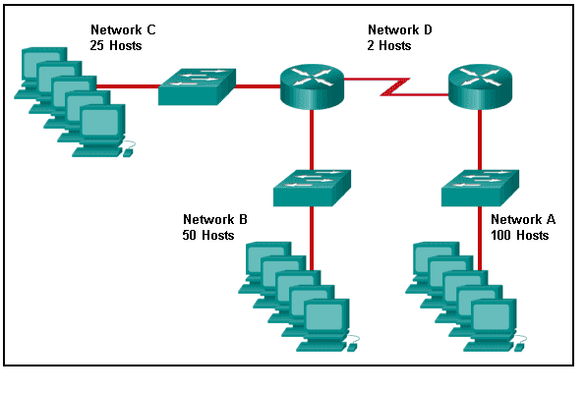

Match the network with the correct IP address and prefix that will satisfy the usable host addressing requirements for each network. (Not all options are used.)

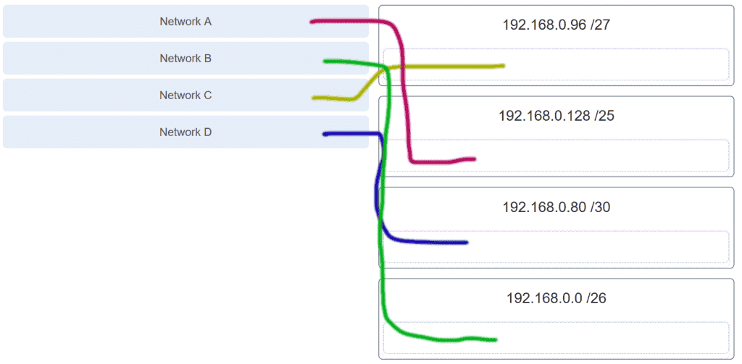

Explanation:  
Network A needs to use 192.168.0.0 /25 which yields 128 host addresses.  
Network B needs to use 192.168.0.128 /26 which yields 64 host addresses.  
Network C needs to use 192.168.0.192 /27 which yields 32 host addresses.  
Network D needs to use 192.168.0.224 /30 which yields 4 host addresses.

149. What characteristic describes a DoS attack?

the use of stolen credentials to access private data  
a network device that filters access and traffic coming into a network  
software that is installed on a user device and collects information about the user  
an attack that slows or crashes a device or network service

150. Match the application protocols to the correct transport protocols

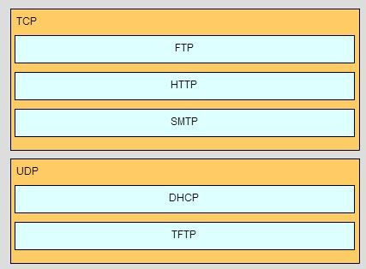

151. What service is provided by SMTP?

Allows clients to send email to a mail server and the servers to send email to other servers.  
Allows remote access to network devices and servers.  
Uses encryption to provide secure remote access to network devices and servers.  
An application that allows real-time chatting among remote users.

152. Match a statement to the related network model. (Not all options are used.)

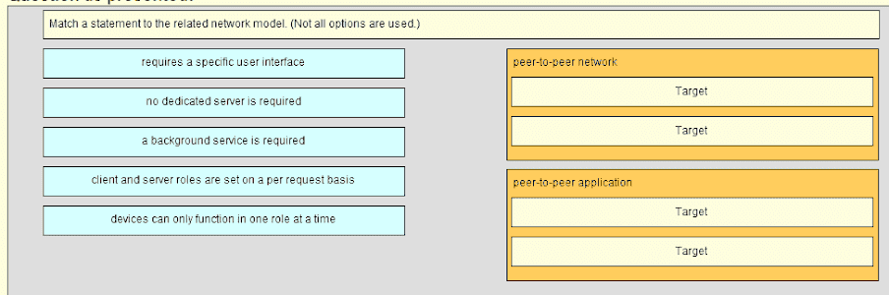

Place the options in the following order:

peer-to-peer network

[+] no dedicated server is required  
[+] client and server roles are set on a per request basis

peer-to-peer aplication

[#] requires a specific user interface  
[#] a background service is required

Explanation:  
Peer-to-peer networks do not require the use of a dedicated server, and devices can assume both client and server roles simultaneously on a per request basis. Because they do not require formalized accounts or permissions, they are best used in limited situations. Peer-to-peer applications require a user interface and background service to be running, and can be used in more diverse situations.

153. Match the application protocols to the correct transport protocols.

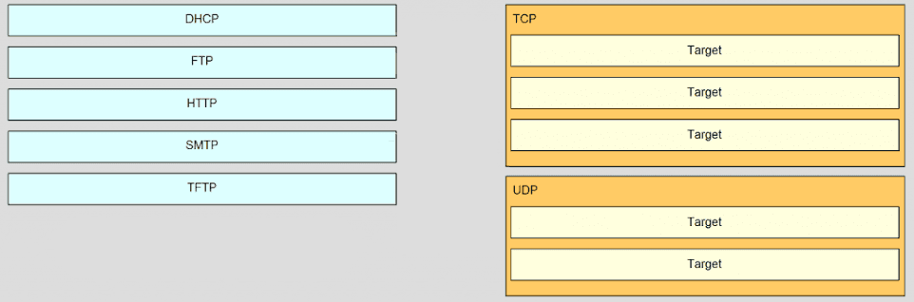

Answer.

TCP

FTP  
HTTP  
SMTP

UDP

DHCP  
TFTP

154. Refer to the exhibit.

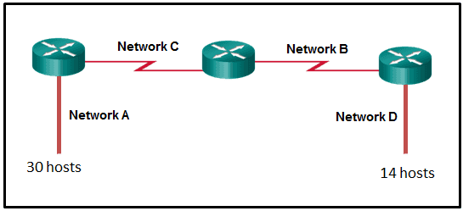

A network engineer has been given the network address of 192.168.99.0 and a subnet mask of 255.255.255.192 to subnet across the four networks shown. How many total host addresses are unused across all four subnets?

88  
200  
72  
224  
158

155. Which two functions are performed at the MAC sublayer of the OSI Data Link Layer to facilitate Ethernet communication? (Choose two.)

places information in the Ethernet frame that identifies which network layer protocol is being encapsulated by the frame  
handles communication between upper layer networking software and Ethernet NIC hardware  
adds Ethernet control information to network protocol data  
applies source and destination MAC addresses to Ethernet frame  
applies delimiting of Ethernet frame fields to synchronize communication between nodes

156. Which connector is used with twisted-pair cabling in an Ethernet LAN?

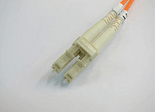

LC conector

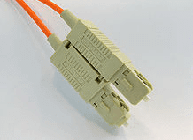

SC conector

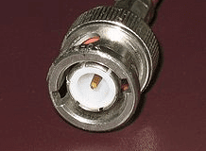

BNC

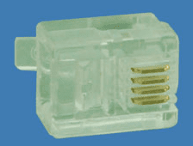

RJ 11

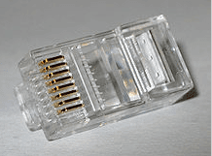

RJ 45 (TRUE ANSWERS)

157. A client packet is received by a server. The packet has a destination port number of 22. What service is the client requesting?

SSH  
SMB/CIFS  
HTTPS  
SLP

158. What characteristic describes an IPS?

a tunneling protocol that provides remote users with secure access into the network of an organization  
a network device that filters access and traffic coming into a network  
software that identifies fast-spreading threats  
software on a router that filters traffic based on IP addresses or applications

159. What service is provided by DHCP?

Dynamically assigns IP addresses to end and intermediary devices.

160. Which two functions are performed at the LLC sublayer of the OSI Data Link Layer to facilitate Ethernet communication? (Choose two.)

responsible for internal structure of Ethernet frame  
applies source and destination MAC addresses to Ethernet frame  
integrates Layer 2 flows between 10 Gigabit Ethernet over fiber and 1 Gigabit Ethernet over copper  
enables IPv4 and IPv6 to utilize the same physical medium  
handles communication between upper layer networking software and Ethernet NIC hardware

161. Which two functions are performed at the LLC sublayer of the OSI Data Link Layer to facilitate Ethernet communication? (Choose two.)

adds Ethernet control information to network protocol data  
responsible for internal structure of Ethernet frame  
implements trailer with frame check sequence for error detection  
enables IPv4 and IPv6 to utilize the same physical medium  
applies source and destination MAC addresses to Ethernet frame

162. Which two functions are performed at the MAC sublayer of the OSI Data Link Layer to facilitate Ethernet communication? (Choose two.)

implements CSMA/CD over legacy shared half-duplex media  
enables IPv4 and IPv6 to utilize the same physical medium  
adds Ethernet control information to network protocol data  
handles communication between upper layer networking software and Ethernet NIC hardware  
integrates Layer 2 flows between 10 Gigabit Ethernet over fiber and 1 Gigabit Ethernet over copper

163. Which two functions are performed at the MAC sublayer of the OSI Data Link Layer to facilitate Ethernet communication? (Choose two.)

places information in the Ethernet frame that identifies which network layer protocol is being encapsulated by the frame  
handles communication between upper layer networking software and Ethernet NIC hardware  
adds Ethernet control information to network protocol data  
applies source and destination MAC addresses to Ethernet frame  
applies delimiting of Ethernet frame fields to synchronize communication between nodes